Generate Multiplication Table.

The given excel file is as below:

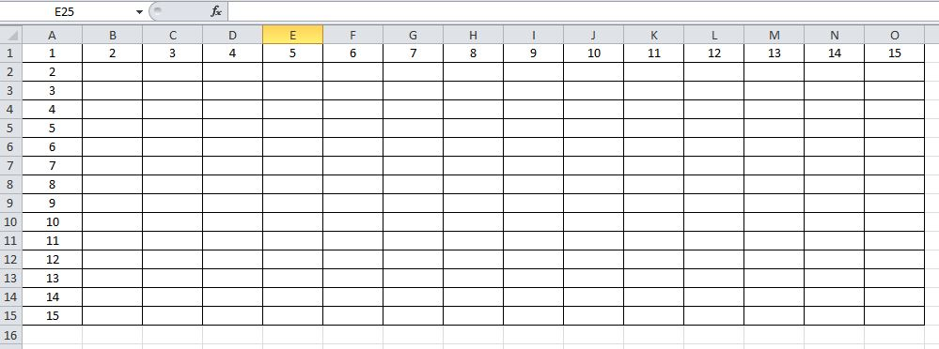

We will use the multiplication formula***=$A2 \* B$1***in cell B2

To create the table, we follow the below steps:

• Select cell B2 and click on it

• Insert the formula: =$A2 \* B$1

• Press enter

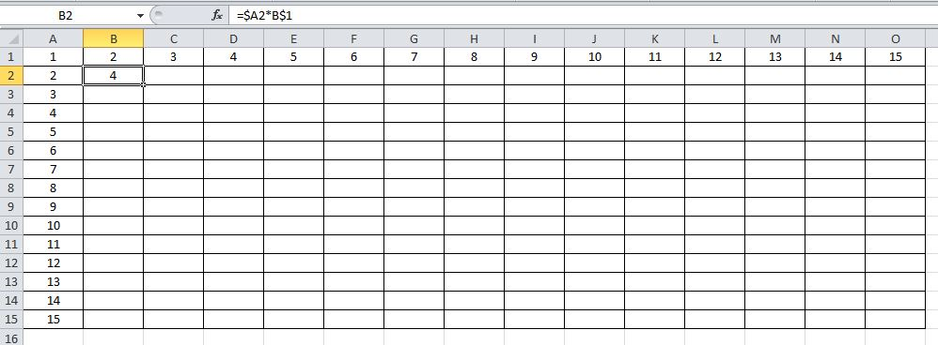

• Drag the formula down to the other cells in the column by clicking and dragging the little “+” icon at the bottom-right of the cell.

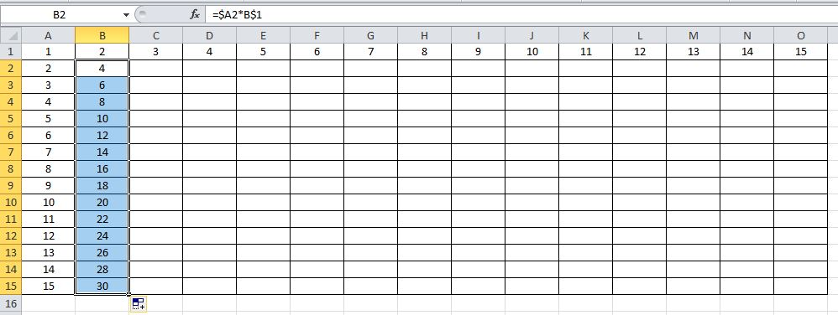

• Drag the formula down to the other cells in the rows by clicking and dragging the little “+” icon at the bottom-right of the cell.

