1.      Fill in the table of 2016 sales by month by store using only 1 SUMIFS Formula (Many Sales Sample Data)

Using the formula as below, we can fill the table.

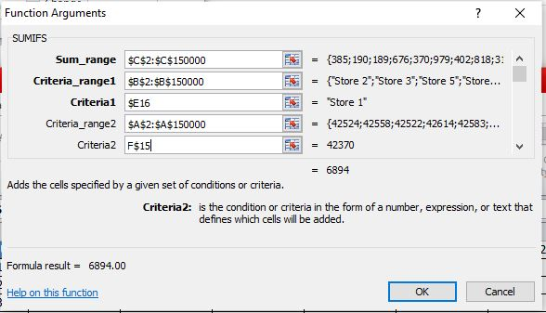

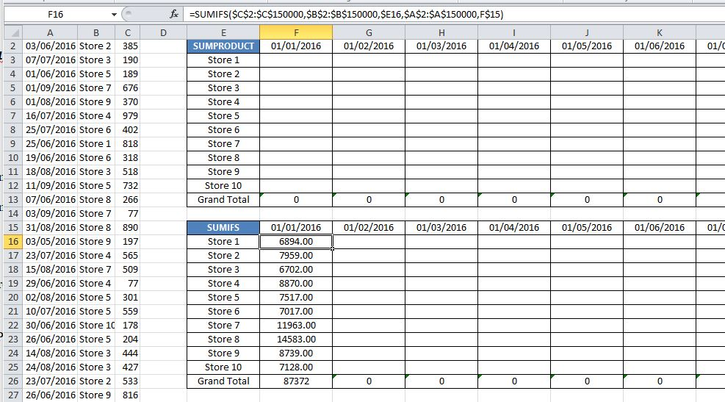

Drag the formula to the other cells and fill the table.

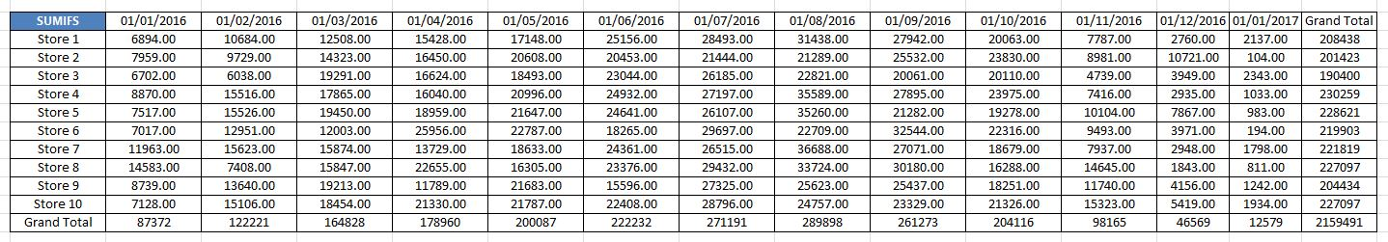

2. Fill in the table of 2016 sales by month by store using only 1 SUMPRODUCT Formula (Many Sales Sample Data)

Using the below formula and dragging the formula to all the cells we can fill the table.

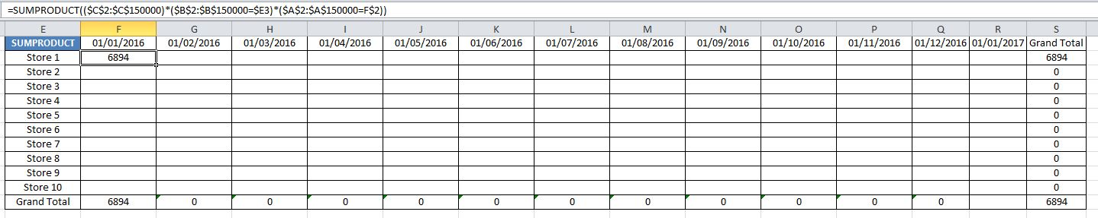

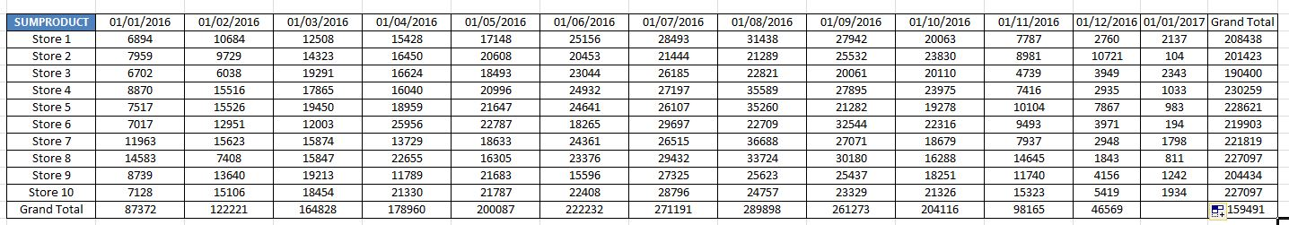

3. Create a Pivot Table that only shoes the 2016 sales by month by store. (Many Sales Sample Data)

Select the Pivot Table option under Insert. After selecting the range of cells, a pivot field list option opens up. We select the columns we want to include.

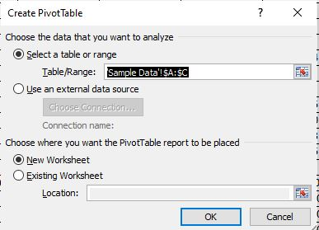

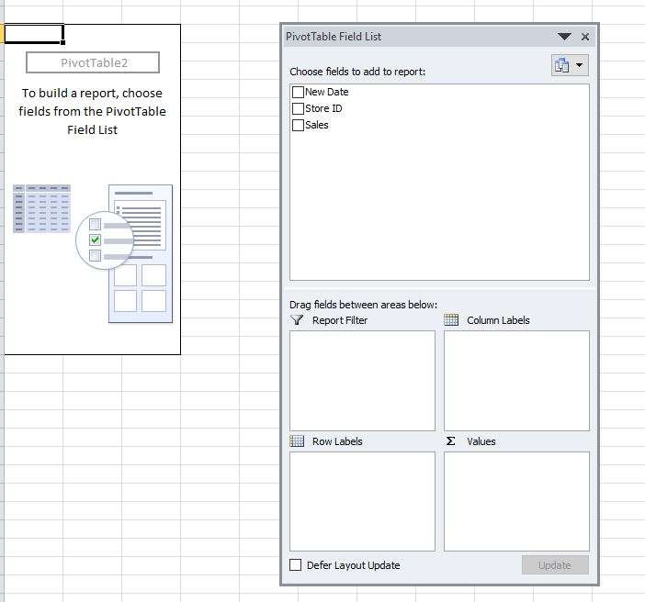

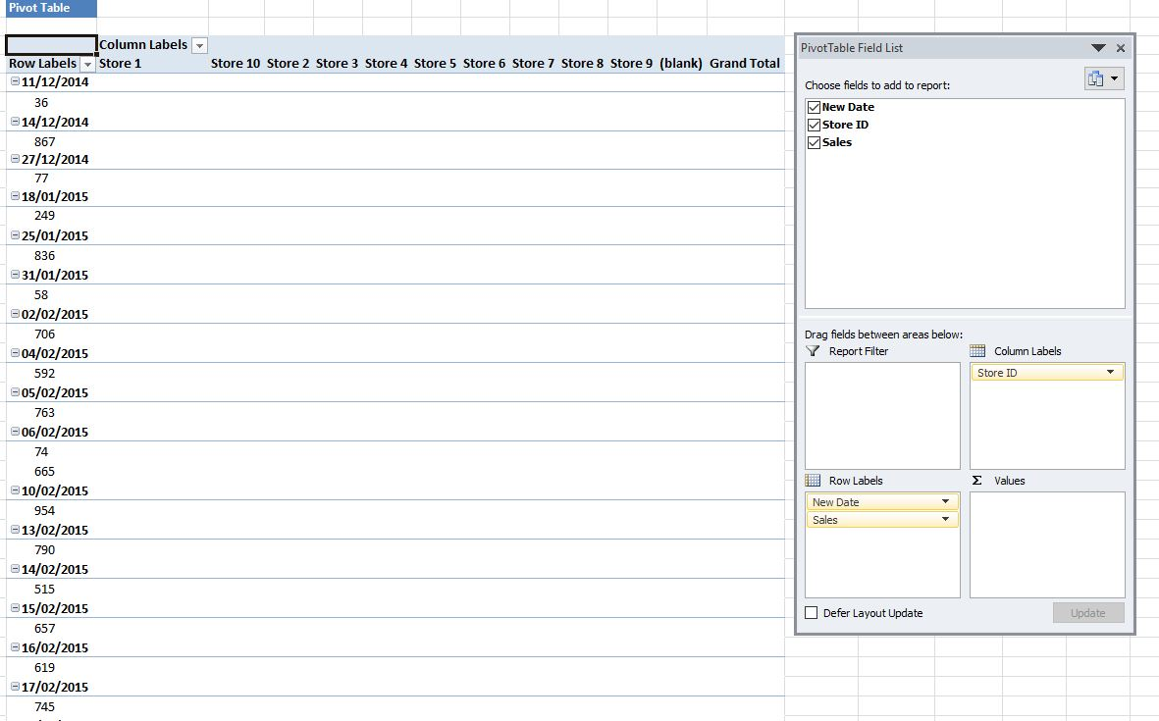

We need to group the sales month wise. Select on the date and choose group selection. Enter the start date and end date as 01/01/2016 and 01/01/2017, respectively.

