Write a formula which returns "Palindrome" or "Not Palindrome" for a given word in the table below:

For cell B4

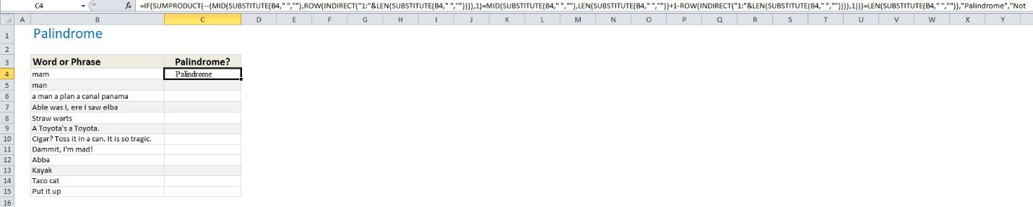

=IF(SUMPRODUCT(--(MID(SUBSTITUTE(B4," ",""),ROW(INDIRECT("1:"&LEN(SUBSTITUTE(B4," ","")))),1)=MID(SUBSTITUTE(B4," ",""),LEN(SUBSTITUTE(B4," ",""))+1-ROW(INDIRECT("1:"&LEN(SUBSTITUTE(B4," ","")))),1)))=LEN(SUBSTITUTE(B4," ","")),"Palindrome","Not Palindrome")

Drag the formula below to the other cells.

