problem workbook

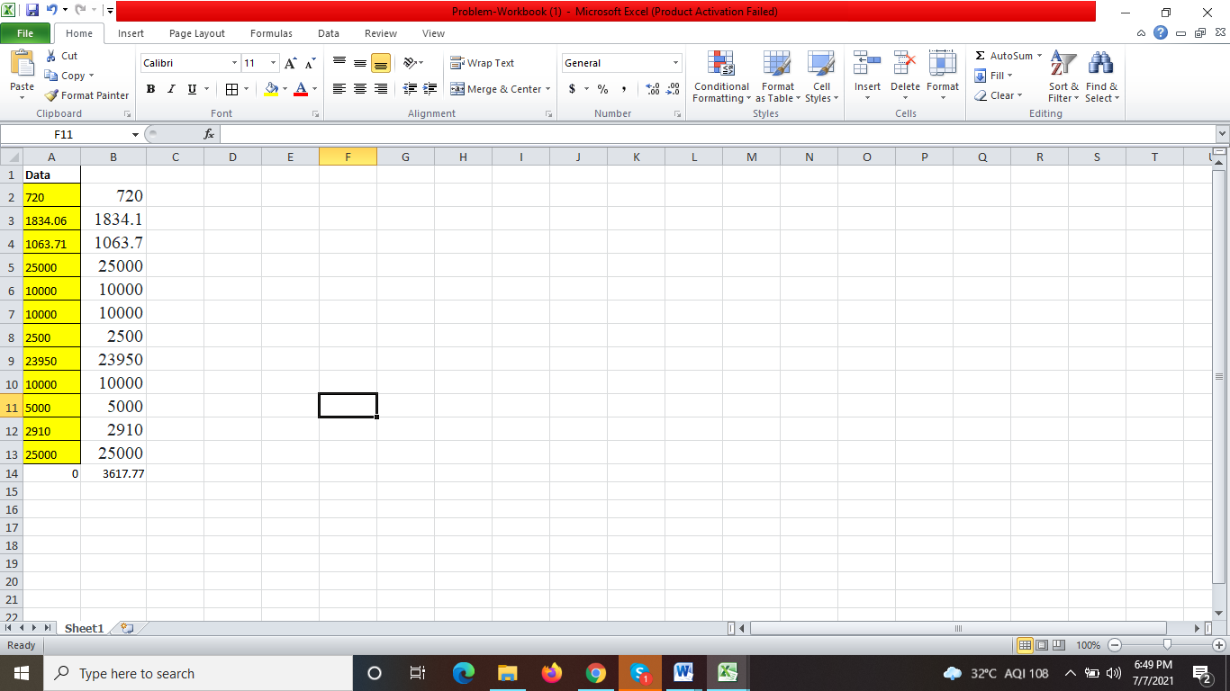

formula: =--SUBSTITUTE(SUBSTITUTE(A2,LEFT(A2,1),""),RIGHT(A2,1),"")