Calculating the amounts of mean,count,sum,min,max,std.

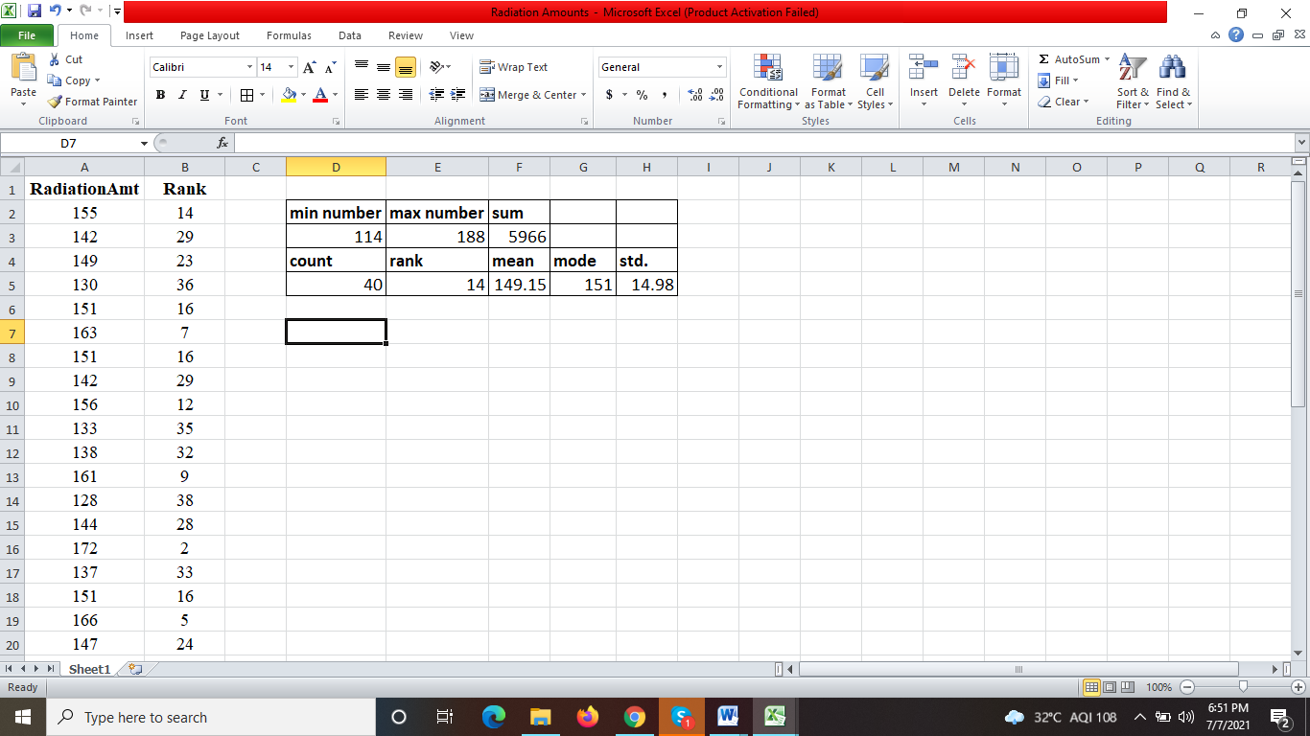

=min(),=max()

=count()

=stdeva()

=average()