**Objective**: Power BI Desktop, Cloud Service and End to End Workflow.

Topic: Charts.

**Exercise**: Create date and normal slicers on one page to affect visuals on other

pages.

**Solution**

Create slicers for Event Date, Continent Name and Country Name

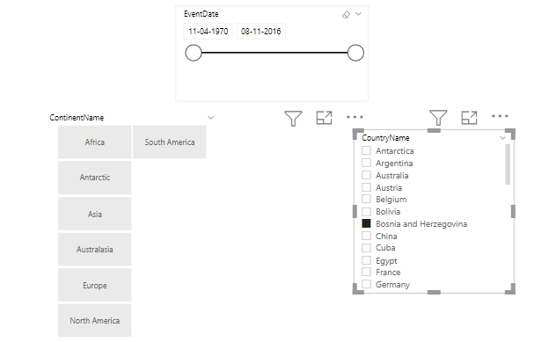

Go to Sync Slicer Option and manage slicer Views

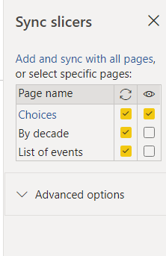

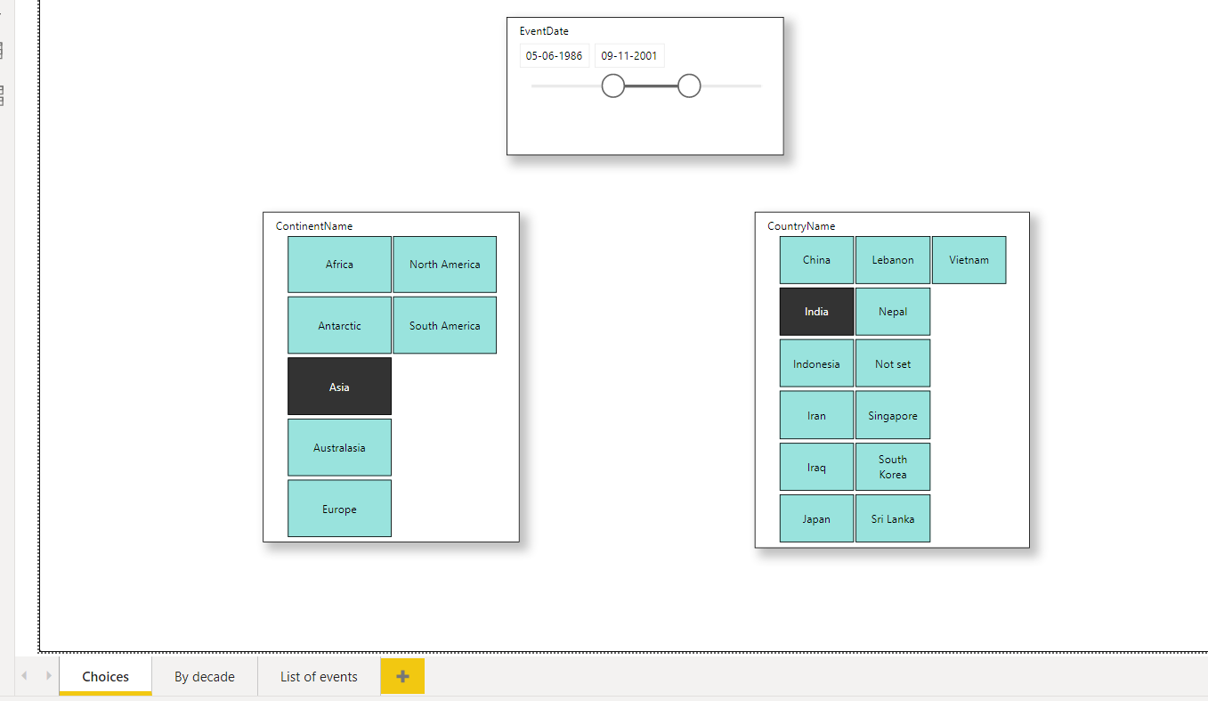

Final dashboard After Sync Slicer Operation