**STEPS:**

• Let’s first launch our PowerBI Desktop application.

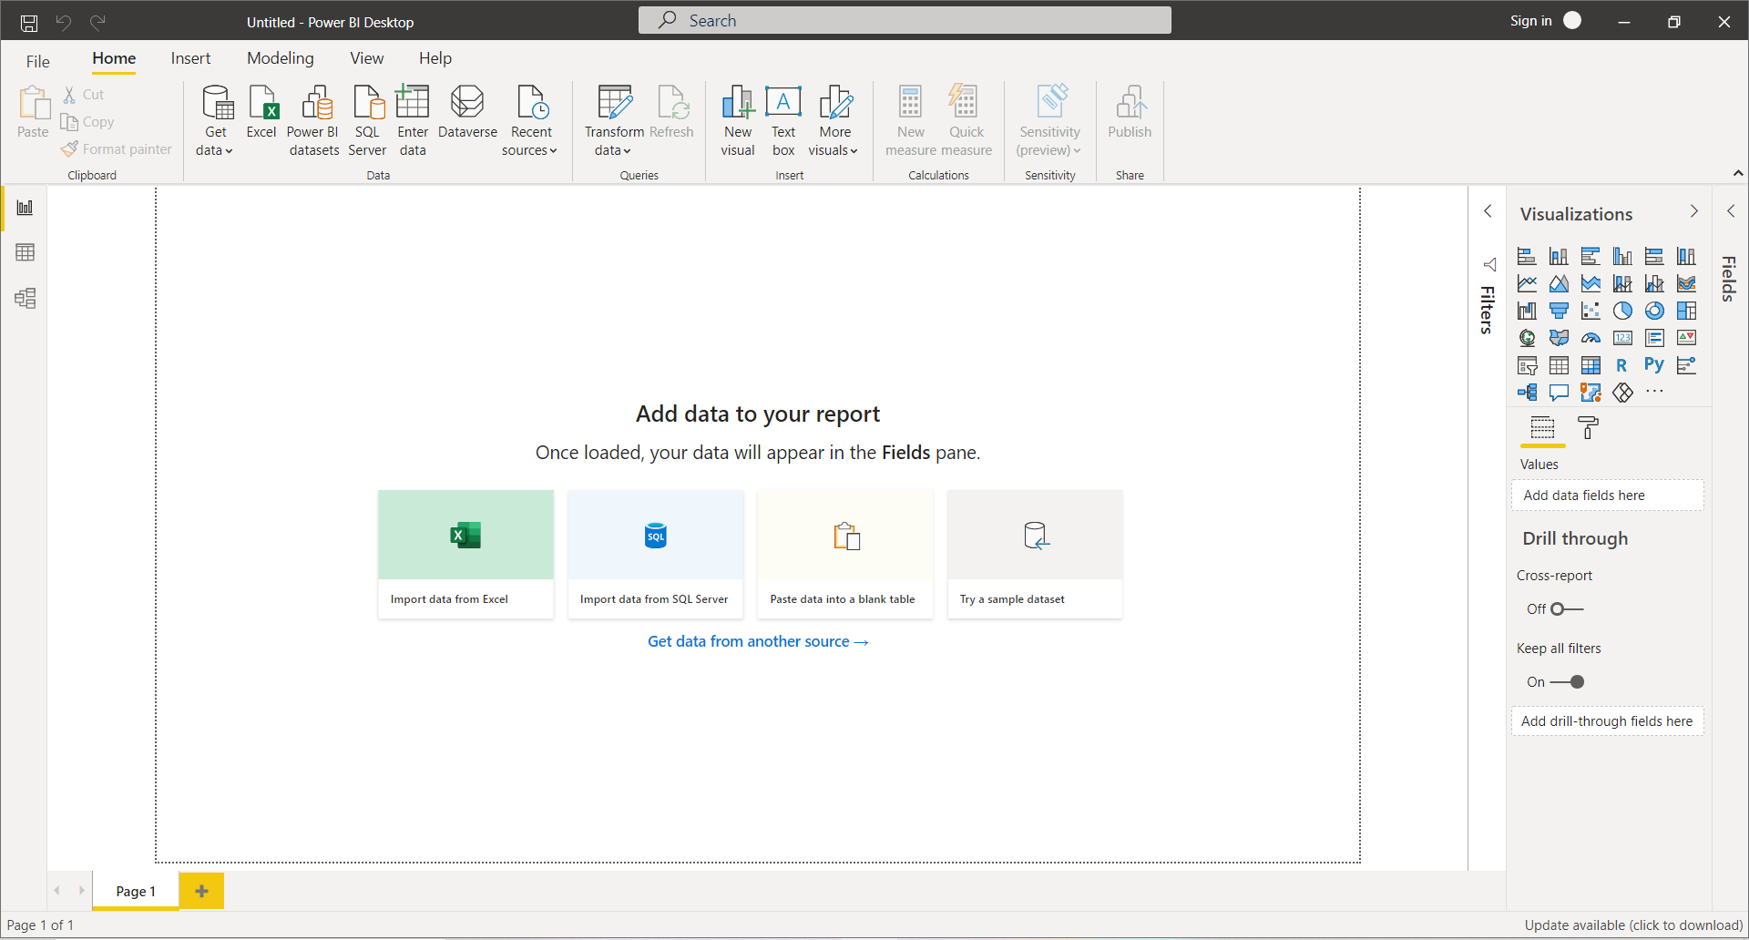

Fig 1.2: PowerBI Interface

•  Moving forward, our next aim is to load the required data into our workspace. For doing so, we will use the option **Get Data** from the Home Tab and from the dropdown menu of Get Data, we will select the Excel option.

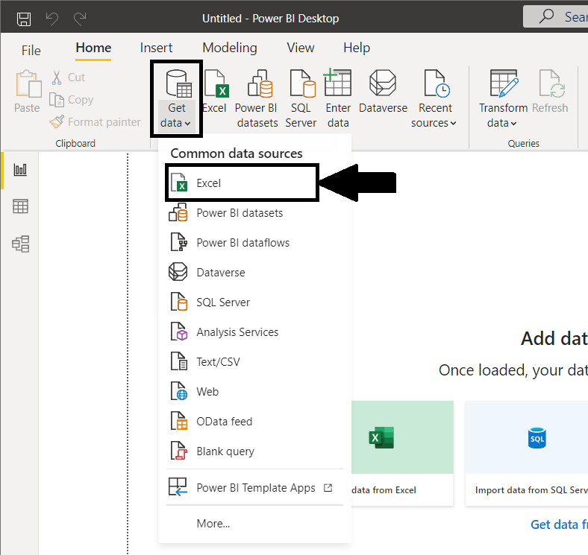

Fig 1.3: Get Data

• After selecting the required excel sheet from the local directory, we then load the data in our workspace using the**Load Data**option from the Navigator.

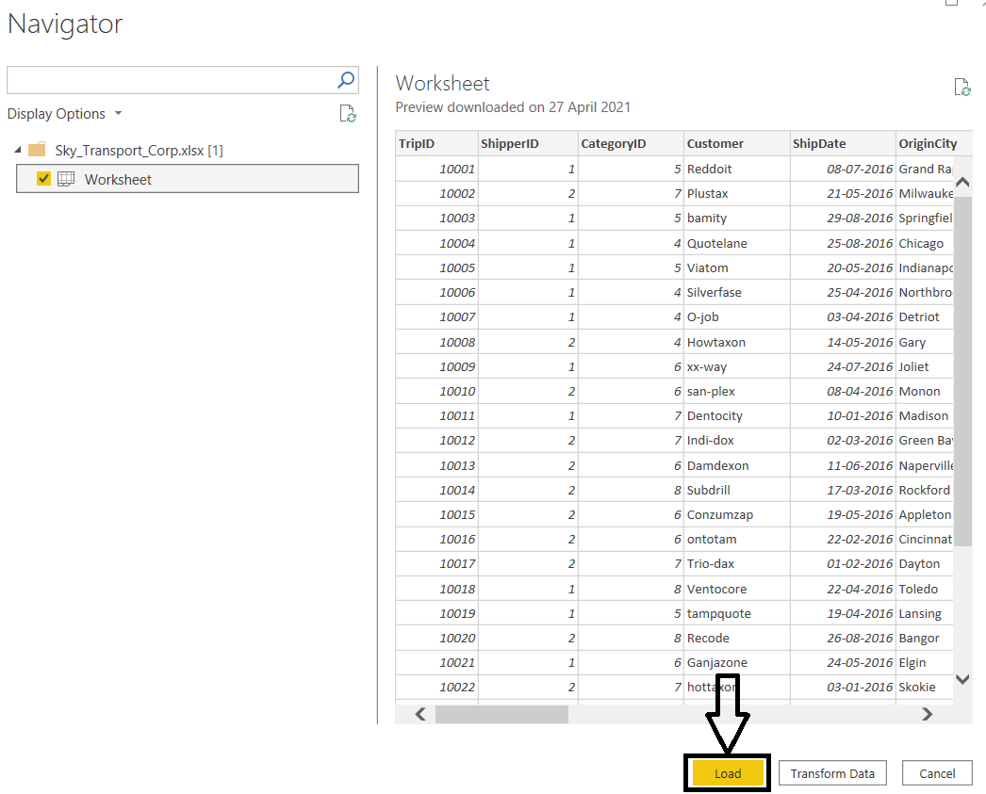

Fig 1.4: Loading Data to workspace

• Once our data is loaded in our workspace, we will move towards the field tab in the right corner and rename the table to “Sky Transport”. Then for hiding the **Category ID and Origin State columns**from our table using the Hide Option.

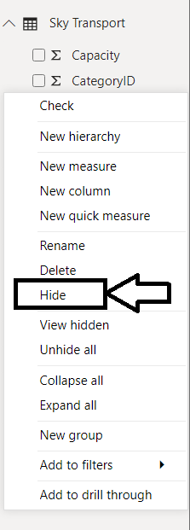

Fig 1.5: Hiding CategoryID and Orgin State columns

• Next, we will create Table by selecting Table from the Visualization tab and add the columns **Customer, Revenue, TotalMiles, TripType** in the Values field.

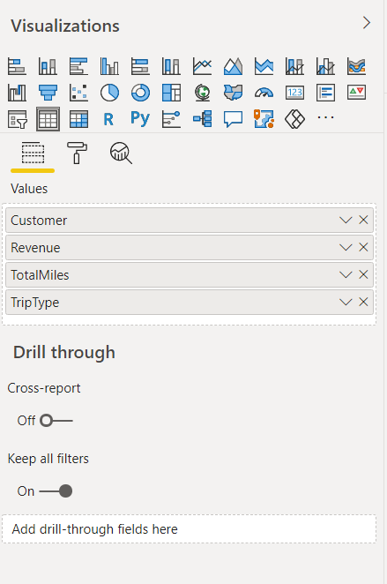

Fig 1.6: Table Visualization

• Now to summarize Revenue and Total Miles we will use the Card visualization. Also, in addition for better visualization we can also add bar graph of Revenue By TripType and a donut chart of TotalMiles by TripType.

•  Our report is ready and now we can save it in a local directory with the name SkyData.

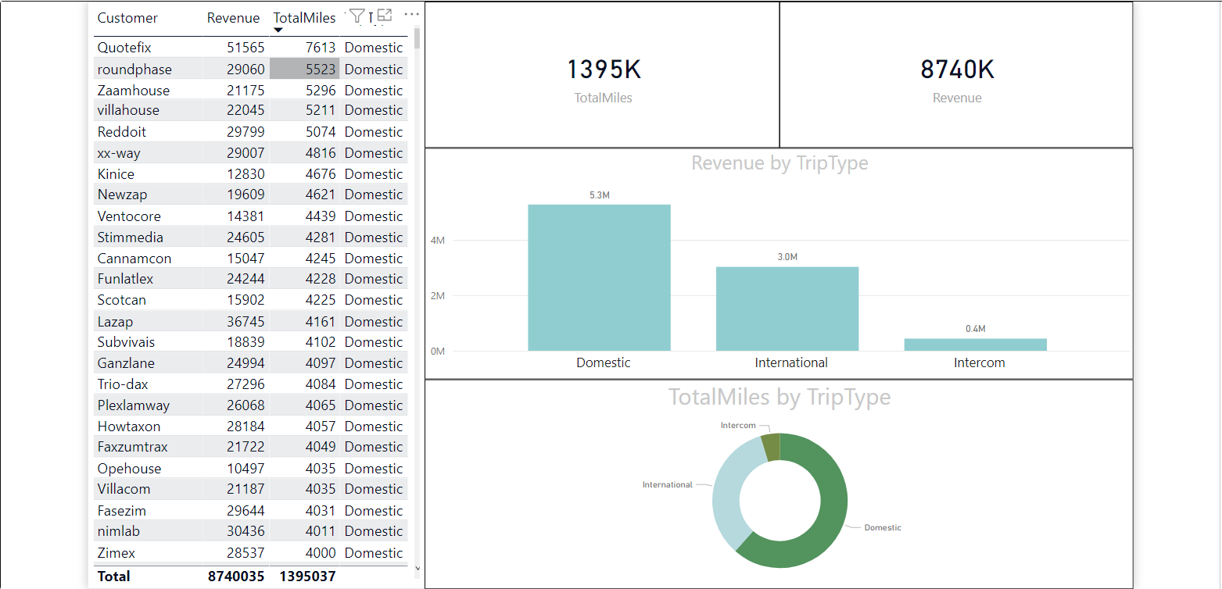

Fig 1.6: Final report