**Objective**– Power BI Desktop, Cloud Service and End to EndWorkflow  
**Use Case** – Working with Bookmark as action  
**Source**– Zoo  
**Analytics**– Create Bookmark  
**Report/Dashboard** – Bookmark as action

• Load the Data from Zoo.xlsx file and clean the data in Power Query Editor if necessary.

**Goal 1** : Try to make a report which has a page for each kind of Image. When you click the image of that creature you will see all the animals of the same type

• First, I created a Dashboard with the images as follows



Name this page as Creatures

• Now, I created three Table visuals for these three types of Pokemon in three different pages and named named as **Water**, **Fire**and **Grass**.

• In the **Table** visual, under **values** section, place **National Pokedex Number**, **English Name**, **Evolves into** and  **Japanese name**.

• In the **Fields**section, under **Filter on this page** section place **Nature Symbol** column and select the **Filter type** as you prefer.

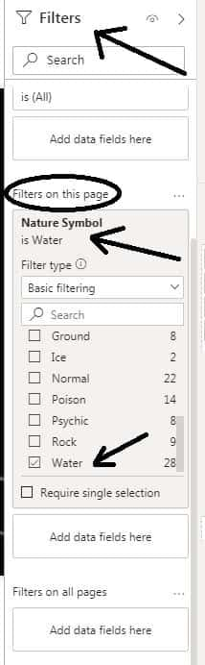

• Now go to **Insert**section, click on **Buttons**drop down menu and select **Back**option and activate the action for it.

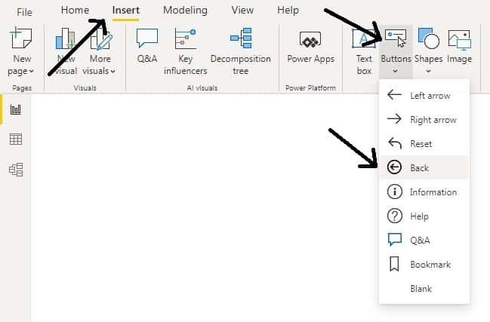

Click on Back

• Hide Water, Fire and Grass pages.

• Now go to **View**section and select **Bookmarks**and **Selection**Pane.

• To view the report for Water type Pokemon, untick the Hide page option for Water page and name the bookmark as Water and update it.

• Make sure that remaining pages are in Hide, except Creatures page.

• Do the same for Fire and Grass pages.

• Now, in the Creatures page click on the **photo**and activate the **Action** and under **Type** section select **Bookmark** and Under **Bookmark**section select the **created bookmarks** as per the **photo** you have selected.

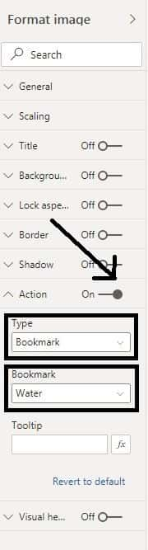

• Test the Photos by clicking them in the Creatures Page and back option which is placed in the Water, Fire and Grass pages.

• Now, **Save** the report as **Zoo** and go to **Home** section then click on **Publish**to publish this report in **Power BI Service**Workspace.

• Then, select the workspace under which the report needs to be saved.

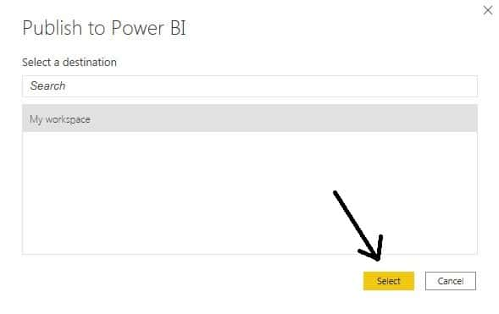

click on Select

• Now in **Power BI Service workspace**, go to **My workspace** and under **Reports** section click **Zoo** and test the report.

• Then the following pages will appear as per click on the Photos in Creatures page.

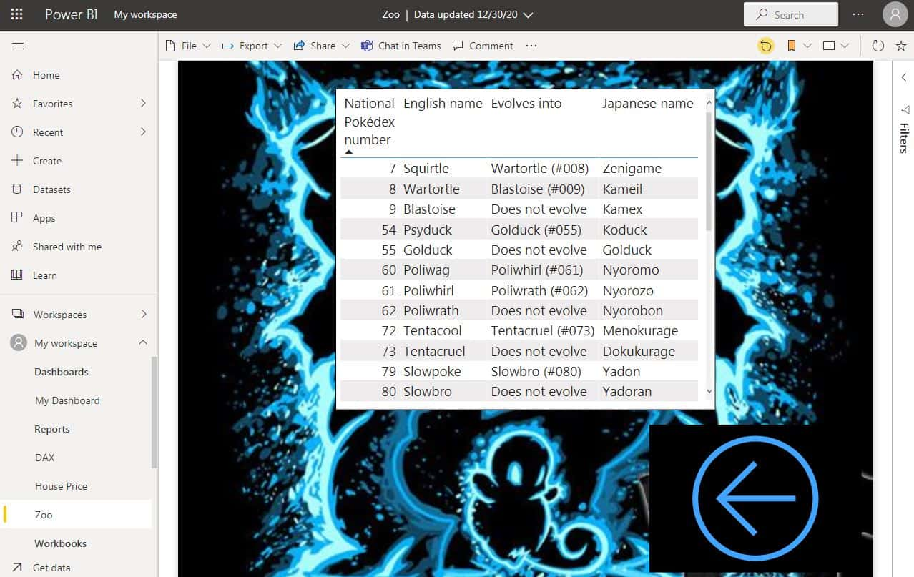

Water

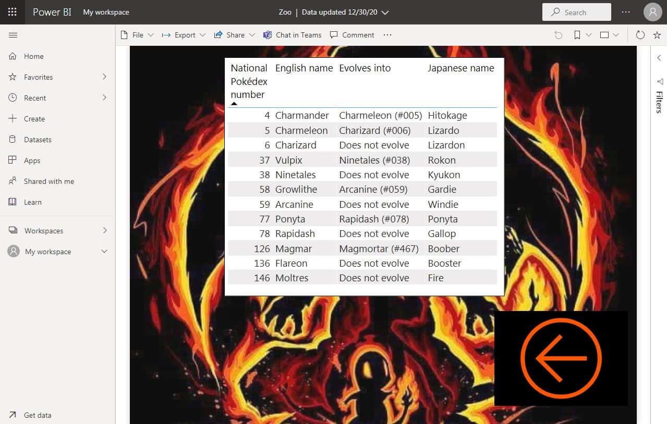

Fire

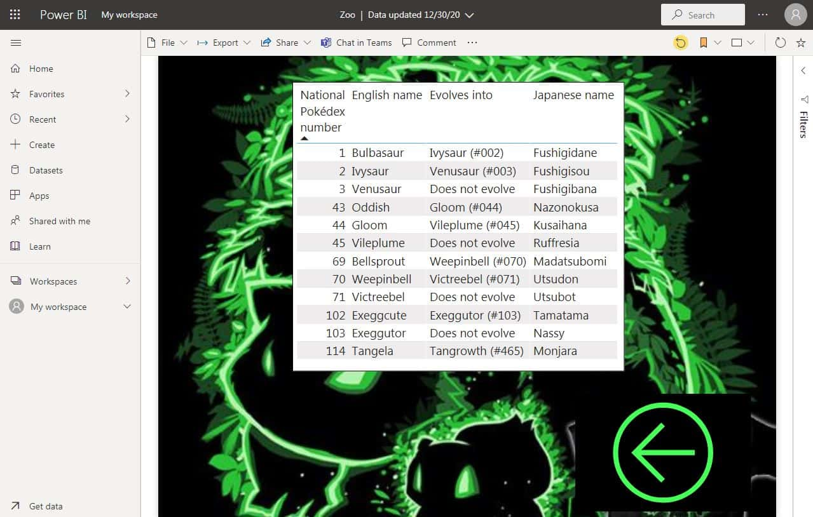

Grass