**Assignment - 13**

**Objective**– Power BI Desktop, Cloud Service and End to EndWorkflow  
**Use Case** – Working with Tooltips  
**Source**– Authors  
**Analytics**– Create Tooltips  
**Report/Dashboard** – Bookmark as action

**Goals :**

• Open the Power BI report file in the above folder. It shows the 100 bestselling books since 1998:

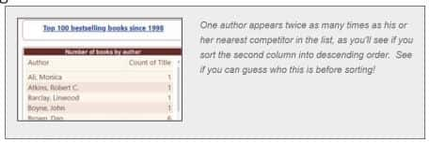

• Create a tooltip page to show the volume of sales for each title:

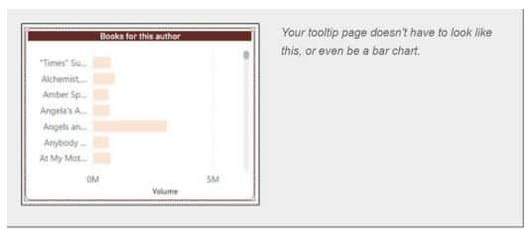

• Assign this page to be the tooltip for the original visual:

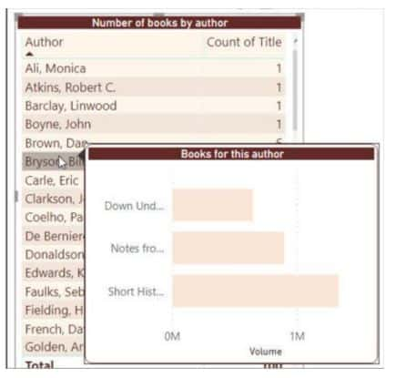

What you might see if you hover over Bill Bryson, for example.

• If you still have time, and want a challenge, create and display a measure to show the name of the author in your tooltip:

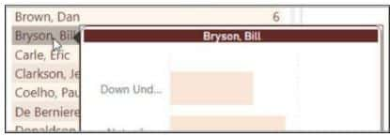

The report page tooltip now shows the name of the author chosen in the title.

• Save & Publish as Authors Info

**Procedure :**

• Open the Power BI report Authors.pbix file.

• Now, I created a **New page** and name it as **Tool tip**then selected **Stacked bar chart** visual and  under **Axis** section place **Title** and under **Values**section place **Volume**

• Name the **Title** of the Visual as **Books for the Author**

• Now, go to the **formatting**option for this page and under **page information** section activate **Tooltip**option.

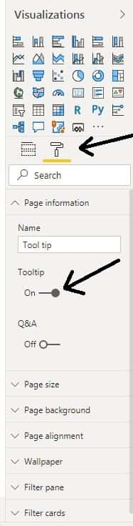

• Now, **hide this page** and **come** to **List of books** page ( original page ).

• In the List of Books page, go to the **formatting**option of the existed Table visual then activate **Tooltip**option  and under **page** section, select the created **Tool tip**.

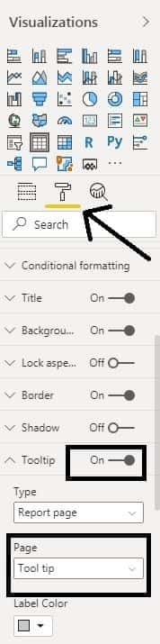

• Now, when we place the cursor on any Author name in the Table visual let's take Rowling, J. K. then the following will appear as the tool tip for it.

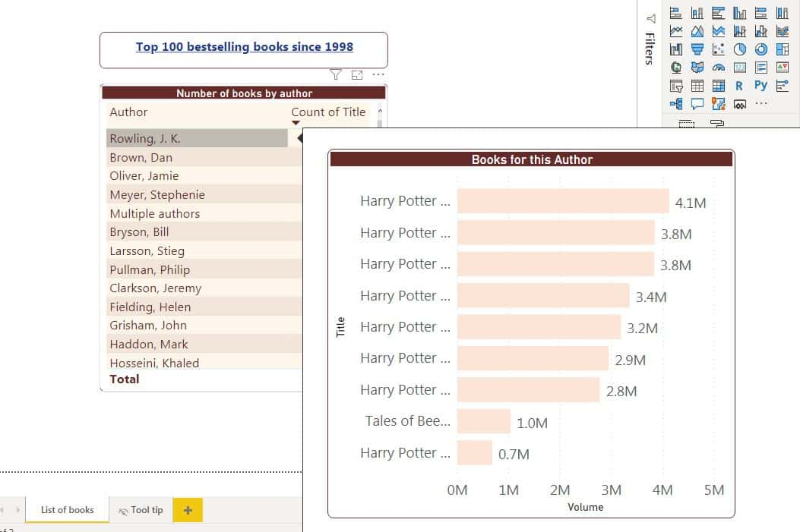

• Now, come to Tool tip page then go to the **formatting**option of the existed **Table visual** and under **Title**name click on **fx**option.

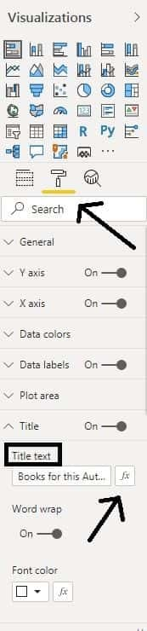

• Now, a pop-up window will appear then select **Author**for the **Based on Field** and click **OK**

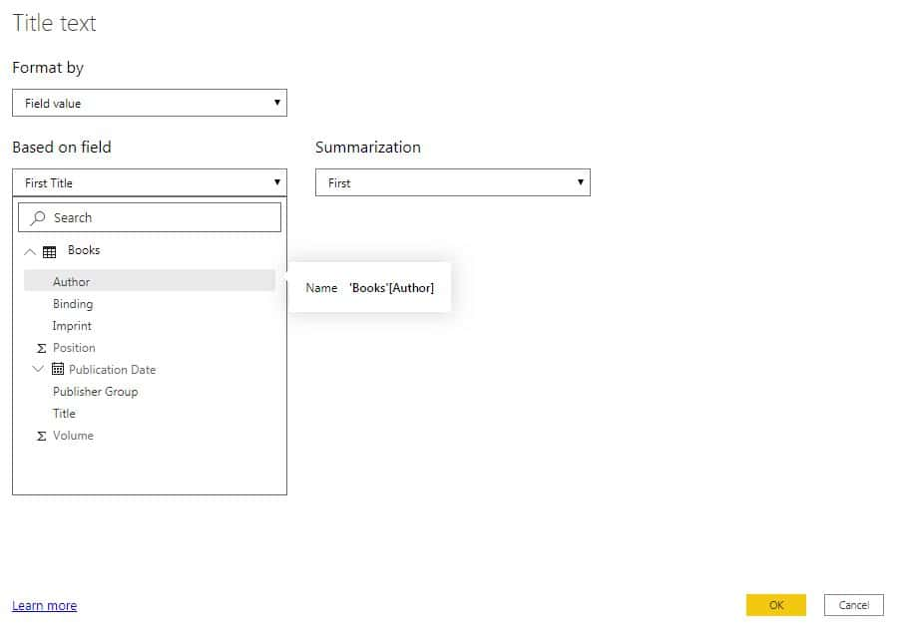

click OK

• Now, when we place the cursor on any Author name in the Table visual in original page ( let's take Rowling, J. K. ) then the following will appear as the tool tip for it.

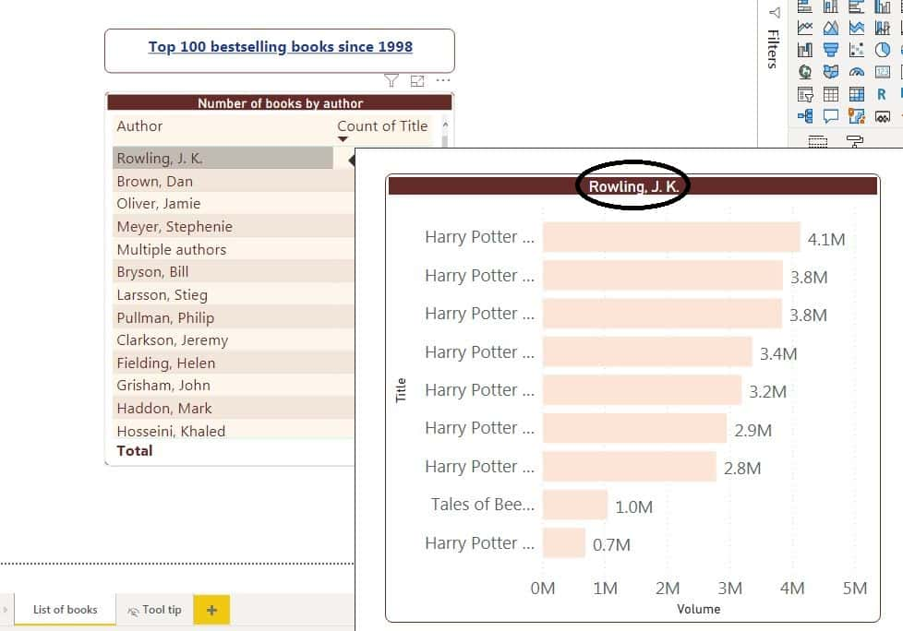

• Now, **Save** this report as **Authors**info and **Publish**in **Power BI Service**

• In the **Power BI Service Workspace**, when we  place the cursor on any Author name ( let's take Rowling, J. K. ) in the Table visual then the following will appear as the tool tip for it.

