**Solution**

First all import the data and build manual relationships.

the best way to do this is find out the common columns among all the three tables and build relationship with each other

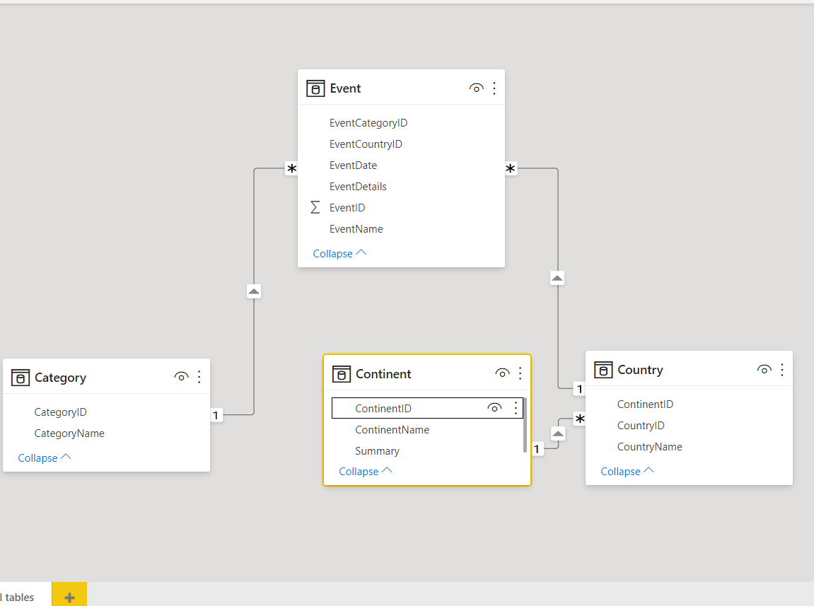

Use related DAX function to bring in the country, continent and category for each event

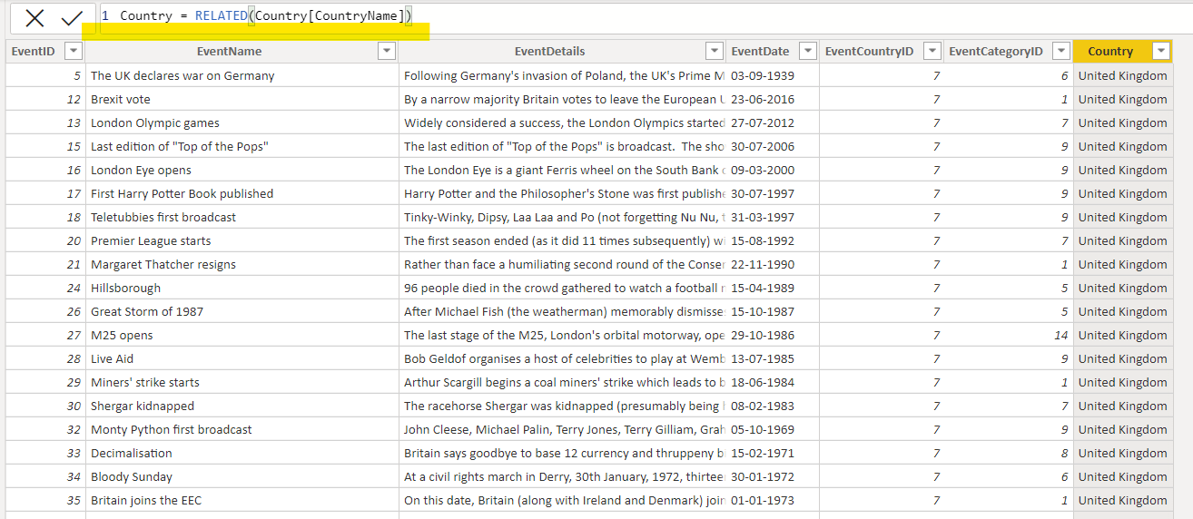

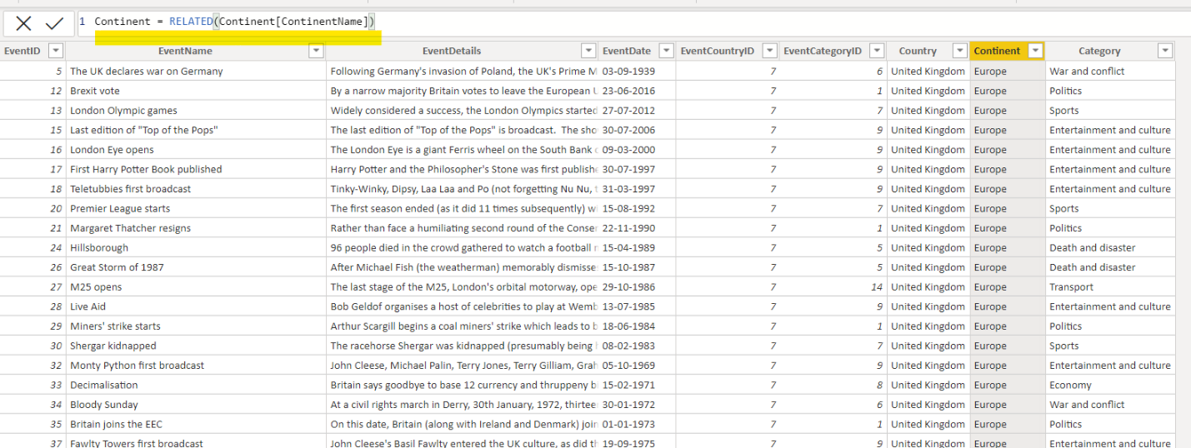

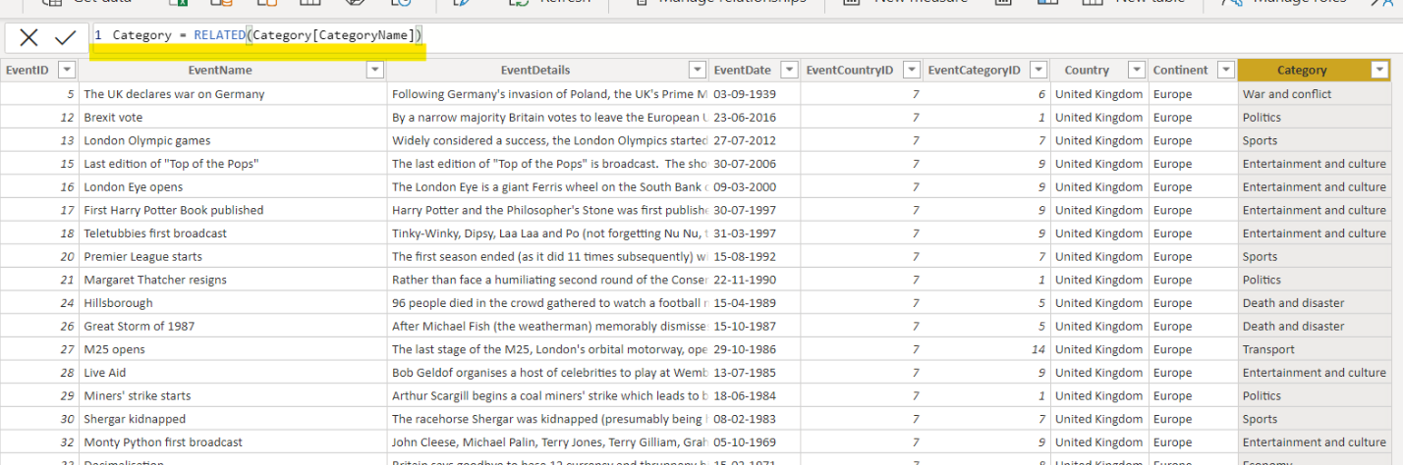

Now create matrix showing Continent and number of events conducted

