**Objective**: Power BI Desktop, Cloud Service and End to End Workflow.

Topic: Parameters.

**Exercise**: Create a DAX measure such that data should be showed to the users

only if something is searched on the slicer.

**Solution**

Get data from the excel file called "Student Survey".

Create the visualizations as required in the assignment, using Slicer, Bar chart,  Funnel chart, Donut chart and Cards. Insert an empty card for showing values according to the DAX measure.

Go to Home --> Enter Data --> change table name to "DAX Measure" --> Load. Then right click on new table created and select "New measure". The DAX used is

Store Setting = IF(ISFILTERED('Student Survey'[Store Setting]), SELECTEDVALUE('Student Survey'[Store Setting], "Displaying the data from selected values") ,"Choose Value from the above slicer")

Now select slicer values and notice the output. When no value is selected

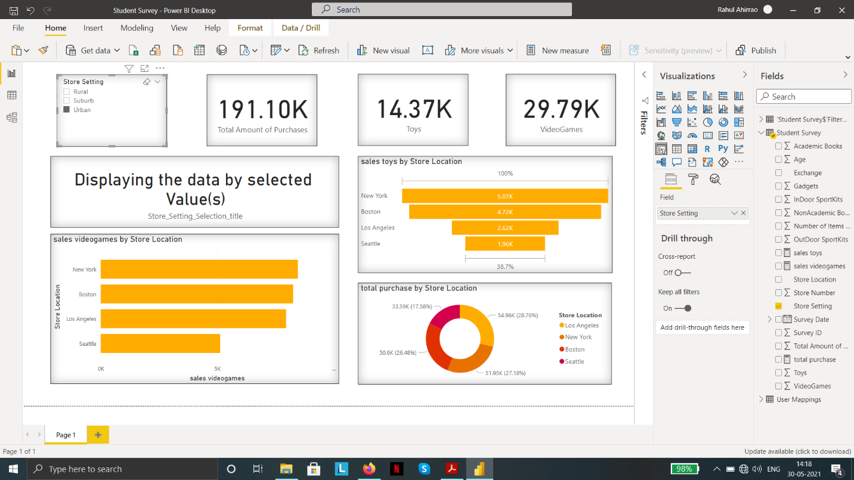

Final dashboard