**Objective:** Power BI Desktop, Cloud Service and End to End Workflow.

Topic: Filtering Data.

**Exercise:** Create a slicer and chart to choose which whale sightings dataset to

see.

• Create a new Power BI Desktop file, and load into it sightings of whales

and porpoises from the Whale and Dolphin Trust.

• Create a slicer based on the data allowing you to choose the species

sighted.

**Solution**

1. First of all import Import the data csv file and remove blank values from the data set

2.After Loading the data ,build relationship between the fact table and Dim table

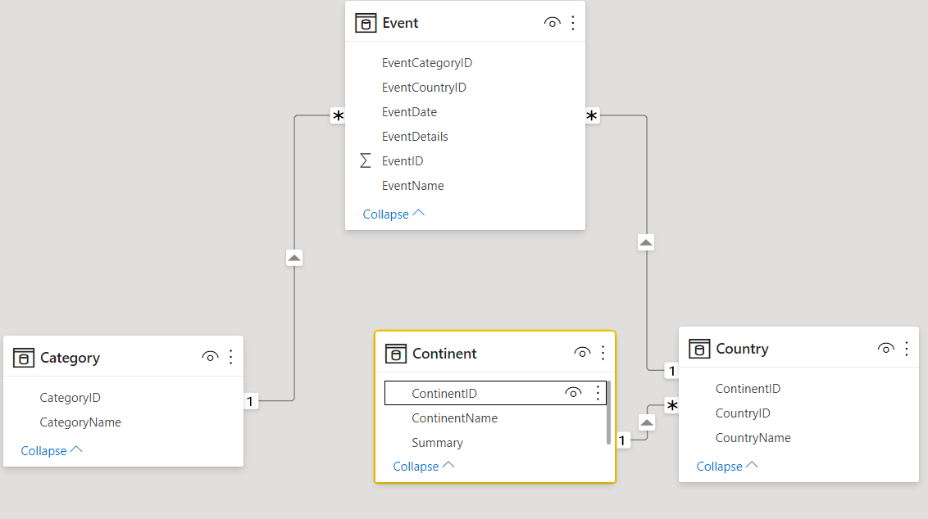

3. Add Month Column in fact data table using dax function

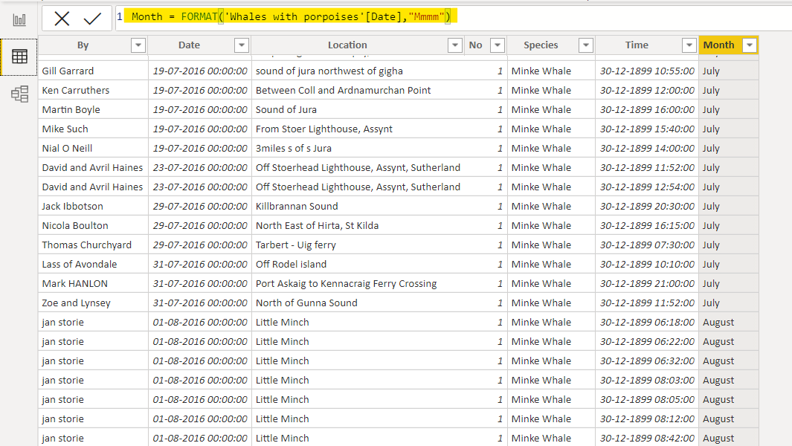

4. Add Bar chart and slicer. filter the slicer according to the business objective

