**Objective**: Power BI Desktop, Cloud Service and End to End Workflow.

**Topic**: Charts.

**Exercise**: Show a chart comparing films when you click on each genre in a tree

map.

**Solution**

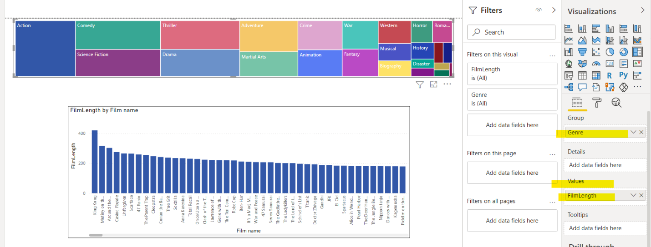

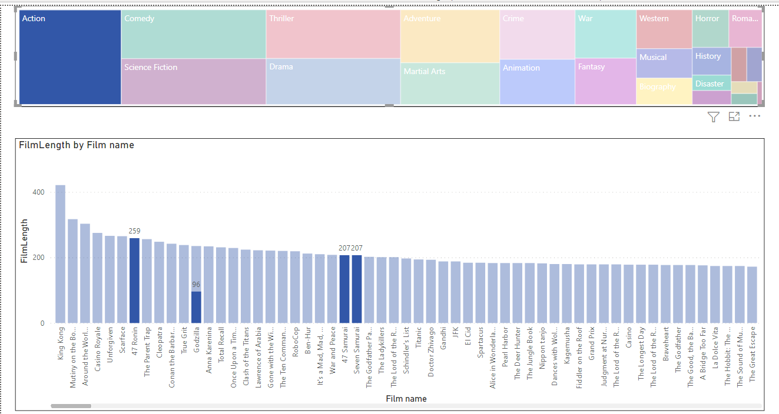

Dashboard showing details of Action Genre