**STEPS:**

• We will start with loading our data  using the **Get Data** Option and Select the **Transform Data**since our data requires some transformation

• Then we will rename the  Column “Net worth (USD) (March 2018)[15]” to  “Billion($)".

• In the next steps , we will replace the word "billion"  with an empty string  "". For this objective we will use the **Replace Value**option from the transform option in the power query editor.

• Next , we will replace the "$" with an empty string again using the same option as used in previous step.

• Since we are left in only whole  numbers in this column , we will now change its data type from text to whole number by clicking on the **Data Type**option in the column header name.

• Our work in power query editor is finished now. We will select the **CLOSE & APPLY** option from the home tab.

• Now we are back in our dashboard . After creating some visualization on the give data the final report looks like the following figure.

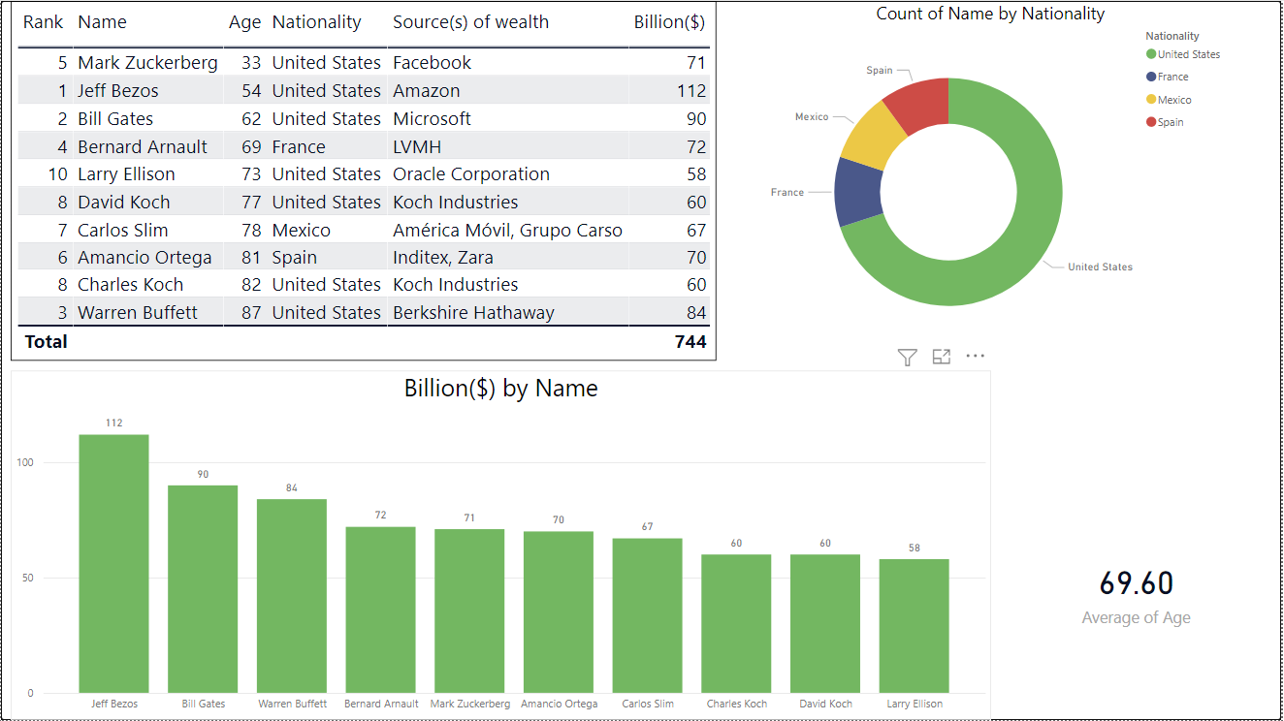

Fig 3.3 Final report

**INSIGTHS:**

• **Jeff Bezos**is the riches with 112B $ wealth followed by **Bill Gates**.

• **Average Age** of the top 10 is **69.60** years

• Majority of the people in the list are from**United States.**

**\* * \***