**STEPS:**

• We will start with loading our data  using the **Get Data**Option and Select the **Transform Data**since our data requires some transformation

• For the first task , We will go to the **Custom Column**option from add column tab and in the popup , name the new column as **Revenue** , and in the custom column formula we will use the following formula

=[Quantity]*[Unit Price]

• Next ,  We will select the **Conditional Column**option from the add column tab and set the New column name to Sales Range and add the conditions. The following diagram represents this step.

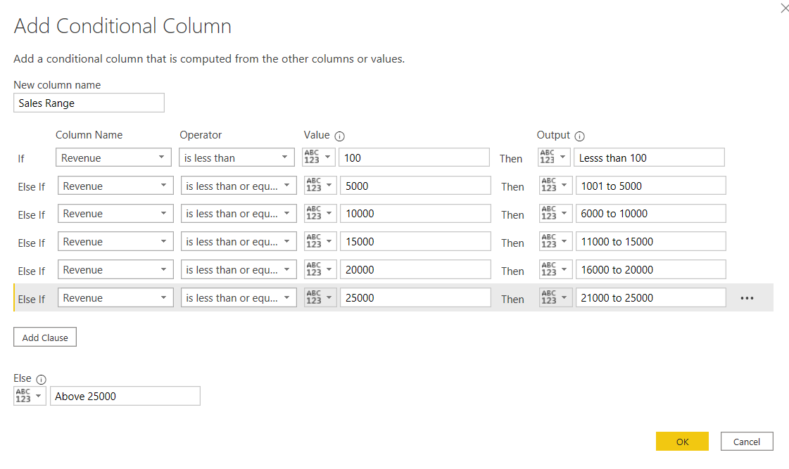

Fig 5.2 Conditional Column

• Similarly for the next objective , We will again  select the **Conditional Column**option from the add column tab and set the New column name to Infra Category and add the conditions.

• After these changes our table looks like the following figure in power editor.

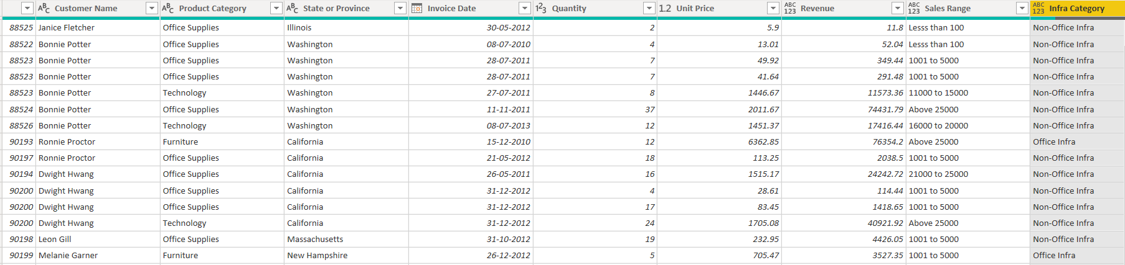

Fig 5.2 Output of Power Query Editor

• Next we use the close and apply option and move towards our dashboard. After creating some visualization on the give data the final report looks like the following figure.

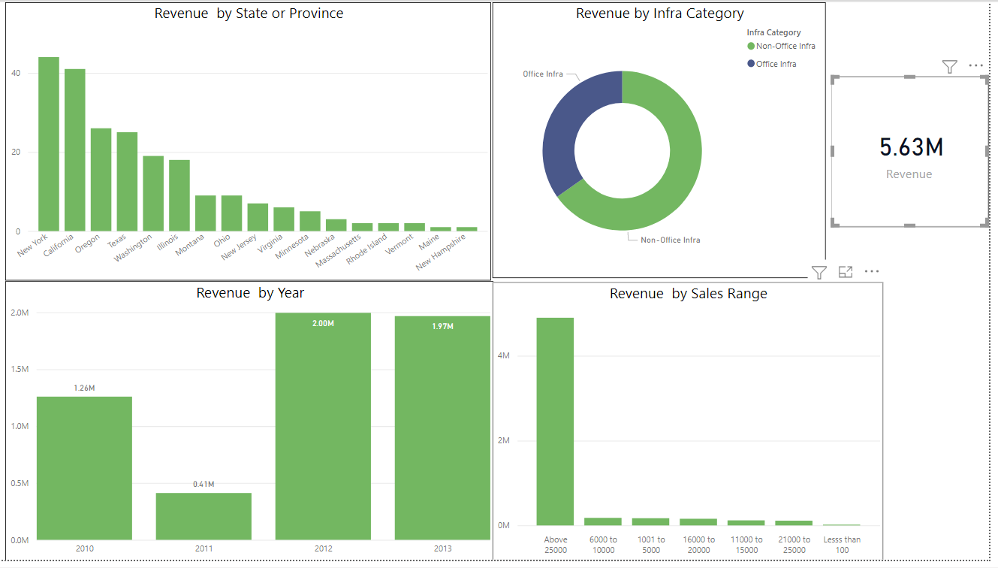

Fig 5.3 Final Report

**INSIGTHS:**

• Total Revenue generated was approximately **5.63M.**

• Most revenue was generated in the **Above 25000** category as compared to other categories.

• Most revenue was generated in the year **2012.**

• **New York** State topped the revenue generation by any state or province.