**STEPS:**

• We will start with loading our data  using the **Get Data**Option and load it to our dashboard

• For the first task , We need to first define Cost column to create another  column for segmentation. In the data view we will select the Purchase table and go to **New Column** options in the table tools tab. The DAX formula for calculating the Cost is as follows:

Cost = Purchase[Price]*Purchase[Quantity]

• Next we will create another column with same method as used in previous step. The DAX formula for the new column - **Category** Column is as follows:

Category = IF(Purchase[Cost]<10 ,"Affordable", "Expensive")

• Next we will create three filters in the product table  to meet the requirements of the given objective. The DAX formulas for the measures are:

**NOT** ON AIR = COUNTROWS(FILTER('Product' , RELATED(Mode[EnvironmentId]) in {1,3}))

**NOT** ON LAND = COUNTROWS(FILTER('Product' , RELATED(Mode[EnvironmentId]) in {2,3}))

**NOT** ON WATER = COUNTROWS(FILTER('Product' , RELATED(Mode[EnvironmentId]) in {1,2}))

• For the next objective we create a species column in the Product table and link it to the species table . The DAX formula for the step is as follows:

Speices = RELATED(Species[FamilyName])

• Similarly , For the next objective we create a region name  column in the Town table and link it to the region table . The DAX formula for the step is as follows:

**Region** name = RELATED(Region[RegionName])

• Next we will create some visuals for confirmations of our DAX inputs. The report for this assignment is shown in the figure below

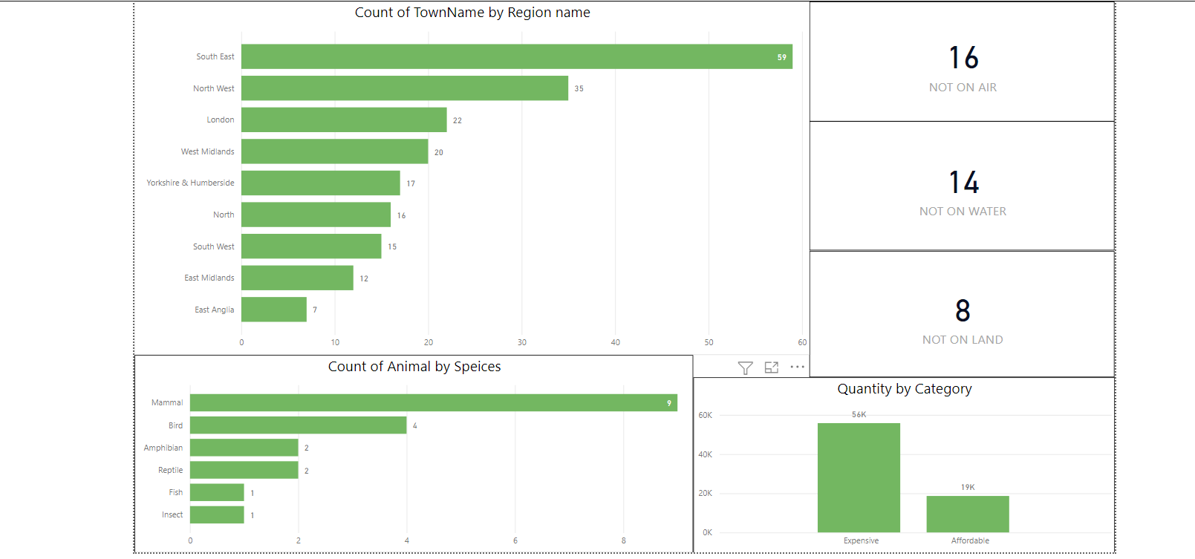

Figure 6.2 Final Report