**STEPS:**

• We will start with loading our data  using the **Get Data**Option and Select the **Transform Data**since we need to create a custom date column. The date table can be formed using advance query which was provided in the dataset of PowerBI. The range of the date is set from year 2012 to 2020. Now we will select the Close and Apply option and move towards the dashboard.

• Next we will write a measure for finding quarterly sales. The DAX formula is as follows:

Quaterly Sales = CALCULATE(SUM(InvoiceLines[SalePrice]) , DATESQTD(DimDate[Date]))

• Next we will write a measure for finding yearly sales. The DAX formula is as follows:

Yearly Sales = CALCULATE(SUM(InvoiceLines[SalePrice]) , DATESYTD(DimDate[Date]))

• Next we will write DAX for creating  a fact table . The DAX formula is as follows:

Fact_Sales = SELECTCOLUMNS(InvoiceLines ,"Sales Price" , InvoiceLines[SalePrice] ,

"Cost Price" , RELATED(Stock[CostPrice]) ,

"Spare Parts", RELATED(Stock[SpareParts]),

"Labour Cost" , RELATED(Stock[LaborCost]),

"Invoice Date" , RELATED(Invoices[InvoiceDate]))

• Next we will manually add a new column to this newly created table. The DAX formula is as follows:

**Total** Cost = Fact_Sales[Cost Price] - Fact_Sales[Spare Parts] - Fact_Sales[Labour Cost]

• Our**fact_sales** table will look like the following diagram.

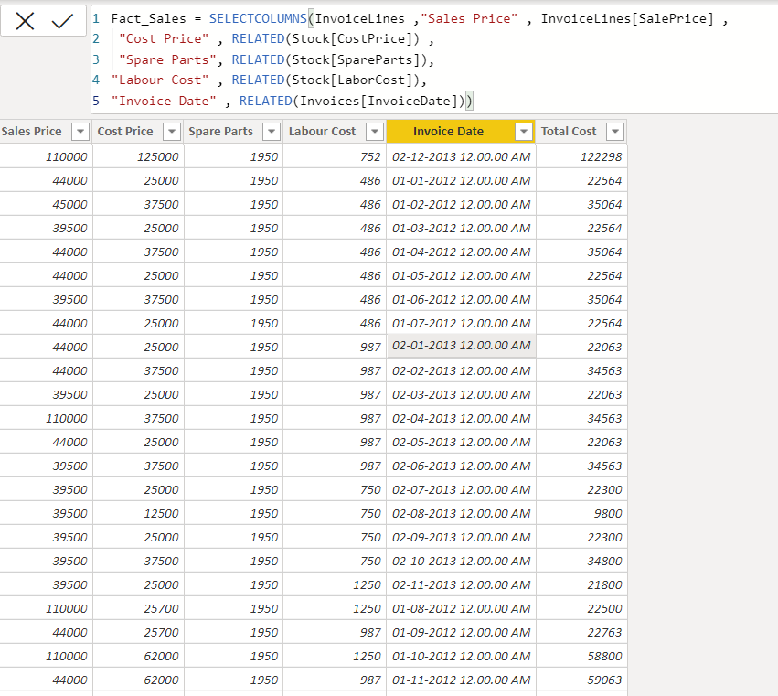

Figure 7.2 Fact Sales Table