**1.Write a Python program to find those numbers which are divisible by 7 and multiple of 5, between 1500 and 2700 (both included).**

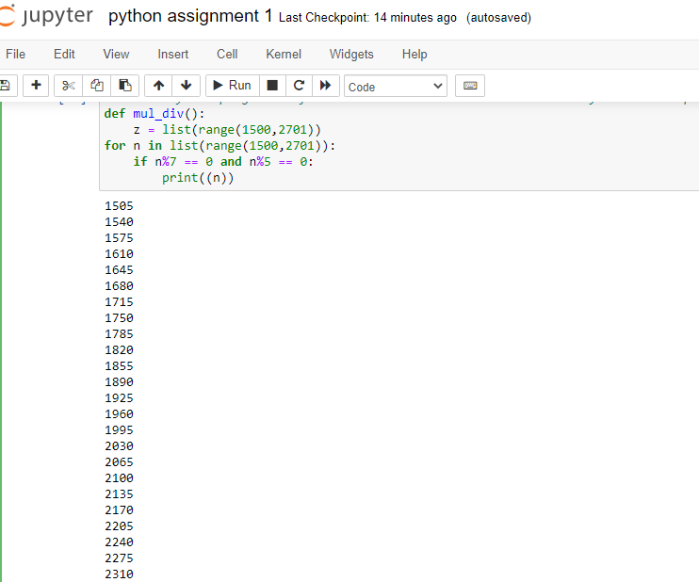

**2. Python program to add two numbers**

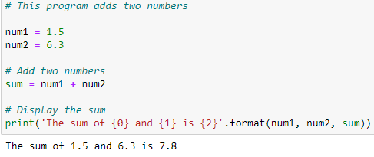

**3. Maximum of two numbers in Python**

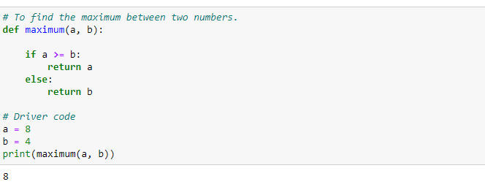

**4. Python Program for factorial of a number**

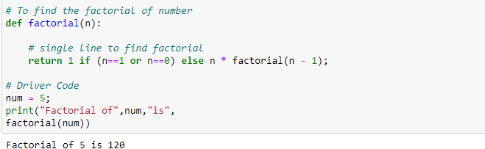

**5. Python Program for simple interest**

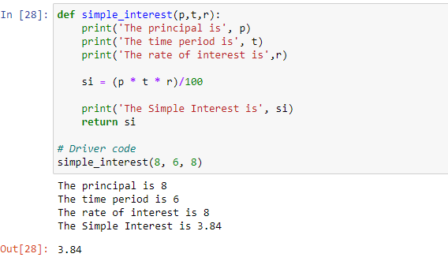

**6. Python Program for compound interest**

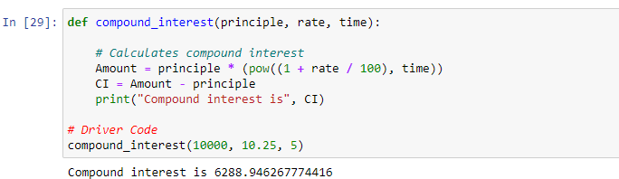

**7. Python Program to check Armstrong Number**

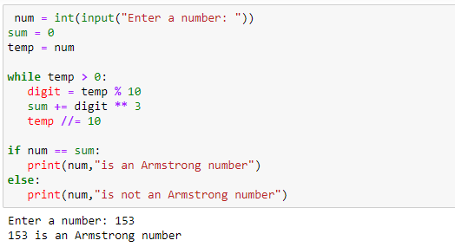

**8. Python Program for Program to find area of a circle**

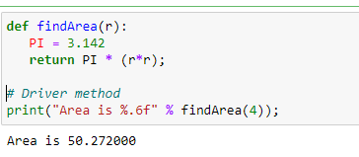

**9. Python program to print all Prime numbers in an Interval**

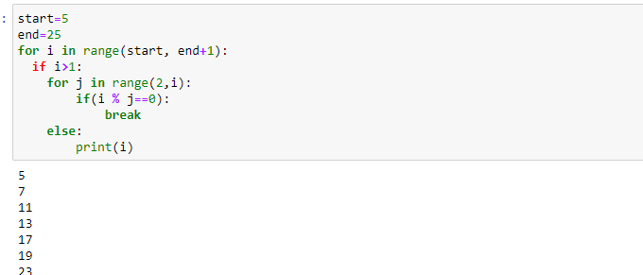

**10. Python program to check whether a number is Prime or not**

