Q.1)   Python Program for Find reminder of array multiplication divided by n ?

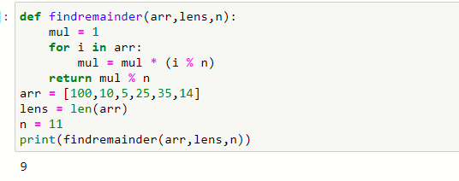

Q.2)  Python Program to check if given array is Monotonic ?

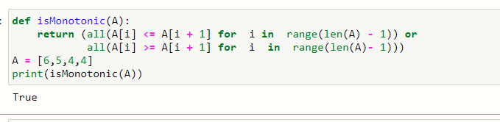

Q.3)  Python program to interchange first and last elements in a list ?

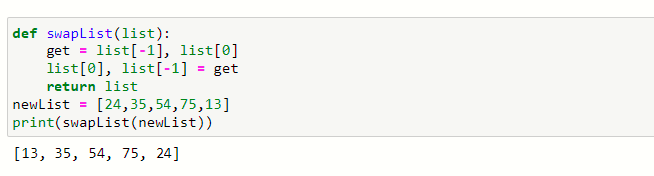

Q.4)  Python program to swap two elements in a list ?

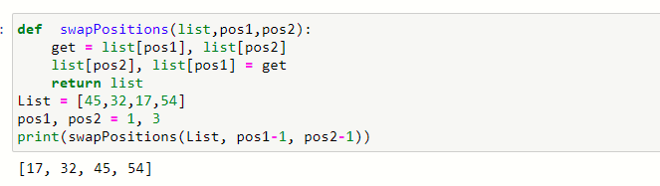

Q.5)  write a program to find length of list ?

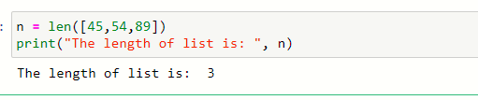

Q.6) write a program to check if element exists in list ?

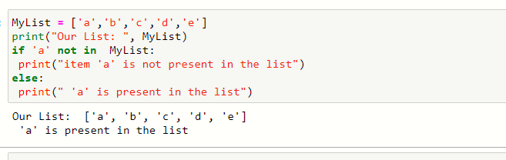

Q.7) write a program to clear a list in Python ?

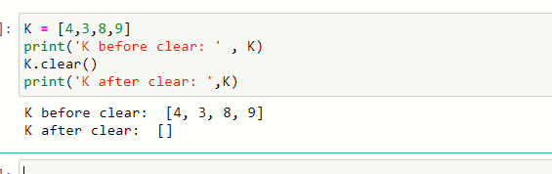

Q.8) write a program to Reversing a List ?

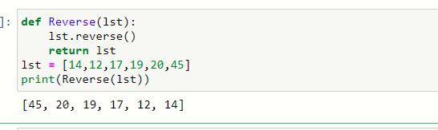

Q.9) write a program to find sum of elements in list ?

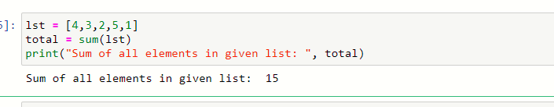

Q.10)  write a program to Multiply all numbers in the list ?

