**Assignment-10.**

**Question-1.** Write an SQL query to determine the 5th highest salary without using TOP or limit method.

**SELECT** first_name, last_name, dept_name,current_salary

**FROM** (

**SELECT** first_name, last_name,dept_name, current_salary, ROW_NUMBER() **over**( **order** **by** current_salary **desc**) **as** highest_salary

**FROM** worker

)

worker

**WHERE** highest_salary <= 5

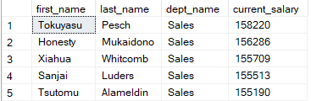

**Question-2.**Write an SQL query to fetch the list of employees with the same salary.

**select** *

**from** worker

**where** current_salary **in** (**select** current_salary **from** worker **group** **by** current_salary **having** **count**(1)>1)

**order** **by** current_salary;

