Task 1:Write an SQL query to print the FIRST_NAME from Worker table after replacing ‘a’ with ‘A’.

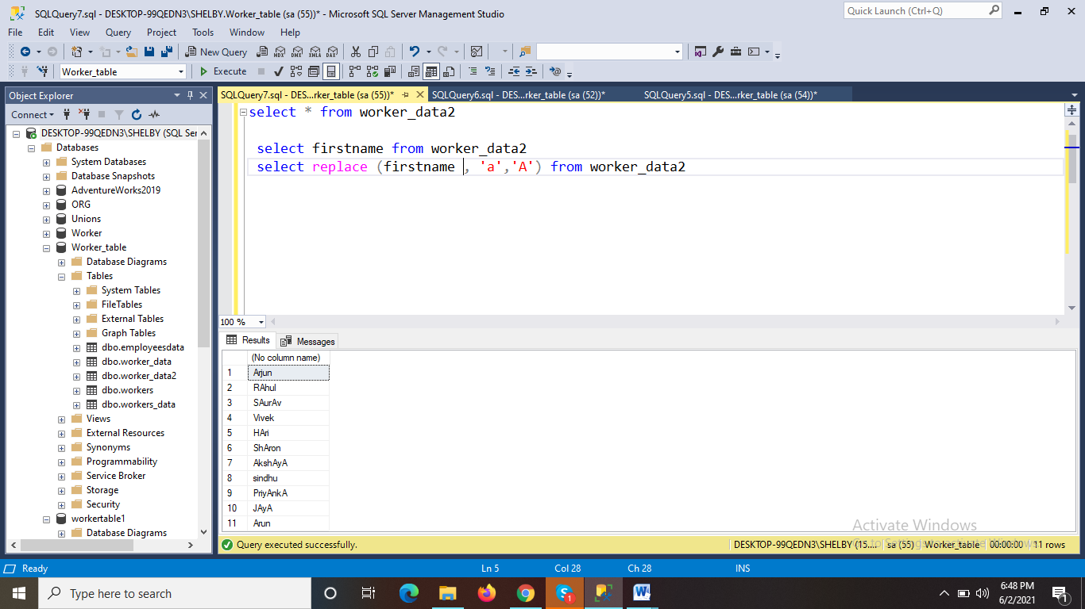

Task 2:Write an SQL query to print all Worker details from the Worker table order by FIRST_NAME Ascending and DEPARTMENT Descending

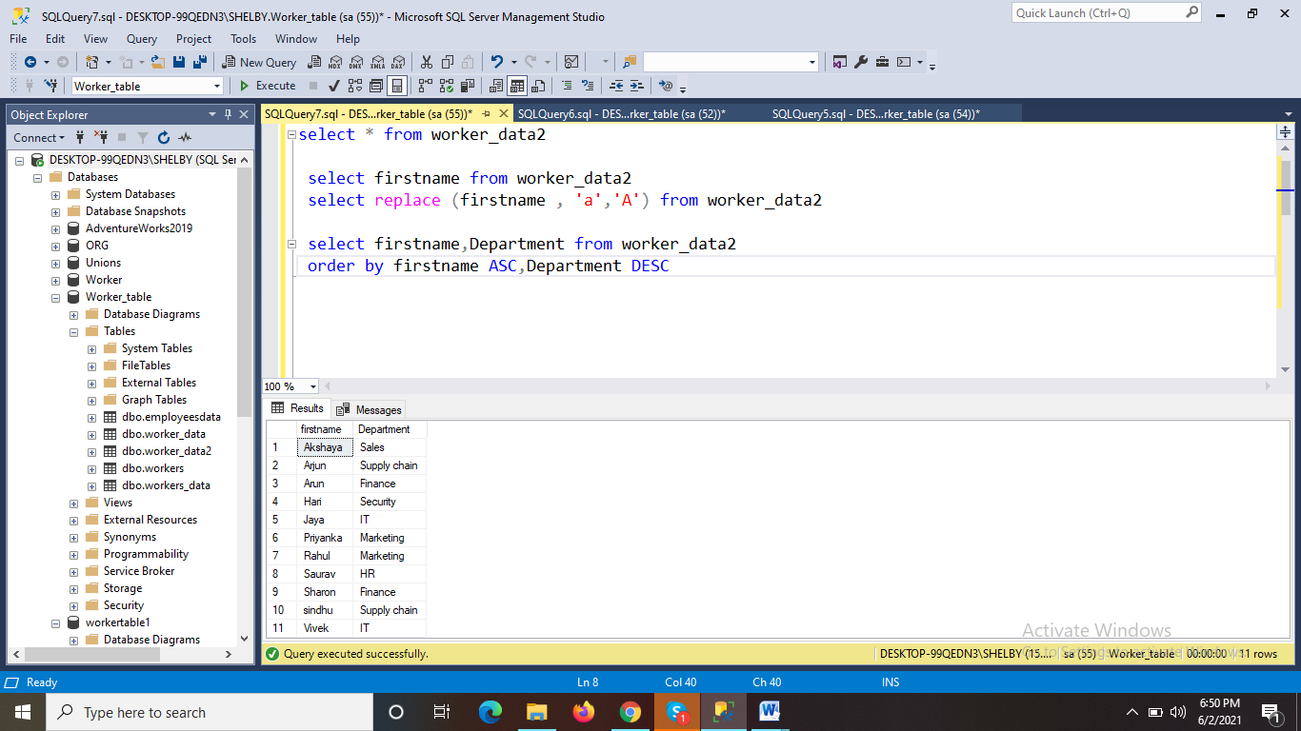

Task 3:Write an SQL query to fetch the names of workers who earn the highest salary

