Task 1:Write an SQL query to print details of workers excluding first names, “Vipul” and “Satish” from Worker table.

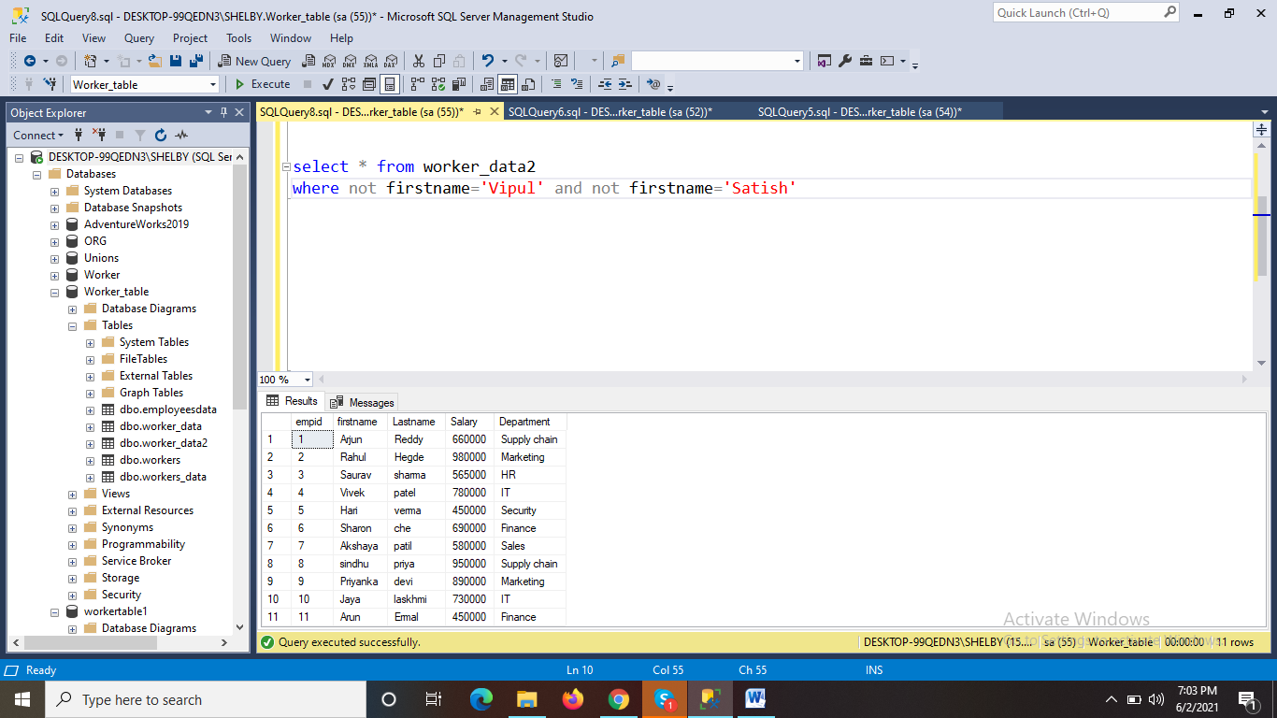

Task 2:Write an SQL query to print details of the Workers whose FIRST_NAME ends with ‘h’ and contains six alphabets

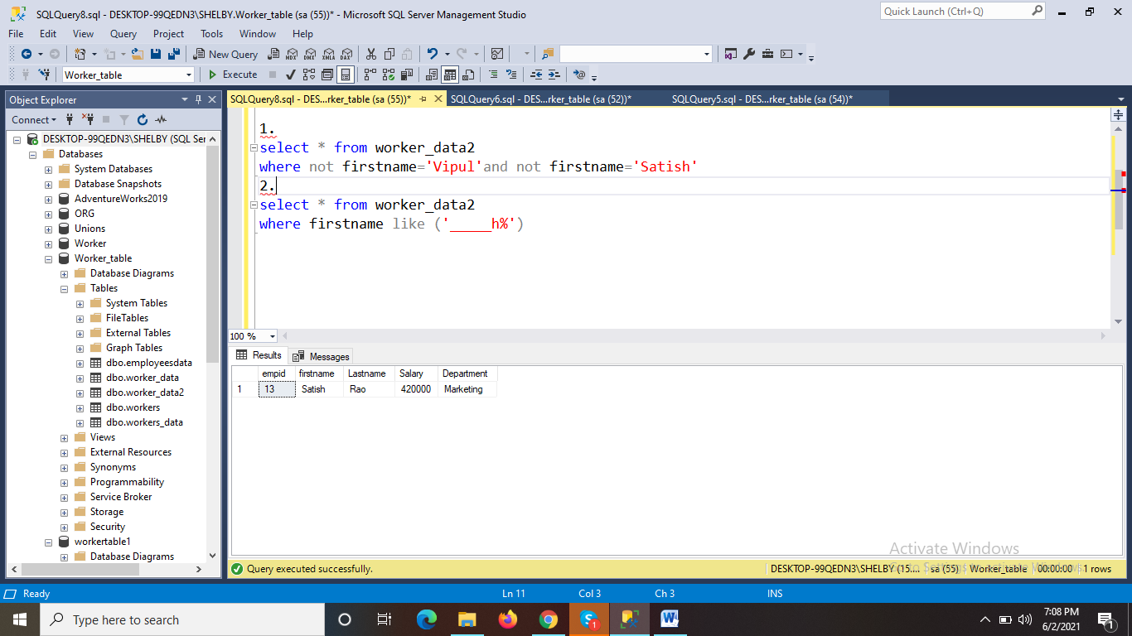

Task 3:Write a query to validate Email of Employee.

