Task 1:Write an SQL query to print details of the Workers who have joined in Feb’2014

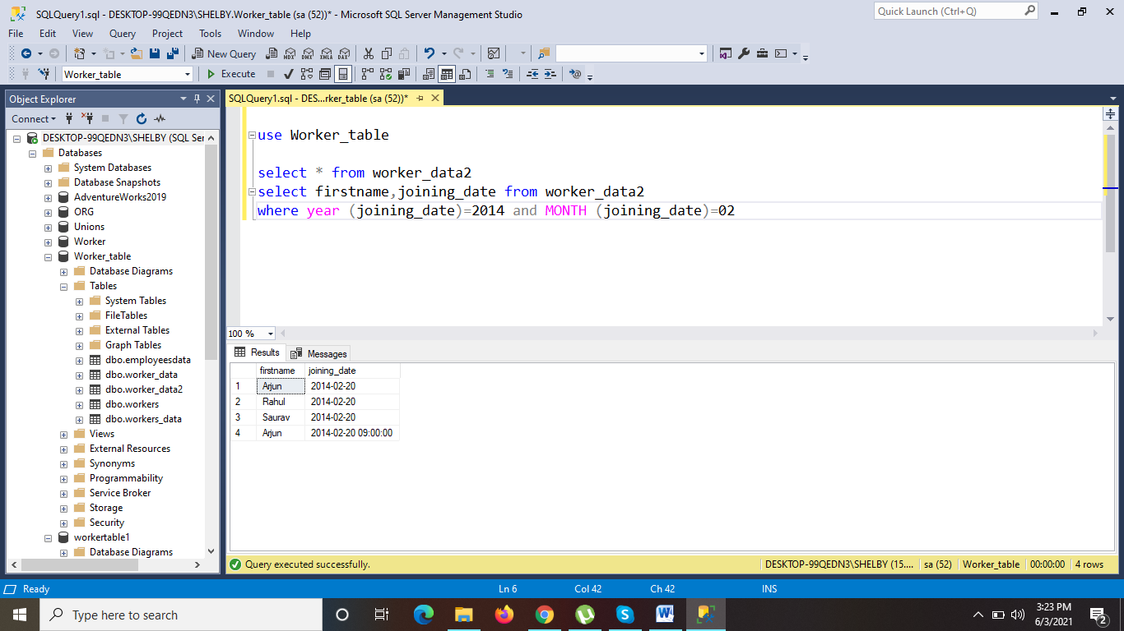

Task 2:Write an SQL query to fetch duplicate records having matching data in some fields of a table.

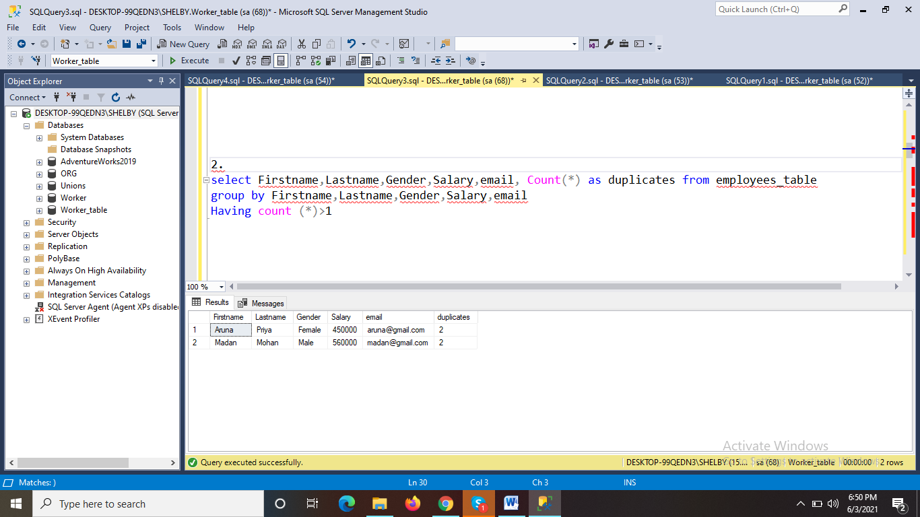

Task 3:How to remove duplicate rows from Employees table.

