Assignment-7

**Question-1**. Write an SQL query to show only odd rows from a table.

**select** *

**from**

(

**SELECT** *, ROW_NUMBER() **OVER**(**ORDER** **BY** (**select** 1)) **AS** rownumber

**FROM** worker

)

worker

**where** worker.RowNumber % 2 = 1;

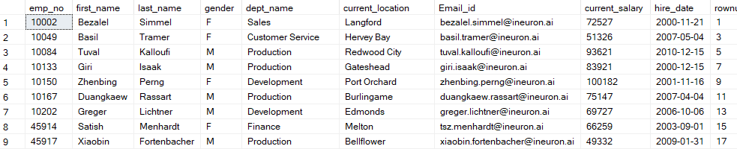

**Question-2**. Write an SQL query to clone a new table from another table.

**select** *

**into** employee1

**from** worker;

**select** *

**from** employee1;

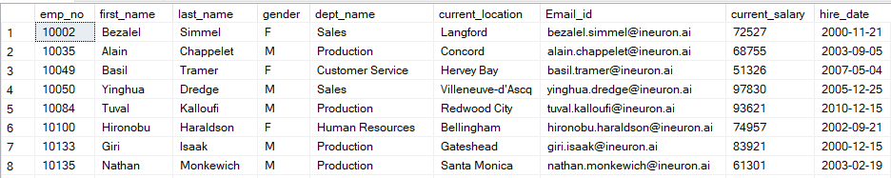

A New table employee1 has been created from worker table.