Task 1:Write an SQL query to fetch intersecting records of two tables.

Here, we will use inner join method to intersect records from two different tables.

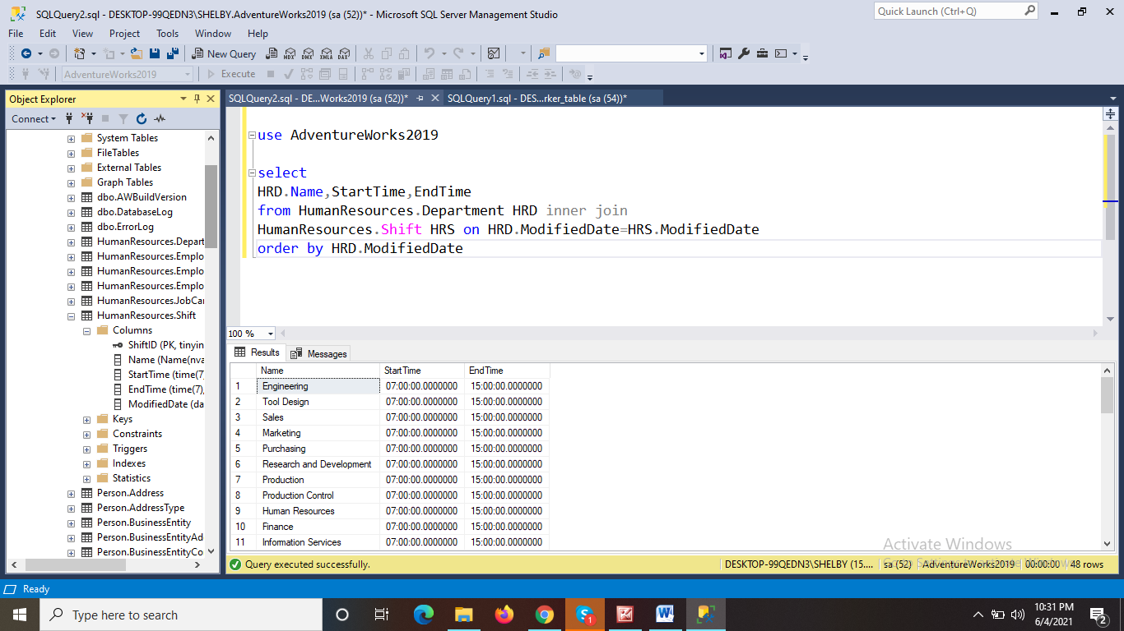

Task 2:

Write an SQL query to show records from one table that another table does not have.

