Task 1:Write an SQL query to show the top n (say 10) records of a table

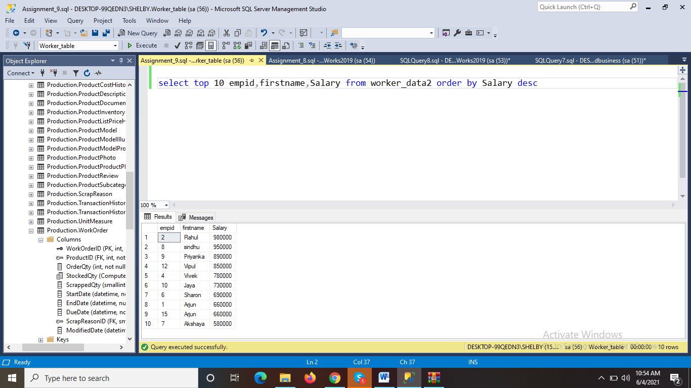

Task 2:Write an SQL query to determine the nth (say n=5) highest salary from a table.

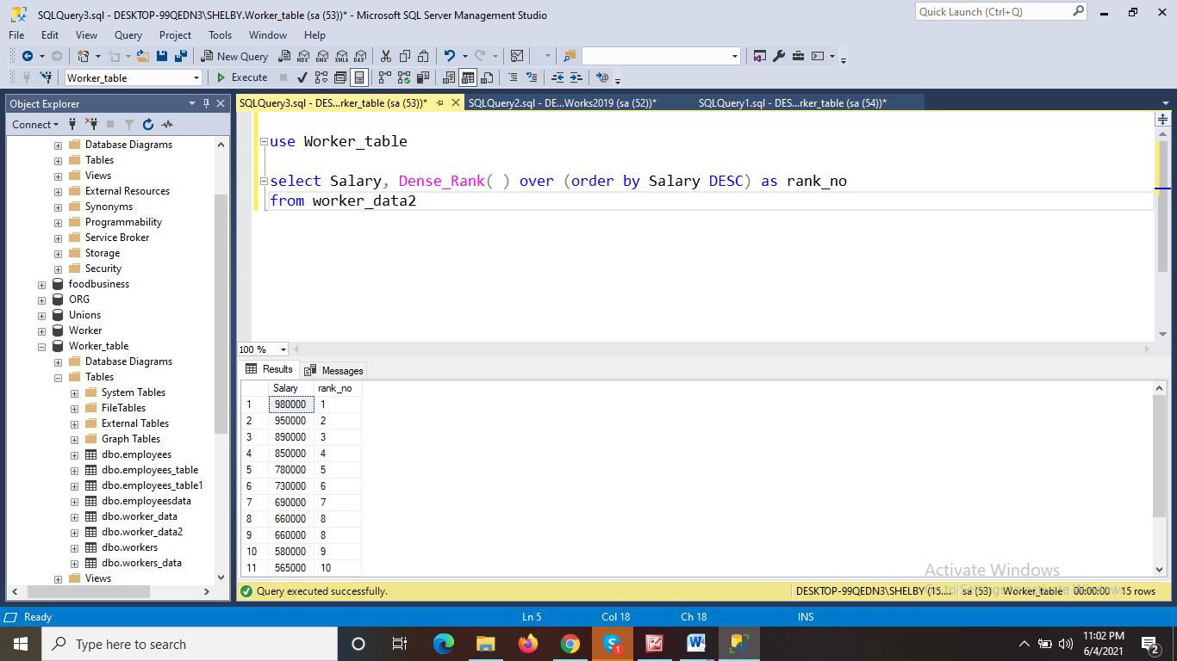

As per the data 5th highest salary is 780000.

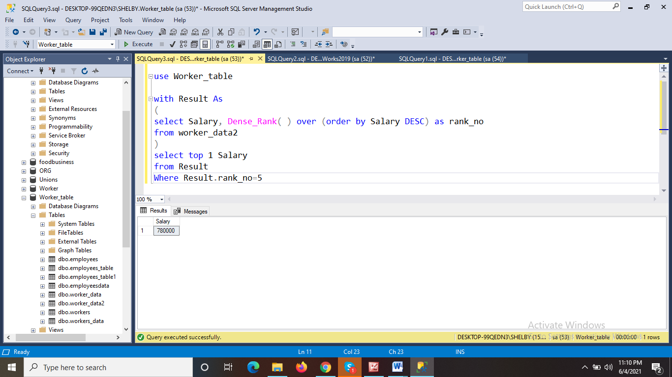

We got the nth highest salary based on cte method