**Project 9 – State to City Drill Down**

First, we start off by building the scatter plot with sales and profit measures in the row and column shelves, respectively. We can place the State dimension in the detail shelf.

After creating the Scatter plot, lets create a set action. Right click on State in dimensions and select create Set »»» Selected State »»»» Choose All.

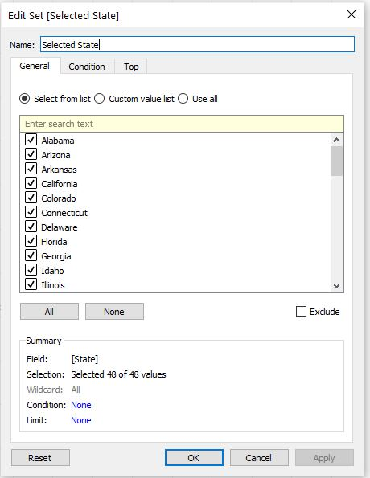

A Selected state set is now available under Sets. Now set an action to the Selected State. Go to Worksheet »»» Actions »»»Add Actions »»» Change Set values »»»» Drill Down to State and define it on the Selected State set that we created. Choose Remove All values from set under clearing the selection will.

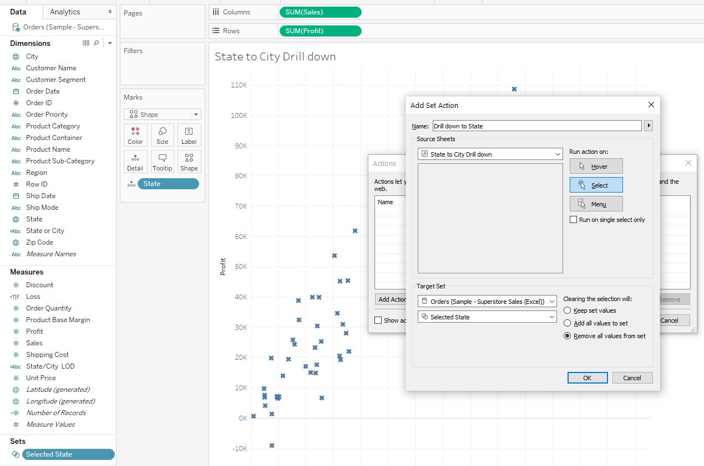

When we click on the states, nothing happens as in no cities to displayed are selected. So, for that, we now create a calculated field »»» Cities in selected state.

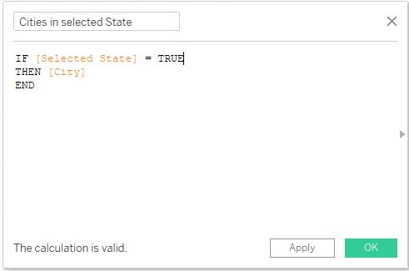

Next, we need to filter out states which are not selected. This can be done by creating calculating fields: Filter part 1, Filter part 2 and Filter part 3.

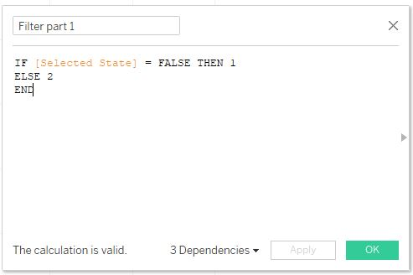

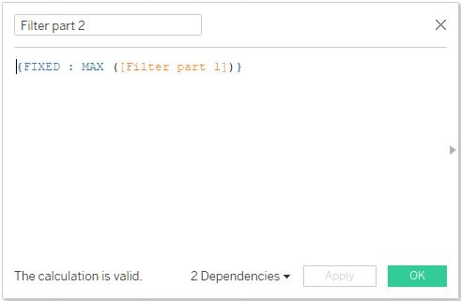

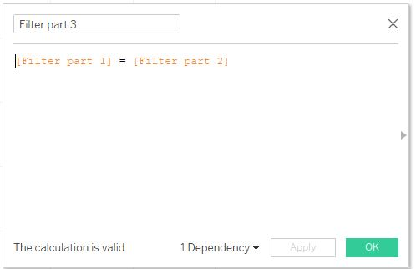

Place the Filter part 3 in the Filter shelf.

Then place the Cities in selected state onto the Detail Mark. Once we select a State we get to see the cities in that state. When we select California, we can see the cities in California.

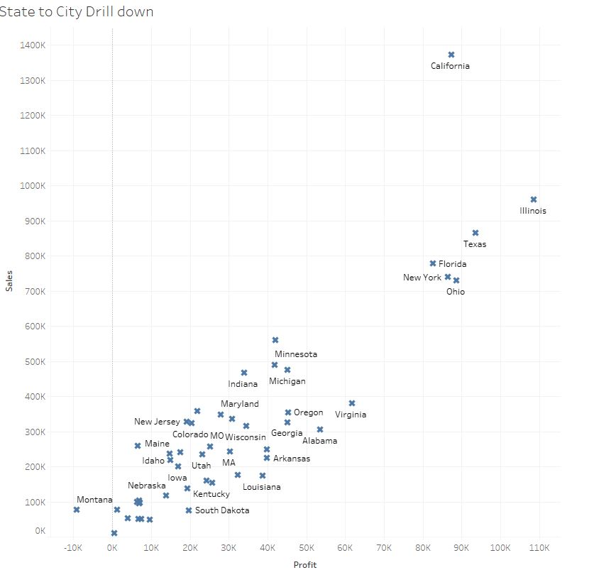

Scatter plot depicting the States

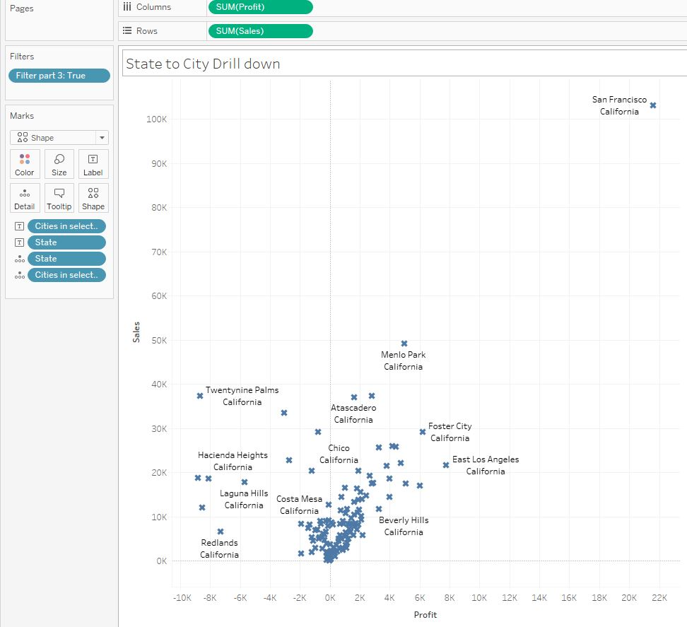

States drill down to cities

 We create another calculated field, Loss, to show all the Sales in Profit as blue and those in loss as Red.

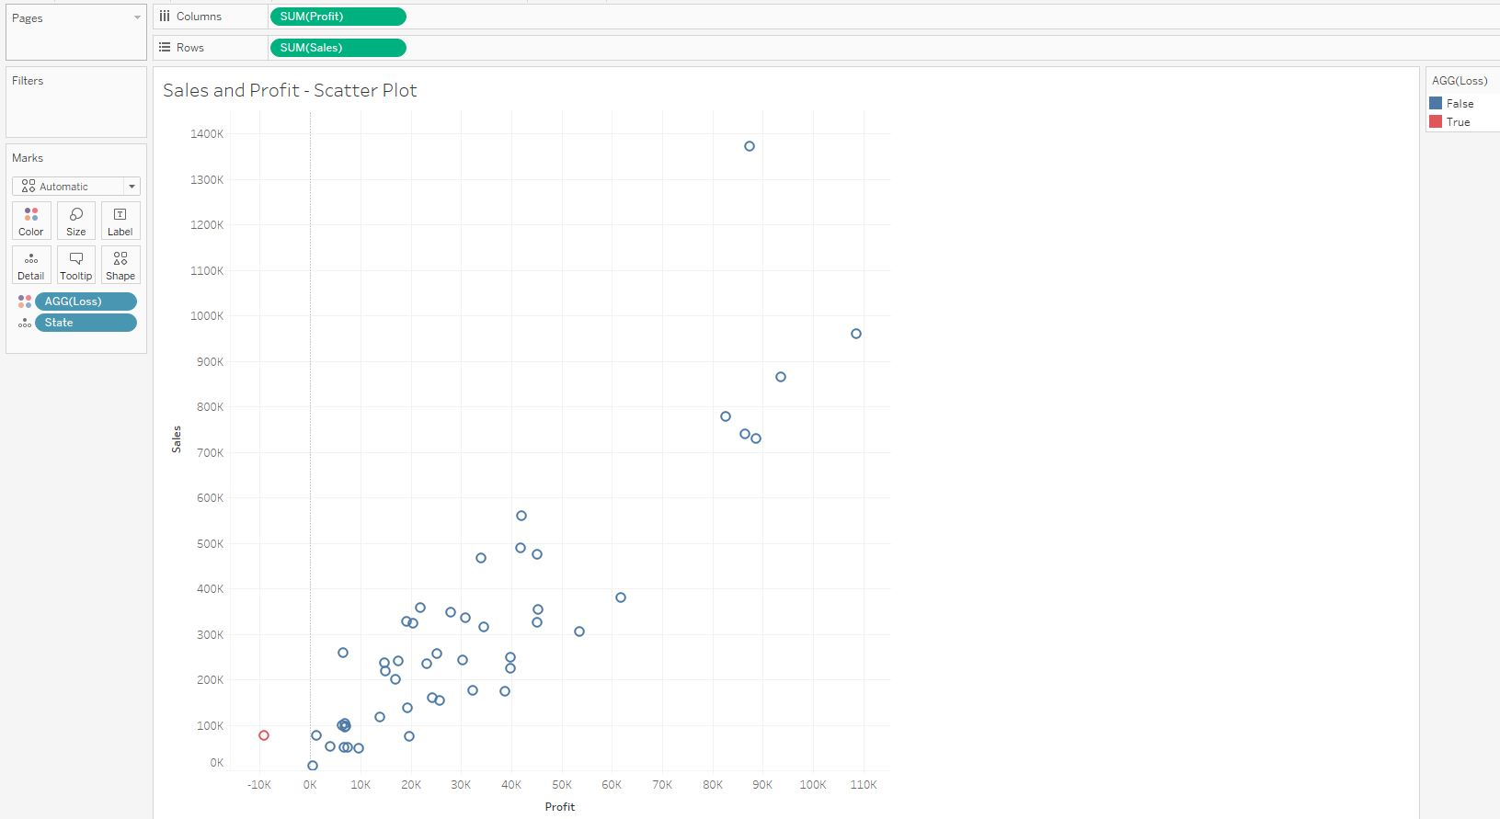

We can further create another calculated field to label the states and cities.

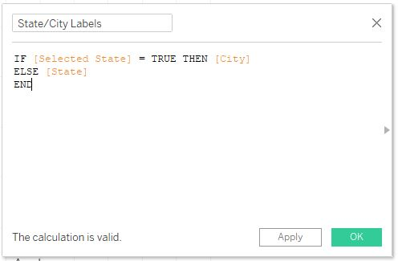

When we select the State Illinois, then the state and cities are as below pics.

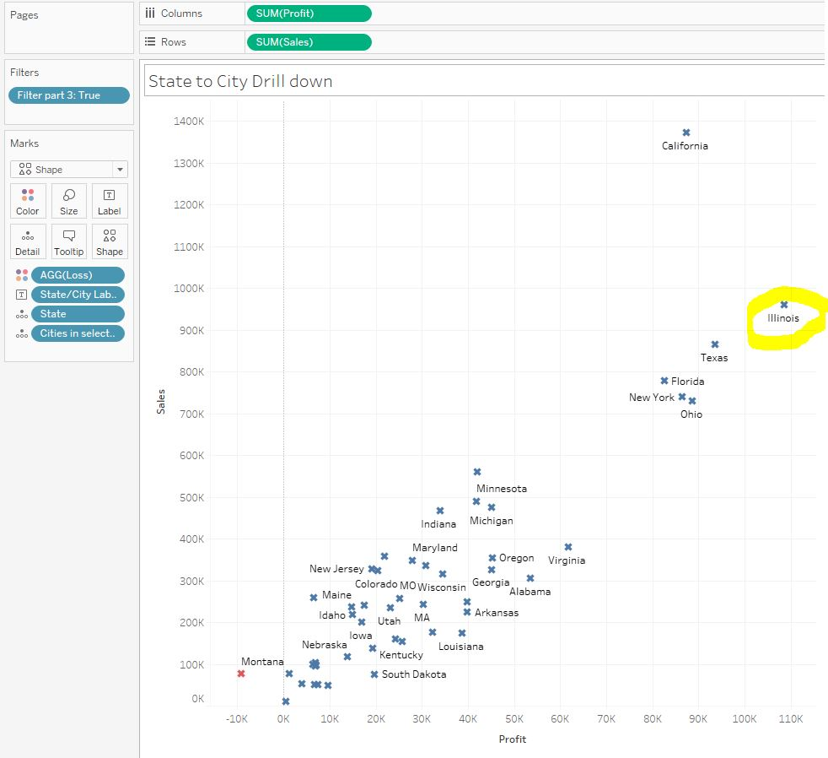

States

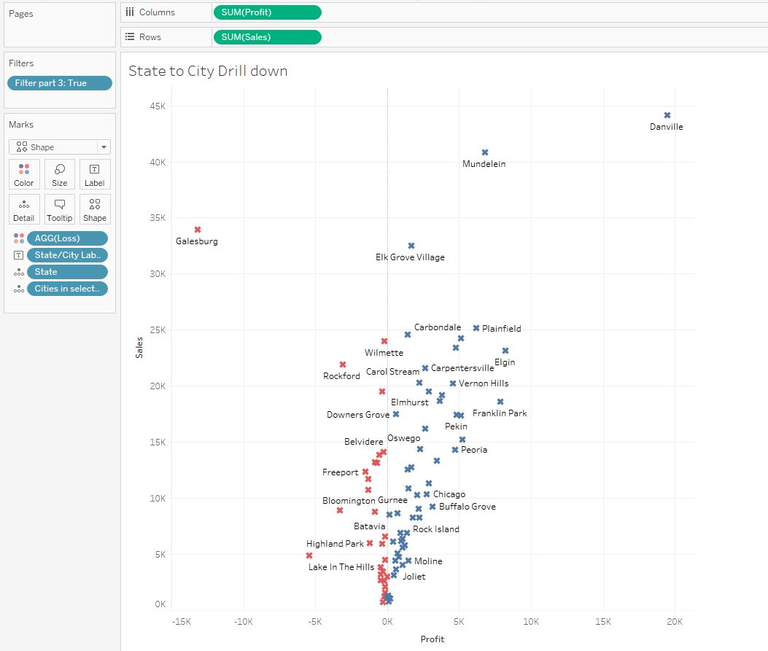

Cities in Illinois

Similarly we create a calculated field for the Title

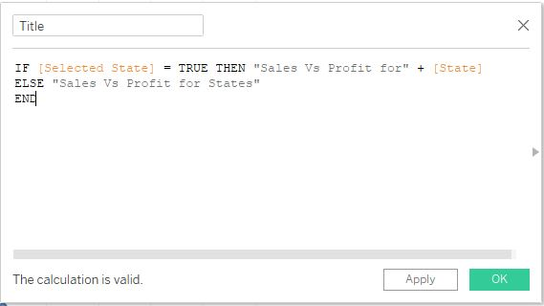

Place the Title calculated field on Detail mark and then insert this in the Title.

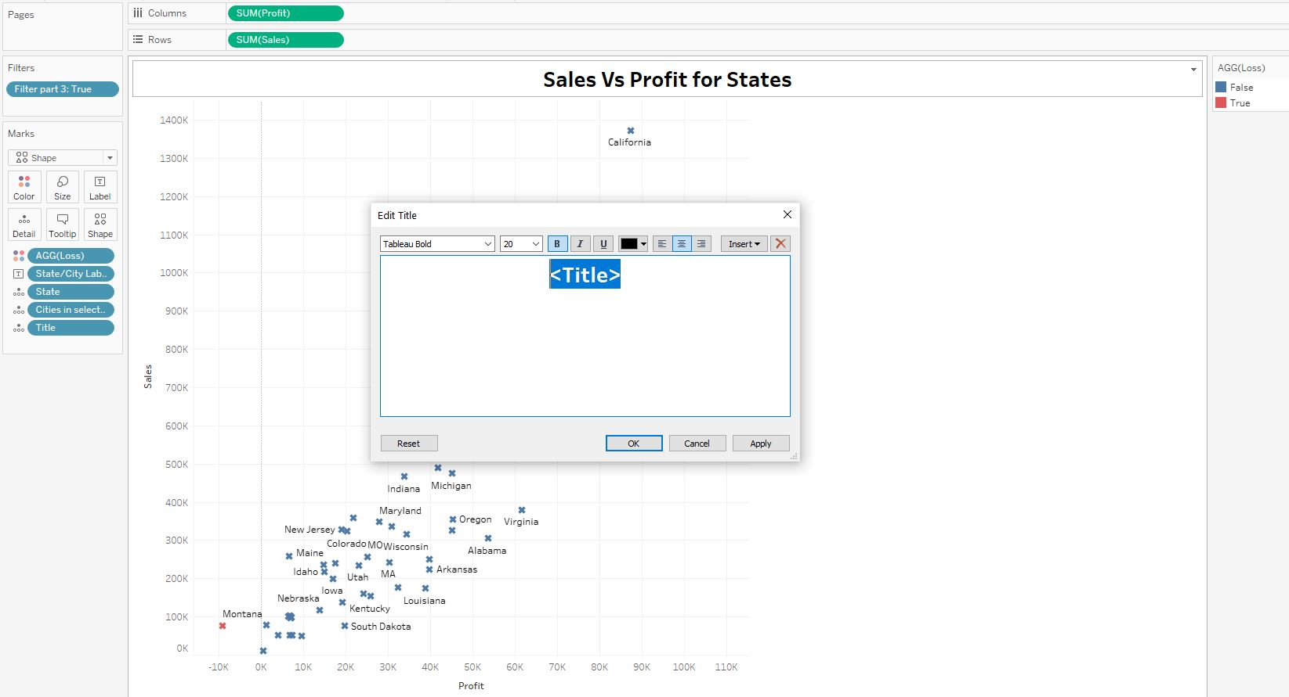

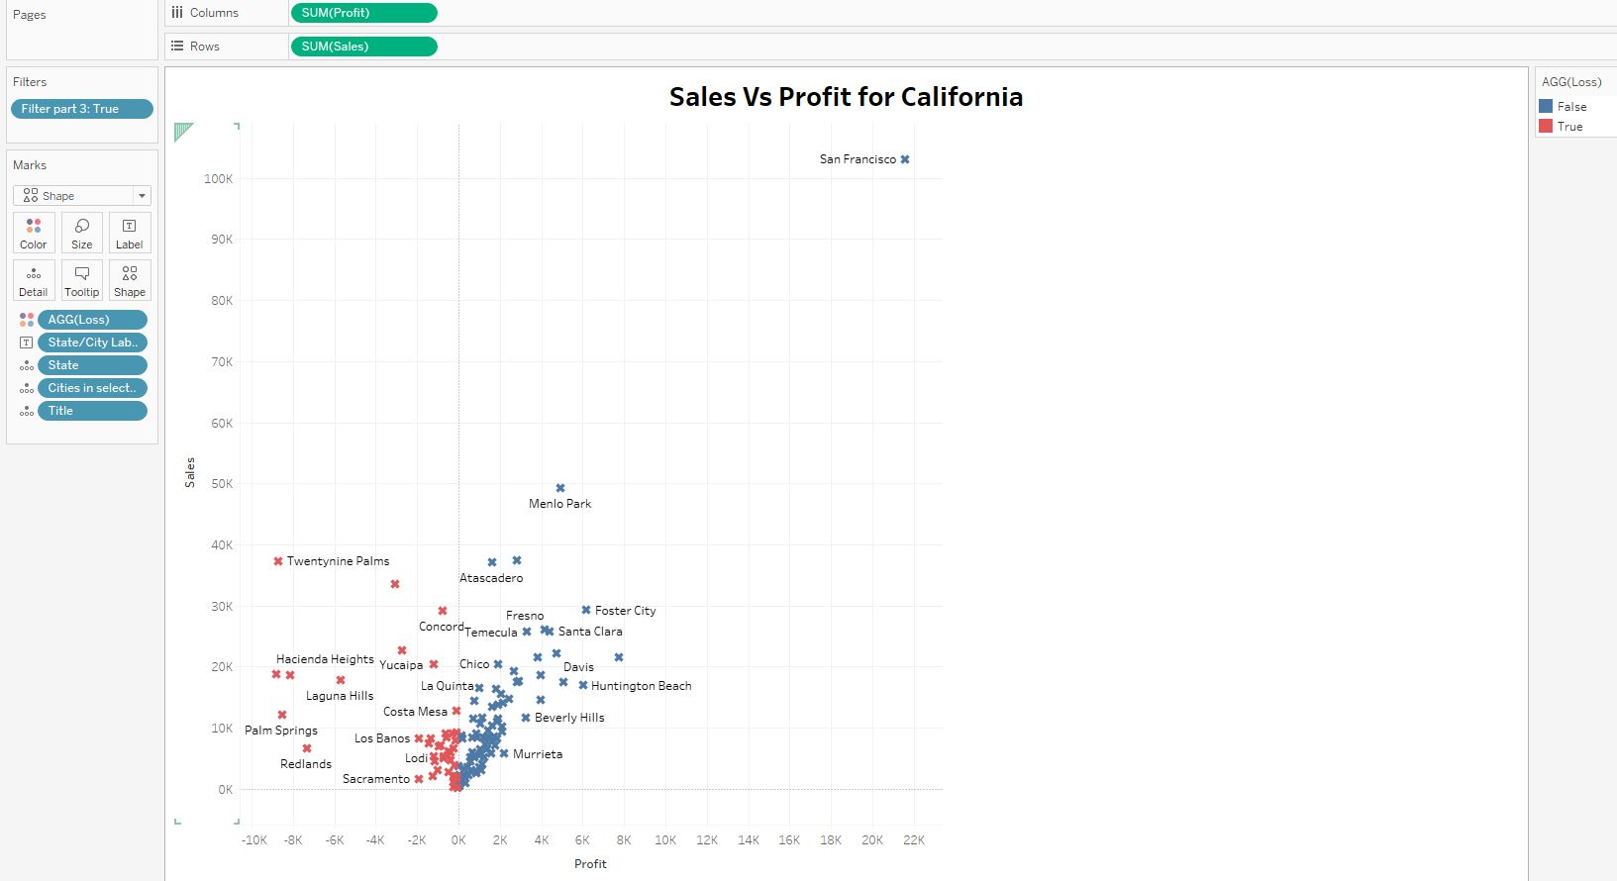

We further create a similar calculated field for Subtitle.

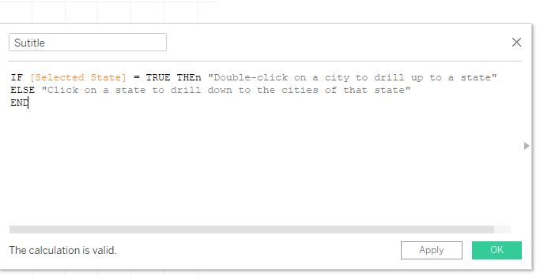

Place it on the Detail mark an insert it below the title.

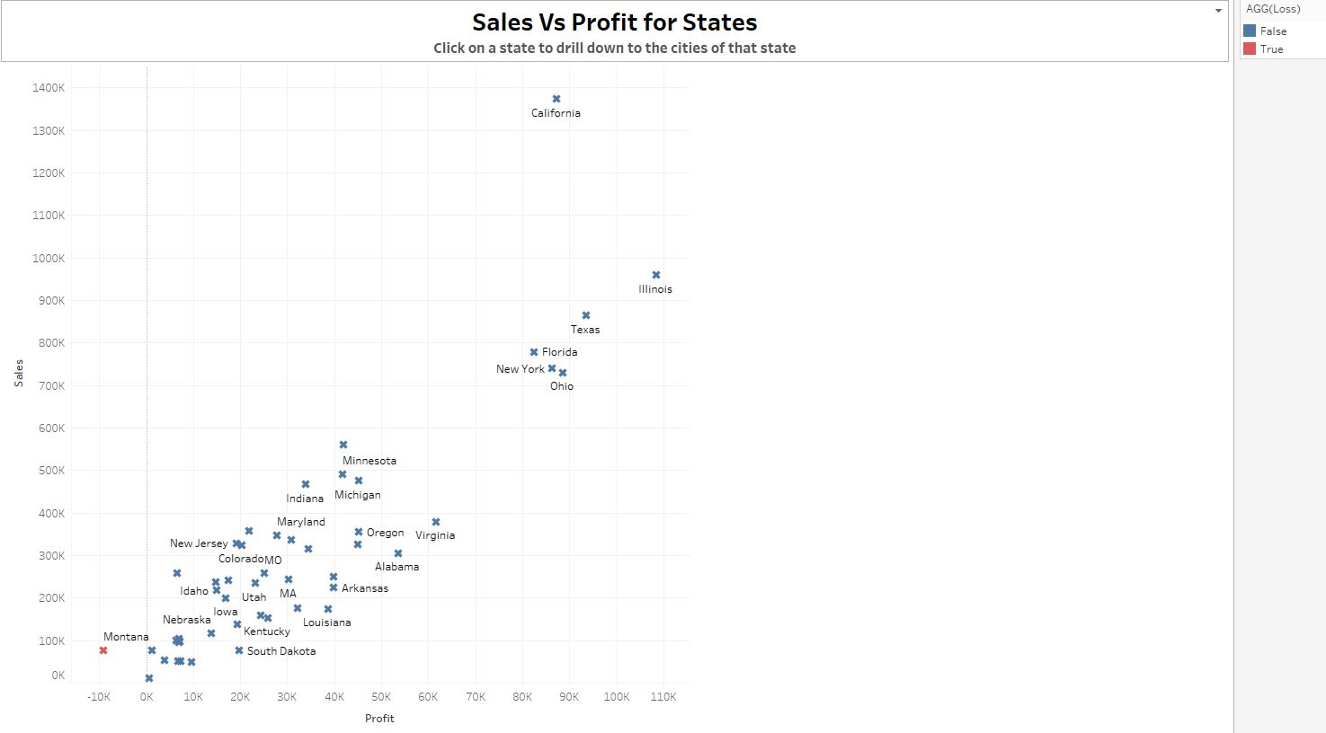

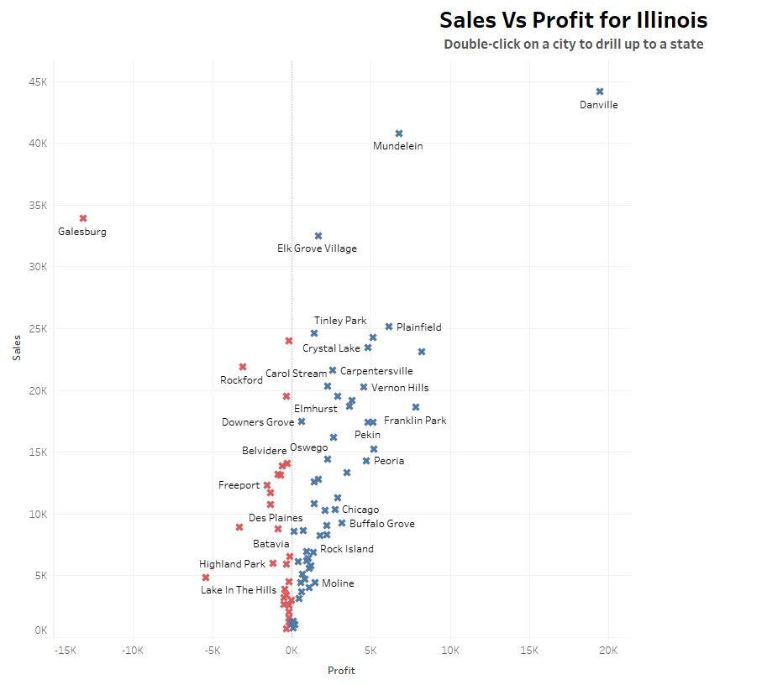

The final dashboard based on the requirement is as below. Clicking on any of the States will drill down to their respective cities.

