**Assignment 2 - Story**

**Problem statement**

The Management at lex Capital has assigned you a task to create few Charts and a Dashboard. Create a presentation as well using the Story Points feature.

Following are the tasks you need to perform:

1. Using the Population data set, create a Symbol Map at Country level where the size of the circle displays the population and the color represents the classification of Birth Rate. Since no field is available for classification, you will need to create a Calculated Field to classify the birth rate based on the following criteria:

Birth Rate below 1.5% is termed as “Below”

Birth Rate between 1.5%-3% is termed as “Moderate”

Birth Rate above 3% is termed as “Above”

2. Using the Health Data, create two Horizontal Bar charts in the same view where the first bar chart is for Average Health Exp % GDP at Country Level and the other one is for the Average Health Exp/Capita at Country Level. Also, create a Parameter for Health Exp % GDP ranging from 1-15%. Use this for bifurcating the charts.

3. Using the Development data, create a dual-axis chart comparing Mobile phone usage against Internet usage at Year level.

4. Using the Development data, create two timelines, one for Average GDP and the other one for Average GDP divided by Average Population. The visualization should be bifurcated based on Country.

5. Create a Dashboard using Travel Data. The Dashboard should include the following visualizations:

• Create a Stacked Bar chart using Region, Tourism Inbound and Year.

• Create a Tree-Map using Tourism Outbound, Region and Country. Add Tourism Inbound as well without altering the visualization.

• Create a Dashboard and turn on the Action Filter for both the charts.

Module 9- Dashboards And Stories

6. Using the Business data, create a Dashboard consisting of the following charts:

• Display correlation between Ease of Business and GDP per Capita at Country level. Add a Logarithmic Trend Line as well.

• Create a chart using Average Days to Start Business, Average Hours to do Tax and Average Tax Rate at the Country level.

• Create a Text table using Country, Business Tax Rate, Days to start Business, Ease of Business and Hours to do Tax.

• Finally create a Dashboard and turn on the Action Filter for all the charts

7. Create a Story using all the visualizations and dashboards.

**Solution**

**Task 1. Using the Population data set, create a Symbol Map at Country level where the size of the circle displays the population and the color represents the classification of Birth Rate. Since no field is available for classification, you will need to create a Calculated Field to classify the birth rate based on the following criteria:**

Birth Rate below 1.5% is termed as “Below”

Birth Rate between 1.5%-3% is termed as “Moderate”

Birth Rate above 3% is termed as “Above”

We need to create a calculated field for the Birth Rate Segment.

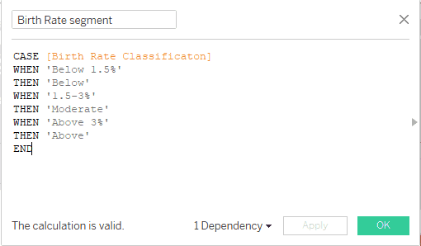

Calculative Field for Birth Rate Segment

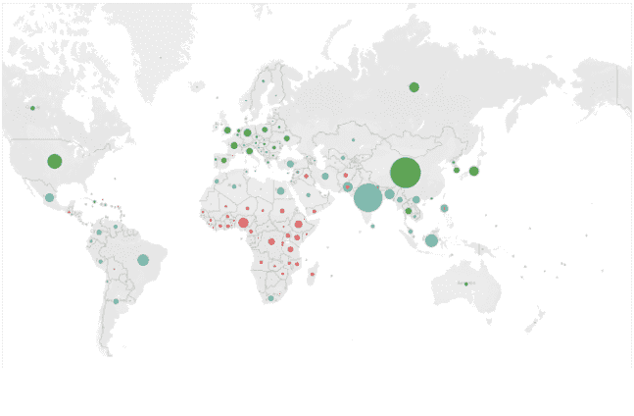

**Task 2 - Using the Health Data, create two Horizontal Bar charts in the same view where the first bar chart is for Average Health Exp % GDP at Country Level and the other one is for the Average Health Exp/Capita at Country Level. Also, create a Parameter for Health Exp % GDP ranging from 1-15%. Use this for bifurcating the charts.**

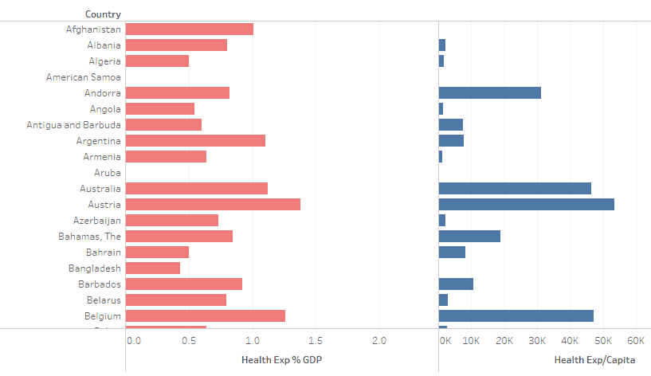

**Task 3**- **Using the Development data, create a dual-axis chart comparing Mobile phone usage against Internet usage at Year level.**

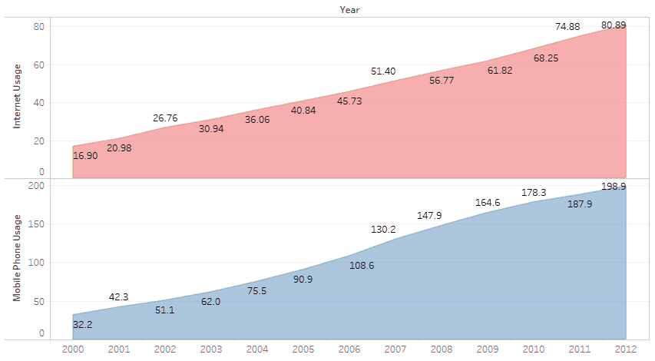

**Task 4 - Using the Development data, create two timelines, one for Average GDP and the other one for Average GDP divided by Average Population. The visualization should be bifurcated based on Country.**

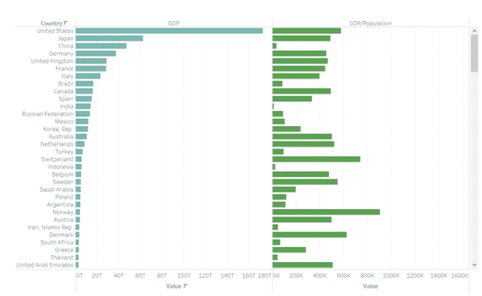

**Task 5 - Dashboard**

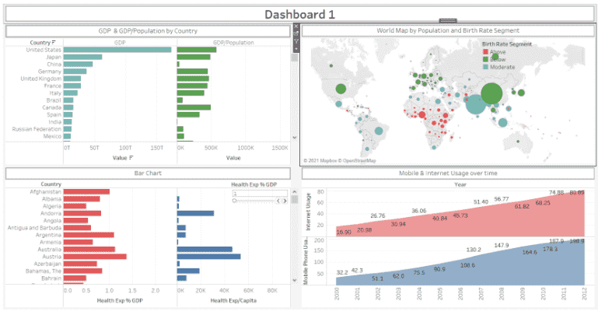

**Task 6 -**

**Create a Dashboard using Travel Data. The Dashboard should include the following visualizations:**

**• Create a Stacked Bar chart using Region, Tourism Inbound and Year.**

**• Create a Tree-Map using Tourism Outbound, Region and Country. Add Tourism Inbound as well without altering the visualization.**

**• Create a Dashboard and turn on the Action Filter for both the charts.**

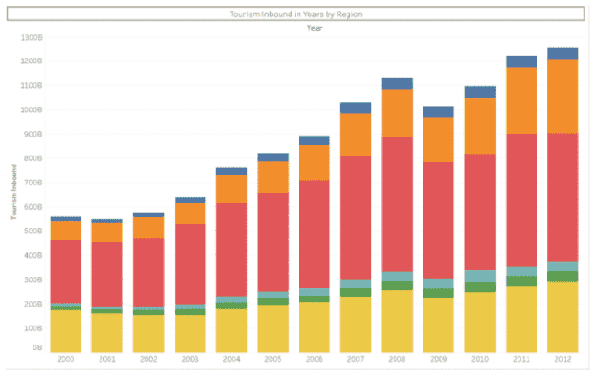

**Task 7 - Treemap**

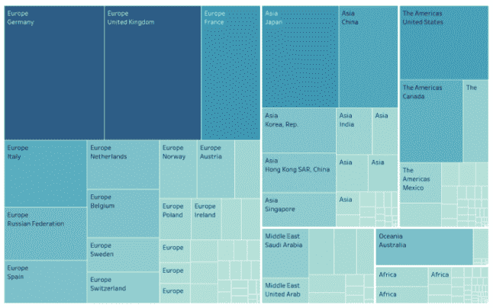

**Final Dashboard**

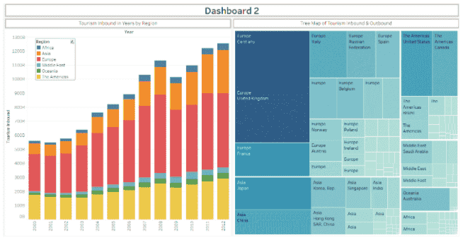

**Task 8 -**

**Using the Business data, create a Dashboard consisting of the following charts:**

**• Display correlation between Ease of Business and GDP per Capita at Country level. Add a Logarithmic Trend Line as well.**

**• Create a Text table using Country, Business Tax Rate, Days to start Business, Ease of Business and Hours to do Tax.**

**• Finally create a Dashboard and turn on the Action Filter for all the charts**

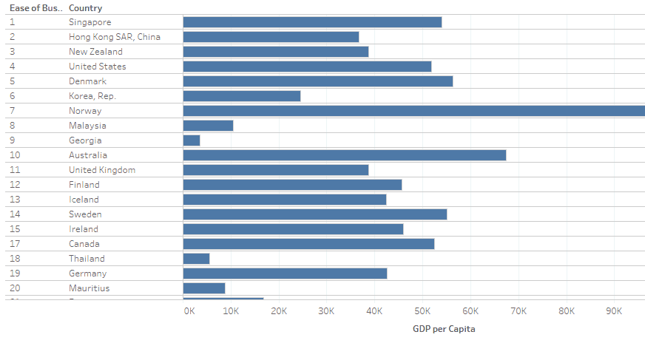

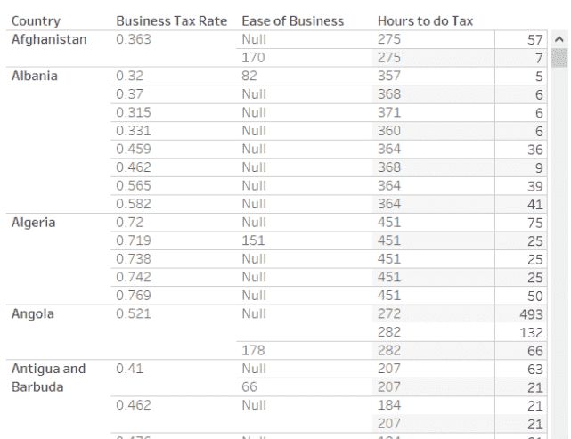

**Dashboard**

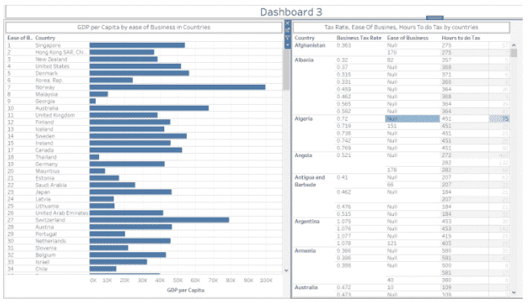

**Task 9 - Create a Story using all the visualizations and dashboards.**

Story from Dashboard 1

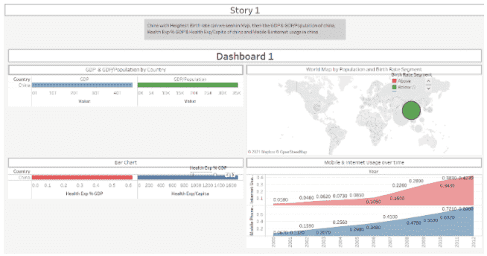

Story from Dashboard 2

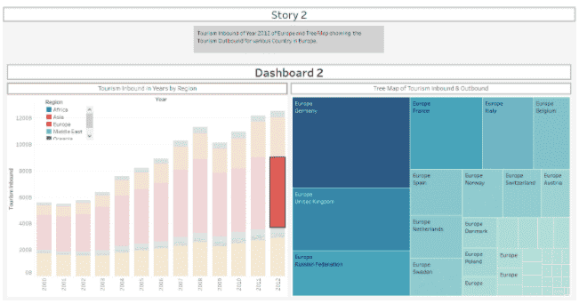

Story from Dashboard 3

