**Assignment-7:**

**Find the following :-**

**- Max FDI**

**- Min FDI**

**- FDI Trend**

**- Sector Grouping & Comparision.**

Connect to "FDI Case Study" excel dataset by clicking on "Microsoft Excel" option under Connect section.

The dataset contains a single table "Data".

Go to Data Source page

step 1) Hold ctrl and select all the years and right click on these selected year columns and click on "Pivot" option.

Then it results to two columns "Pivot Field Name" and "Pivot Field Value".

step 2) Rename "Pivot Field Name" as Year and "Pivot Field Value" as FDI.

**Max FDI:**

step 1) Drag and drop "Sector" dimension on to Rows shelf.

step 2) Drag and drop "FDI" measure on to Label under Marks card. Sort the values in descending order.

step 3) Right click on "SUM(FDI)" pill under Marks card and change Measure type to Maximum.

step 4) Drag and drop "FDI" measure on to Color under Marks card.

step 5) Right click on "SUM(FDI)" Color pill under Marks card and change Measure type to Maximum.

step 6) Now, click on "MAX(FDI)" color legend card and click on "Edit Colors"

Then select Palette type as "Sunrise-Sunset Diverging" from dropdown.

Now, we can see the result visual as shown below:

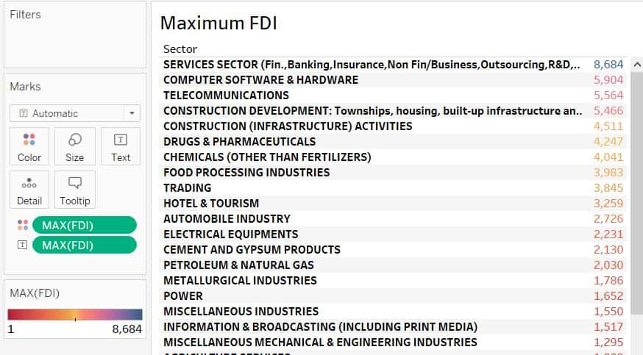

**Min FDI:**

step 1) Drag and drop "Sector" dimension on to Rows shelf.

step 2) Drag and drop "FDI" measure on to Label under Marks card. Sort the values in descending order.

step 3) Right click on "SUM(FDI)" pill under Marks card and change Measure type to Minimum.

step 4) Drag and drop "FDI" measure on to Color under Marks card.

step 5) Right click on "SUM(FDI)" Color pill under Marks card and change Measure type to Minimum.

step 6) Now, click on "MIN(FDI)" color legend card and click on "Edit Colors"

Then select Palette type as "Sunrise-Sunset Diverging" from dropdown.

Now, we can see the result visual as shown below:

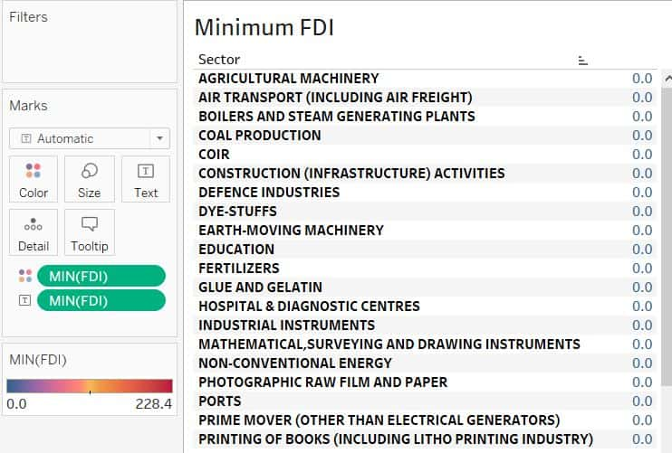

**FDI Trend:**

step 1) Drag and drop "FDI" measure on to Rows shelf and "Year" dimension on to Columns shelf.

step 2) Click on label icon 'T' to show labels.

we can see bar chart visual as shown below:

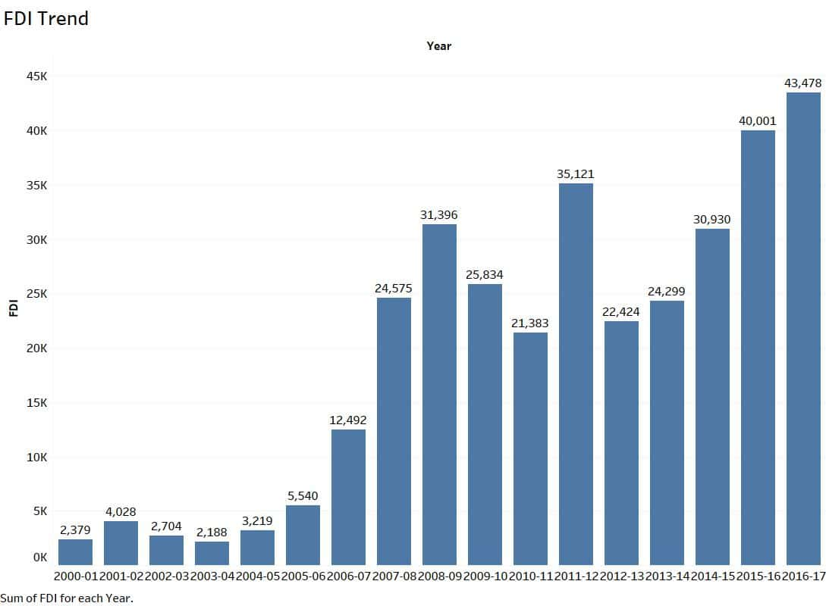

**Insights:**

We can see upward trend from 2004-05  to 2008-09.

Again we can see constant upward trend from 2012-13 to 2016-17.

**Sector Grouping & Comparision:**

step 1) Drag and drop "Sector" dimension on to Rows shelf and "FDI" measure on to Columns shelf.

step 2) Sort the chart in descending order.

step 3) Now, click on "SUM(FDI)" color legend card and click on "Edit Colors"

Then select Palette type as "Red-Green-Gold Diverging" from dropdown.

step 4) Click on label icon 'T' to show labels.

Now, we can see the result visual as shown below:

