**Assignment-8:**

**Use the Superstore_USA data and find the customer loyalty on the following scenarios**

**- How much sales has come from customer from the previous in the current year in terms of Sales Value.**

**- How much sales has come from customer from the previous in the current year in terms of Sales Percentage.**

**- Find the orders placed by each customers**

After connecting to "Superstore_USA" excel data,

Drag and drop "Orders" , "Returns" and "Users" tables to Data Model section to make connections between the tables.

**How much sales has come from customer from the previous in the current year in terms of Sales Value.**

Here we find customer loyalty in terms of Order Date and Sales.

step 1) Hold ctrl and select "Order Date" dimension and "Sales" measure then select horizontal bar chart visual from Show Me section.

step 2) press ctrl+w to swap Rows and Columns.

Now we got sales for each Order Date year as shown below:

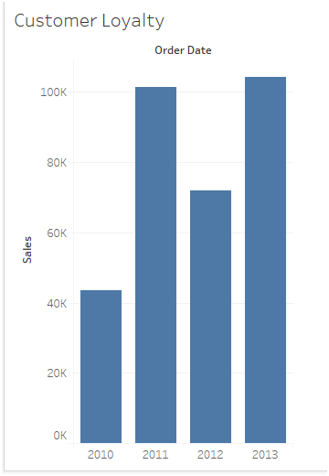

Lets create a calculated field and  use Fixed LOD on customer id and perform minimum aggregation on Order Date to get loyal customers:

step 3) Click on "Analysis" on the top section and click on "Create Calculated field" option.

In the pop up window,

Give the name as "Loyal Customers" and give the formula as shown below:

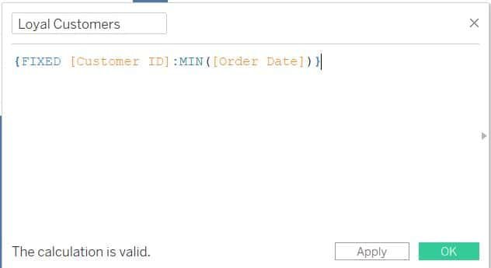

Here we try to find loyal customers with their unique id who constantly maintain minimum order over the years.

Click on OK.

Then "Loyal Customers" dimension gets created.

step 4) Now, drag and drop "Loyal Customers" dimension on to Color under Marks card.

step 5) Sort the year filter in descending order.

Now we can see the bar chart along with year filter as shown below:

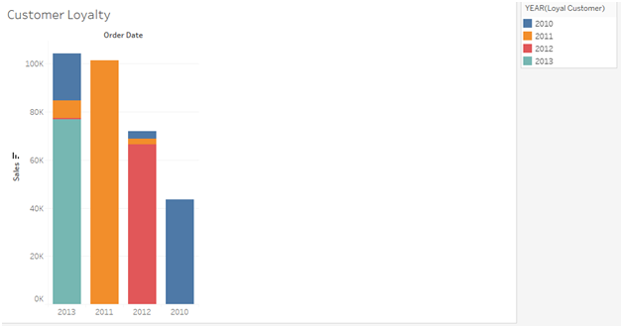

Here,

• Blue color indicates loyal customers of 2010.

• Orange color indicates loyal customers of 2011.

• Pink color indicates loyal customers of 2012.

• Sky Blue color indicates  loyal customers of 2013.

**Insights:**

Customers joined in year 2010 brought 19 lakh sales.

Comparing 2011 Sales with its previous year 2010:

The newly joined customers in 2011 brought 9 lakh sales when compared to its previous year 2010 customers who brought 10 lakh sales. This indicates "customers joined in year 2010 are loyal in 2011 year as well.

Comparing 2012 Sales with its previous year 2011:

The newly joined customers in 2012 brought less sales (5 lakh 33 thousand) than the customers who joined in 2011(5 lakh 52 thousand) and the customers who joined in 2010(10 lakhs).

The loyalty of customers of 2011 decreased in the year 2012 when compared with 2011.

The loyalty of customers of 2010 increased in the year 2012 when compared with 2011.

Comparing 2013 Sales with its previous year 2012:

The newly joined customers in 2013 brought less sales (4 lakh 50 thousand) than the customers who joined in the year 2010,2011. But brought better sales when compared with the customers who joined in the year 2012.

The loyalty of customers of 2012 decreased in the year 2013 when compared with 2013.

The loyalty of customers of 2011 increased a little bit in the year 2013 when compared with 2012.

The loyalty of customers of 2010 increased constantly from 2011 to 2013 which indicates

that "the customers of 2010 are more loyal than the customers of 2011,2012 and 2013".

**How much sales has come from customer from the previous in the current year in terms of Sales Percentage.**

step 6) Right click on "SUM(Sales)" green pill of the Rows shelf and click on "Quick Table Calculation" then select "Percent of Total" option.

Now, we can see year wise customers loyalty in terms of sales percentage as shown below:

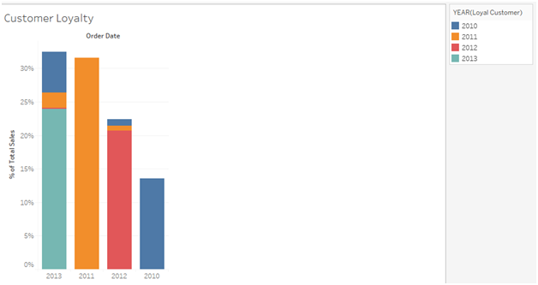

**Find the orders placed by each customers**

Take a new sheet and rename it as "No. of Orders".

step 1) Click on "Analysis" on the top section and click on "Create Calculated field" option.

In the pop up window,

Give the name as "Orders Per Customer" and give the formula as shown below:

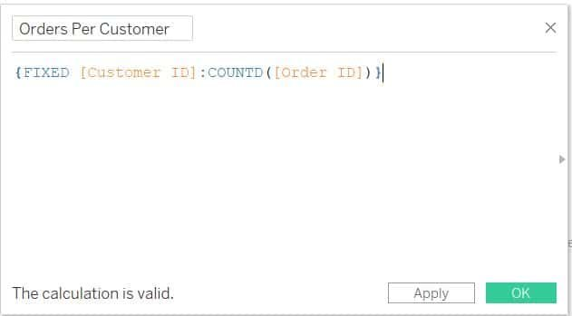

Calculating distinct count of orders for each customer id

Then "Order Per Customer" measure gets created.

step 2) Drag and drop "Customer ID" dimension on to Rows shelf and "Orders Per Customer" measure on to Columns shelf.

step 3) Right click on "SUM(Orders Per Customer)" pill on Columns shelf and click on "Discrete" option.

step 4) Right click on "Customer ID" pill on Rows shelf and change Measure type to Count(Distinct).

Now, we can see a line chart as shown below:

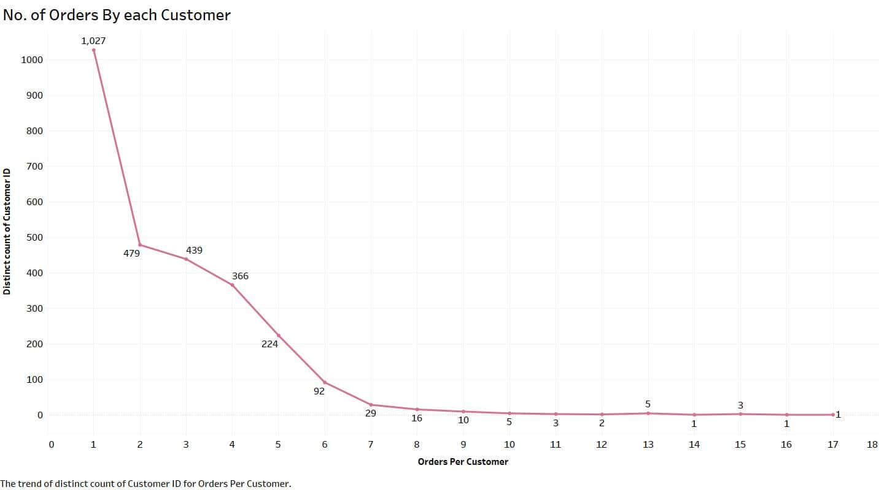

**Insights:**

•  customer id 1027 who placed just one order.

• customer id 1 placed 17 orders which are highest as per the records.