Use the GlobalData data set and find the following:-

- Create a hierarchy of the Continent, Region and Country

Once the dataset is loaded into tableau, it’s important to verify that the dimensions and measures are correctly identified. However, the datatype of continent and region is assigned as string and not geography, like it has been assigned for country. Before we proceed further, we need to assign a geographic role to Continent and Region as below:

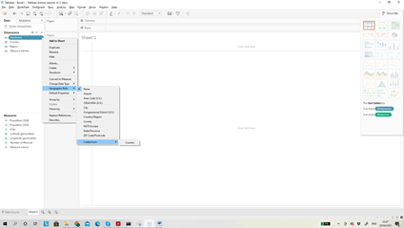

A hierarchy "Continent, Country" gets created under Tables section.

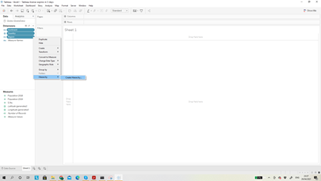

Region is also added to the hierarchy of Continent and Country »»» Right click on Region »»» Hierarchy »»» Add to Hierarchy »»» then click on Continent, Country option.

Rename the hierarchy created as Locations and sort the hierarchy in the order of Continent, Region and Country.

- Create a map with continent as dots for each continent

Drag and drop the Locations pill onto the sheet. Dots will be placed on each continent. Further drag and drop Locations onto the Label in the Marks card. Each continent will be labelled as below:

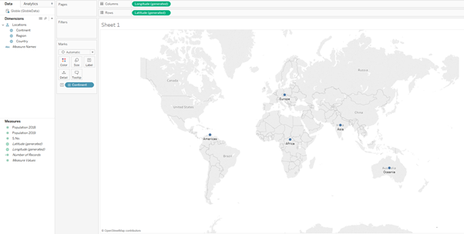

- Change the color of the dots with the help of color marks

Drag and drop Location on to Color under Marks card.

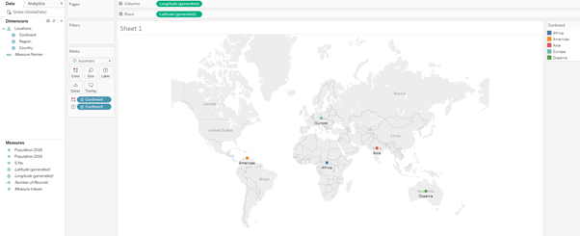

- Change the shape of the dots with different dot for each continent

Drag and drop "Location" on to Shapes under Marks card and change the marks type from Automatic to Shape. We can further edit the shapes by clicking on Shape under Marks card and in the pop up window choose the type of shape for each continent.

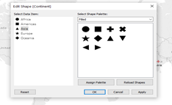

We can increase the size of the shapes by clicking on the Size under Marks card.

