Use the Superstore_USA data and find the following scenarios

- Create a Bar chart showing the sales in terms of Product Sub Category

- Create a SET of the top 10 Customer and Use it to show the Customer which comes within the SET.

- Create a Bar chart showing the Profit in terms of Product Sub Category

- Create a SET of the top 10 Customer and Use it to show the Customer which comes within the SET.

- Combine both the SET and use to show the customers who brings both Profit & Revenue.

We first create a bar chart with Customer name and Sales and after sorting, select the 1st bar and holding shift key choose the next 9. Choosing the symbol of Venn diagram we create set and name it as top 10 customers.

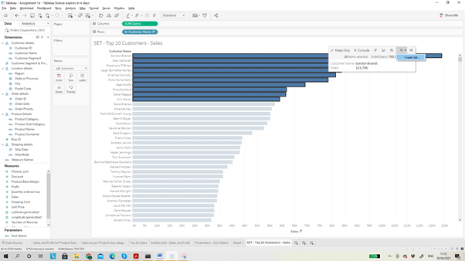

A different section called set is created under Measures.

Now we can bring the Set to row shelf and sales in column shelf. So in row shelf we see IN/OUT (Set name as Top 10 Customers). IN means those that are part of the set and OUT are those that are not part of the set.

Then bring the Customer Name into row shelf and we will have sections with those in and out of the set.

Now clicking on IN in the bar graph and edit alias we can change the name of IN as Top 10 customers.

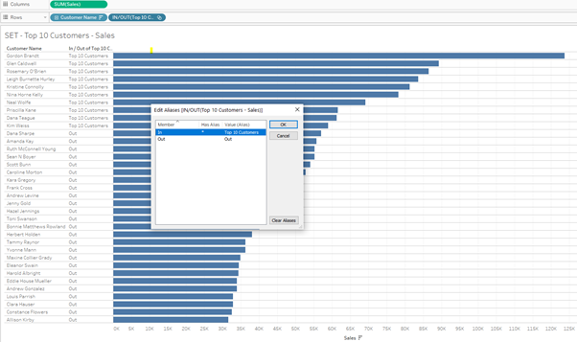

We can bring in the Product Sub-category to see the top 10 customers for each of the product sub-category.

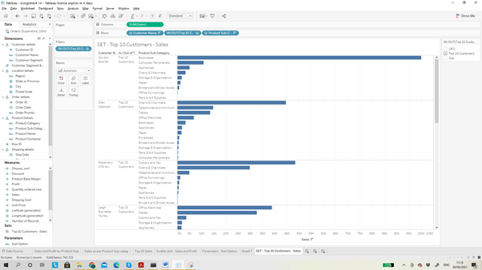

Similarly we can create Top 10 customers in terms of profit and create a set.

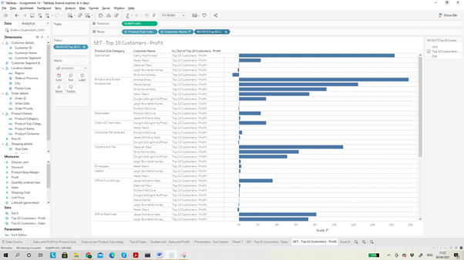

Now we have 2 sets Top 10 customers for Sales and Profit.

Combine both the SET and use to show the customers who brings both Profit & Revenue.

Select both the parameters »»» right click on one of them »»» select combine set »»» name the new combined set as Sales and Profit.

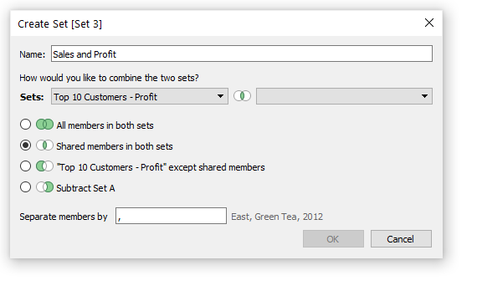

Showing the customers that are among the Top 10 Customers in terms of Sales and Top 10 Customers in term of Profit.

