**Problem Statement:**

**Use the CarMakers dataset and analyse the following:**

**- Create a Side by Side Bar chart using the fuel type Dimension.**

**- Show the Average Mileage in terms of City and Highway.**

**- List out three drawback of using the Side by Side bar chart.**

Click on "Text file" option under Connect section and browse through the path to connect to CarMakers csv dataset.

The dataset consists of a single table "CarMakers".

Go to sheet 1 and rename it of your choice.

step 1) Hold ctrl and select  "Fuel Type" dimension, "City-Mpg" measure and "Highway-Mpg" measure then select "side-by-side bar chart" from "Show Me" section.

step 2) Under "Measure Values" change "SUM(City-Mpg)" to "Average" option and "SUM(Highway-Mpg)" to "Average" option.

step 3) Click on Label under Marks card and tick mark "Show mark labels" checkbox.

step 4) Under "Measure Values", right click on the "AVG(City-Mpg)" and click on "Format" option.

Then "Format AVG(City-Mpg)" section gets displayed on the left corner.

step 5) Under this section, click on "Pane" and under "Default" property, go to "Numbers" and select the "Number(Custom)" and change the "Decimal places" to 0.

Lets do the same for "AVG(Highway-Mpg)" measure:

step 6) Under "Measure Values", right click on the "AVG(Highway-Mpg)" and click on "Format" option.

step 7) Then "Format AVG(Highway-Mpg)" section gets displayed on the left corner.

step 8) Under this section, click on "Pane" and under "Default" property, go to "Numbers" and select the "Number(Custom)" and change the "Decimal places" to 0.

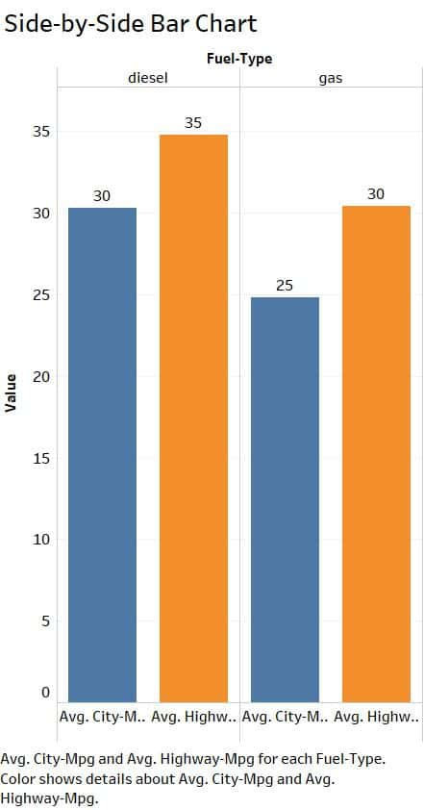

**Insights:**

• In terms of Average City-Mpg, diesel type cars are preferable

• In terms of Average Highway-Mpg also, diesel type cars are preferable.

**Three drawbacks of using the Side by Side bar chart:**

1) The side-by-side bar chart has the limitation of sidebar numbers.

2) It is difficult to read with a lot of components at one glance.

3) More bars will be complex and  hard to explore any useful information.