Use the Superstore_USA data and do the following: Create visuals in order to showcase the following visual segments

- Composition

- Comparison

- Relation

- Trend

- Geo Maps

Visual segment is a process in which data provides insights into solving a problem in a visual format – as trends, graphs, patterns and relationships in a data.

There are 6 main visual segments

-Composition – Eg, we have a sales data with 3 categories of sales and we want to know the contribution of each sale to the final sales figure – PIE CHART; TREE MAP – To visualize how much contribution has been made by each feature towards a common feature.

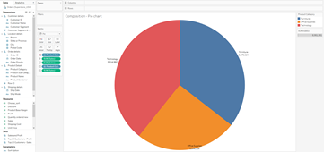

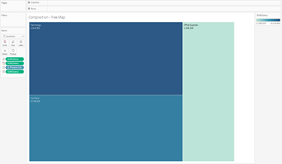

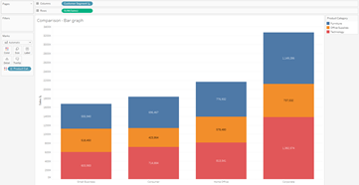

-Trend – Eg: Finding trends in terms of stock market, in terms of the falling wickets – Line Charts

Showing the trend of sales for Order date in terms of years for the different product categories.

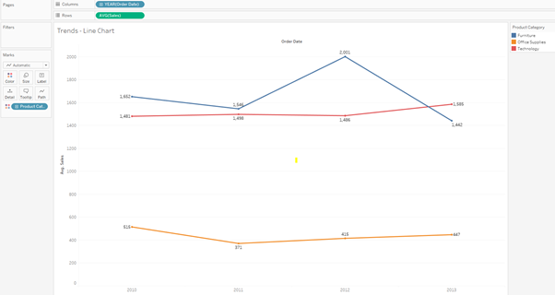

-Maps – Eg: Working with geographical data – towns, regions etc – MAPS

Ensure the data type of the dimensions is correct. We need to assign geographic role to region as it was detected as a string datatype.

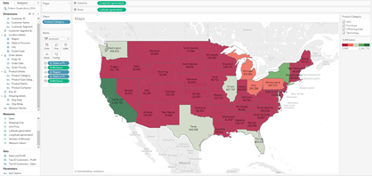

-Relation – Helps to find the relationship between 2 measures in a dataset. Eg: If we want to know the relation between Sales and profit in terms of quantity.

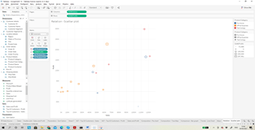

A dashboard with all the images:

