Use the Demographic_Details and perform the following analysis

- Find the Death Rate for each State

- Perform String calculation by creating separate column for the cities without the city code

- Create a Death Rate Category as High, Mid and Low with the help of Logical Calculations

Create a hierarchy for State and City as Location. Assign a geographical role for City to change its datatype from string.

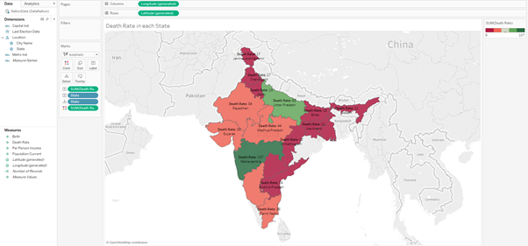

- Perform String calculation by creating separate column for the cities without the city code

For this first select String from ALL when you open the calculated field section.

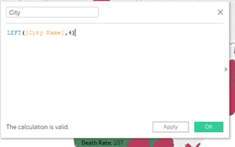

4 is the number of characters that we want to extract from the left.

Now we will get a dimension. But with this we will extract only the first 4 characters of the city name. We need the full city name.

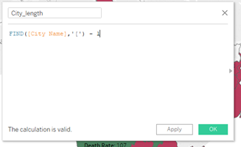

When we encounter the delimiter  ‘[‘, stop and give the length of the City Name.

This time a measure, City_length is created.

Now we will refer a calculated field within another calculated field.

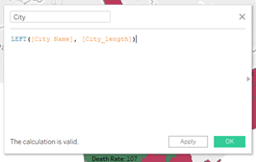

Include City under the Location hierarchy. We can hide the City Name column.

We can illustrate a simple table with the City names and Death rate to show that our calculation worked.

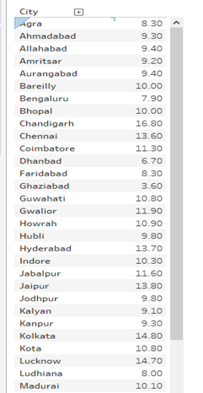

- Create a Death Rate Category as High, Mid and Low with the help of Logical Calculations

Create a calculated field - Death Rate Category

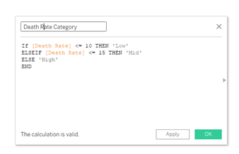

But for the state level we still have inconsistencies as below. For the state of Andhra Pradesh, we see the category as both High and Low.

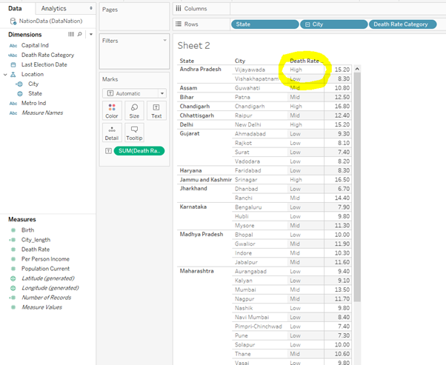

So this can be dealt by using Aggregate values – MIN, MAX, AVERAGE, SUM.

Aggregate value calculation will always return a measure as they are dealing with numerical values and will never return a dimension.

We create a new calculated field – Average Death Rate

