**Problem Statement:**

**Use the MotoCad data set and do the following**

**- Create a Alias for VS, AM dimension**

**- Create Group for the Carb as Light and Heavy Cars**

**- Create a Hierarchy with Light & Heavy Cars, Carb and Car Name**

Connect to "MotoCad" text data by clicking on "Text file" under Connect section

**Creating Aliases for Vs and Am dimension:**

We can create aliases for dimensions only and we can't create aliases for measures.

Here we have Vs and Am under measures. So, lets convert these measures to dimensions using below step.

step 1) Right click on "Vs" measure and click on "Convert to Dimension" option.

step 2) Right click on "Am" measure and click on "Convert to Dimension" option.

There are two ways to create aliases:

• one way is by right clicking on the dimension and clicking on "Aliases" option to create.

• other way is bringing dimension to the sheet as text and right click on the values and select "Edit Alias" option.

Lets try both ways on these dimensions.

"Vs" dimension has two values 0 and 1.

Lets consider 0 as "Standard Engine" and 1 as "VS Type Engine".

step 3) Right click on "Vs" dimension and click on "Aliases"

A window with the name "Edit Aliases [Vs]" pop ups.

step 4) In the window, under "Value(Alias)" header, click on "0" value and edit the value name as  "Standard Engine". Then, click on "1" value and edit the value name as "VS Type Engine".

Click on OK.

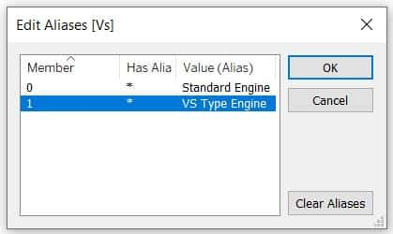

"Am" dimension also has two values 0 and 1.

Lets consider 0 as "Manual Engine Type" and 1 as "Automated Engine type"

step 5) Drag and drop "Am" dimension on to sheet i.e on to Rows shelf.

step 6) Right click on 0 value and click on "Edit Alias" option.

Then "Edit Alias" window pop ups. give the name as "Manual Engine Type". Click on ok.

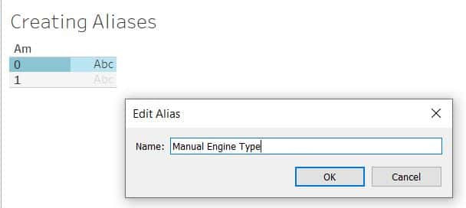

step 7) Similarly, change the alias name for value 1 as "Automated Engine type". Click on ok.

Now, Go to "Data Source" page and tick mark "Show Aliases" checkbox.

Now, you can see that the "Vs" and "Am" columns show the created aliases.

We can create a report with these aliases

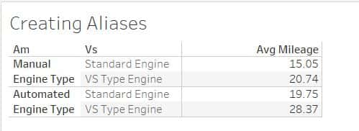

Showing Average Mileage for Am and Vs Aliases

**Creating Group for the Carb as Light and Heavy Cars:**

Features of Grouping:

• Grouping can be performed on dimensions.

• It is the best way to reduce the members of a dimension.

• It always returns us a new dimension.

• it never change the final value of the dimension.

• Group dimension can be used as a normal dimension in the dataset.

Take a new worksheet and name it of your choice.

Lets group the carburetor i.e Carb as Light and Heavy Cars.

Here we have Carb as a measure. so lets convert it into dimension

step 1) Right click on "Carb" measure and click on "Convert to Dimension" option.

When you drag and drop "Carb" dimension to Rows shelf. you can see the values of Carb as 1, 2, 3, 4, 6, 8.

Lets group 1,2,3 values of Carb as Light Cars and 4,6,8 values of Carb as Heavy Cars.

step 2) Right click on "Carb" dimension, click on "Create" then click on "Group".

Now, A window "Create Group [Carb]"  pop ups.

step 3) Give the Field Name as "Car Types"

step 4) Hold down shift key and select 1,2,3 values and click on "Group" option.

Then a (paper pin icon) field with name 1,2,3 gets created. Rename the field as "Light Cars".

step 5) Again hold down shift key and select 4,6,8 values and click on "Group" option.

Again a (paper pin icon) field with name 4,6,8 gets created. Rename the field as "Heavy Cars".

Click on Apply and click on ok.

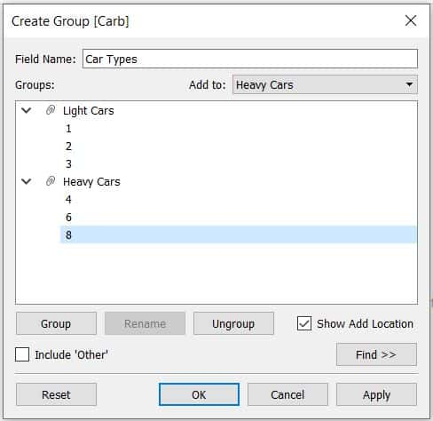

Now, we can see a group dimension "Car Types" with a pin icon gets created under Dimensions.

**Creating a Hierarchy with Light & Heavy Cars, Carb and Car Name:**

Uses of creating hierarchies:

• Hierarchies will always gives the output as a new dimension.

• Hierarchies will never effect the final dimension value or any part of the report.

• To make the report optimize and interactive.

Take a new worksheet and name it of your choice.

step 1) Hold ctrl and select Car Name, Car Types and Carb dimensions and right click on these selected dimensions. Now, click on "Hierarchy" then click on "Create Hierarchy" option.

Now "Create Hierarchy" window pop ups. Give the name as "Car Details" and click on ok.

We can also sort the hierarchy as per the requirement.

step 2) Here, Sort the hierarchy like below:

Car Types as first, Carb as second, Car Name as third.

step 3) Now, drag and drop "Car Types" to Rows shelf.

step 4) Click on the + icon of "Car Types" pill. it shows Carb dimension on the sheet.

step 5) Click on the + icon of "Carb" pill. it shows "Car Names" dimension on the sheet.

step 6) Now, drag and drop "Mpg" measure on to Text under Marks card. Change the "SUM(Mpg)" to Average.

step 7) Drag and drop "Measure Names" to Columns shelf so that we can give a header name to "AVG(Mpg)" column. here I gave the name as "Avg Mileage".

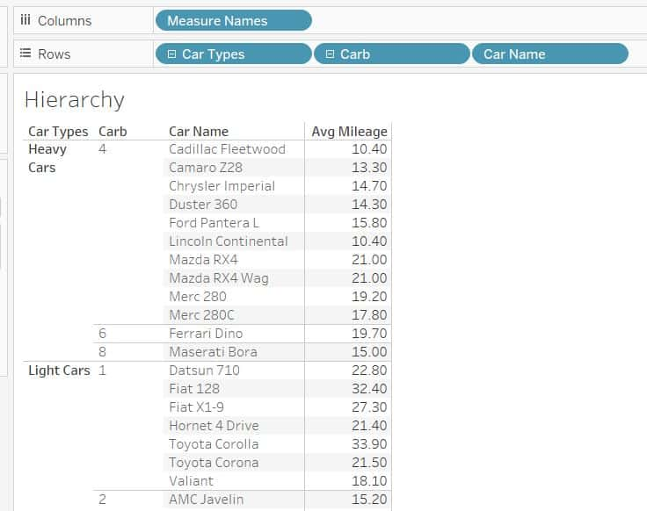

Car Types Hierarchy with Avg. Mileage for each Car Name