**Problem Statement:**

**Use the Store_Data data and do the following**

**- Create Bar Chart showing the Top N and Bottom N products in terms of the Product Names.**

**- Your Visual should show both the details in terms of the Top N and Bottom N product in a single chart.**

After connecting to "Store_Data" excel dataset,

Drag and drop "Orders" , "Returns" and "Users" tables to Data Model section to make connections between the tables. Rename the sheet 1 of your choice.

step 1) Drag and drop "Product Name" on to Rows shelf.

step 2) Drag and drop "Profit" measure on to Column shelf.

step 3) Drag and drop "Profit" measure on to both Color and Label fields under Marks card.

step 4) Sort the bar chart in descending order

lets create "Top N" parameter:

step 5) Click on the down arrow beside search bar and click on "Create Parameter" option.

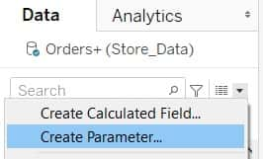

Then "Create Parameter" window pop ups.

step 6) Give the name as "Top N".

Give the Data type as "Integer".

Give the Current value as "10".

Set the Allowable values as "Range"

Then under Range of values:

Tick mark "Minimum", "Maximum" and "Step size" checkboxes.

Give the Minimum value as 1, Maximum as 20 and Step size as 1.

Then click on ok.

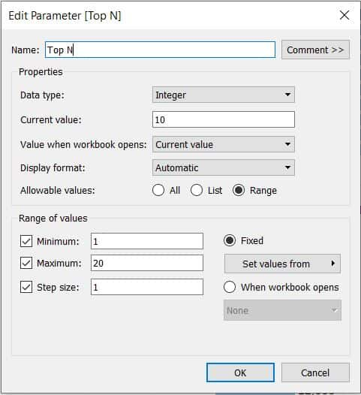

Now, Parameters section gets created with "Top N" parameter.

step 7) Right click on the "Top N" parameter and click on "Duplicate".

Now, a duplicate copy of "Top N" gets created. Lets edit this as "Bottom N"

step 8) Right click on the "Top N (copy)" parameter and click on "Edit".

step 9) Give the name as "Bottom N". and keep the changes as the same.

step 10) Click on ok.

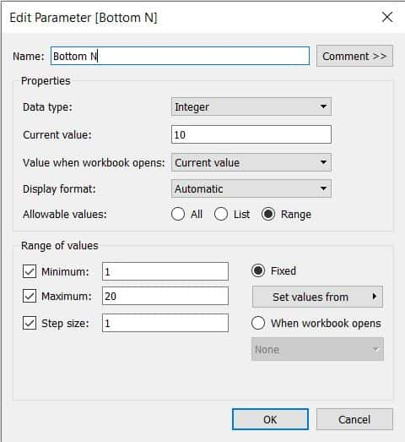

Then under "Parameters" section, "Bottom N" parameter gets created.

step 11) Right click on "Top N" parameter and click on "Show parameter".

step 12) Now click on the downward arrow icon of newly created "Top N" filter card and click on "Type In" option. (so that end user can enter the custom Top N value )

step 13) Click on the downward arrow icon of newly created "Bottom N" filter card and click on "Type In" option. (so that end user can enter the custom Bottom N value )

Now, we have to create "Top N" and "Bottom N" sets.

step 14) Right click on the "Product Name" dimension and click on "Create" and then click on "Set".

"Create Set" window pop ups.

step 15) Give the name as "Top N by Parameter".

Click on "Top" in the window.

Select "By field" radio button and Replace the field value with "Top N" from the list.

Click on ok.

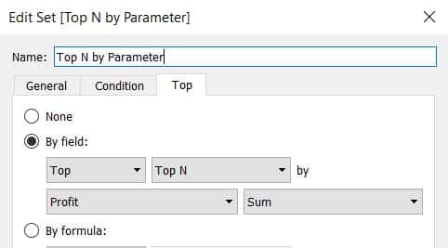

Now, "Top N by Parameter" set gets created.

step 16) Right click on the "Top N by Parameter" set and click on "Duplicate".

Now, a duplicate copy of "Top N by Parameter" gets created. Lets edit this as "Bottom N by Parameter".

step 17) Right click on the "Top N by Parameter (copy)" set and click on "Edit".

"Top N by Parameter (copy)" window pop ups.

step 18) Give the name as "Bottom N by Parameter".

Under "By field", replace "Top" with "Bottom" and "Top N" with "Bottom N".

Click on ok.

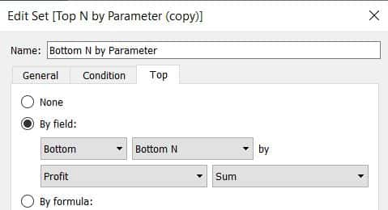

Now, "Bottom N by Parameter" set gets created.

Lets combine both the sets as we need to show Top N and Bottom N of products in a single chart.

step 19) Hold ctrl and click on "Top N by Parameter" set and "Bottom N by Parameter" set and click on "Create Combined Set" option.

Create set window pop ups

Give the name as "Top N & Bottom N" and click on ok.

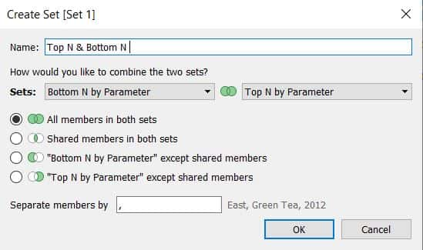

step 20) Drag and drop "Top N & Bottom N" set to Filters card.

As we have predefined the value with 10, we can Top 10 and Bottom 10 products in terms of Profit as shown below:

