PROGRAM 1

SHELL SCRIPT
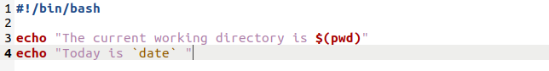
OUTPUT
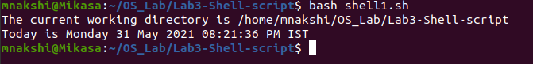
PROGRAM 2

SHELL SCRIPT
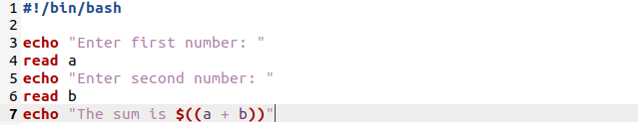
OUTPUT
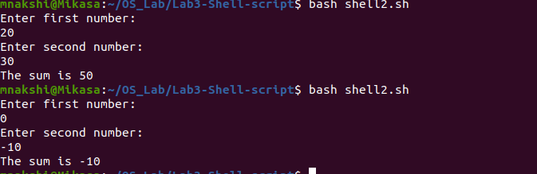
PROGRAM 3

SHELL SCRIPT
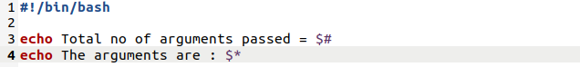
OUTPUT
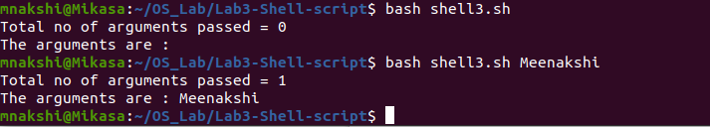
PROGRAM 4

SHELL SCRIPT
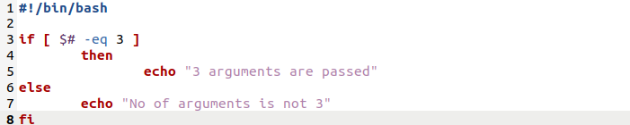
OUTPUT
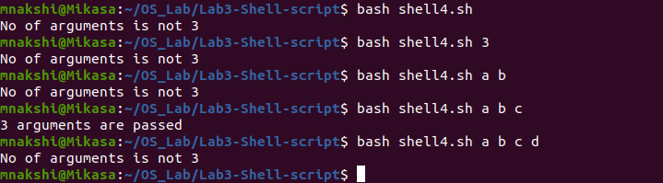
PROGRAM 5

SHELL SCRIPT
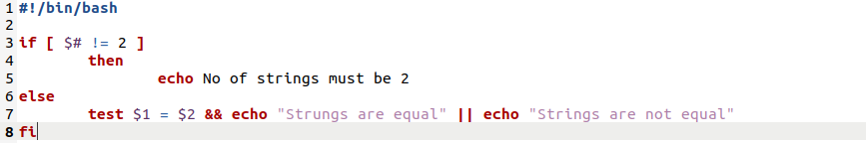

OUTPUT
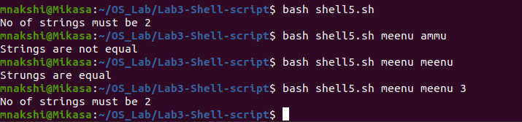
PROGRAM 6

SHELL SCRIPT
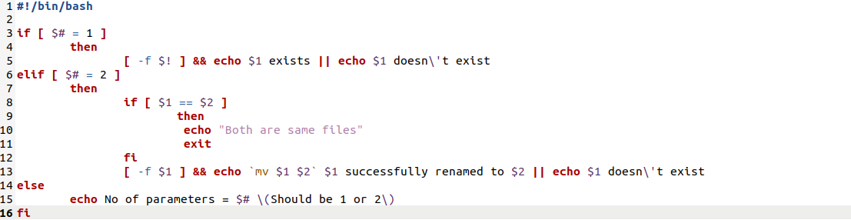
OUTPUT
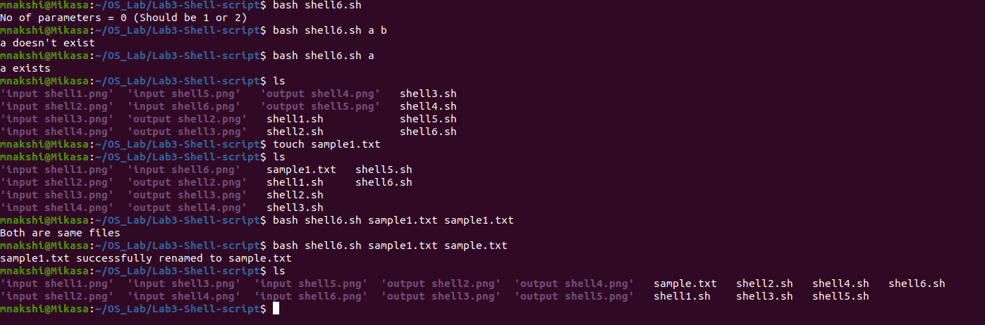

PROGRAM 7

SHELL SCRIPT
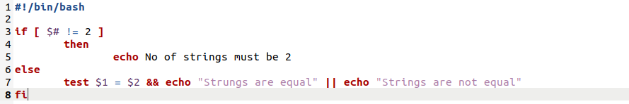
OUTPUT
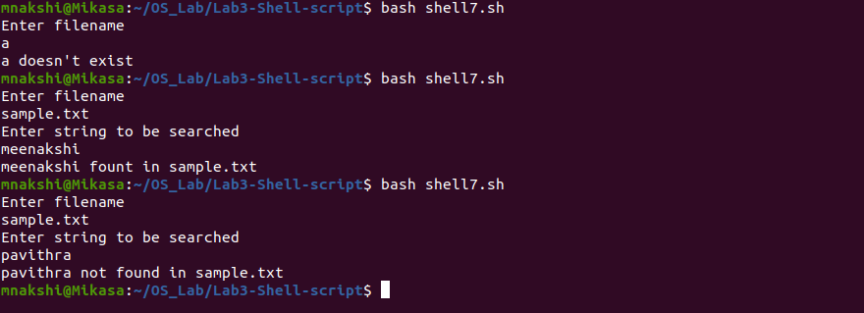
PROGRAM 8

SHELL SCRIPT
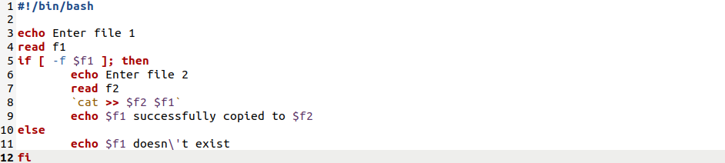
OUTPUT
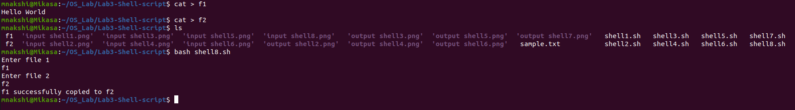

PROGRAM 9

SHELL SCRIPT
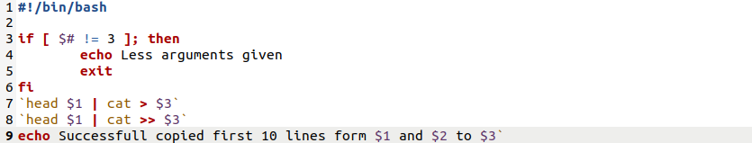
OUTPUT
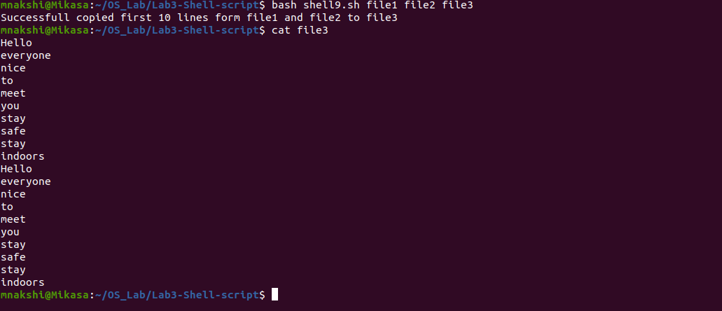
PROGRAM 10

SHELL SCRIPT
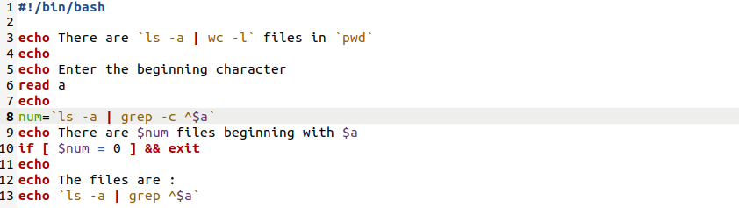

OUTPUT
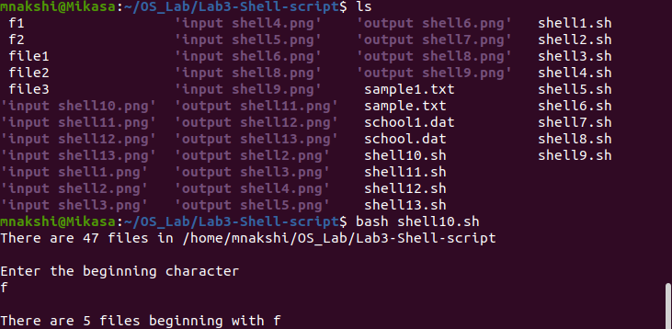
PROGRAM 11

SHELL SCRIPT
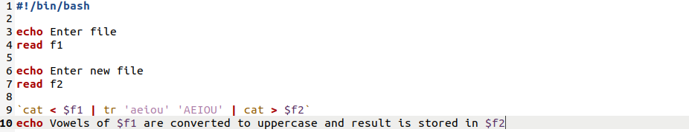
OUTPUT
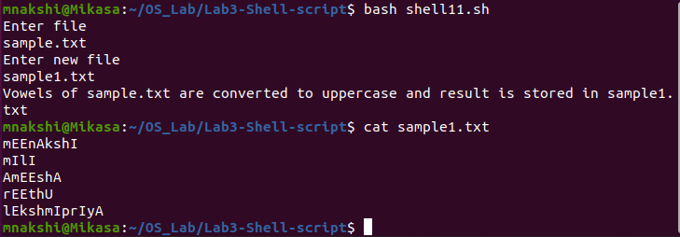

PROGRAM 12

SHELL SCRIPT
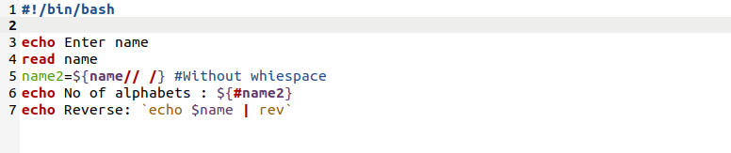
OUTPUT
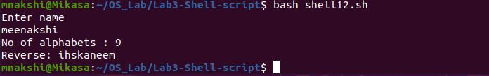
PROGRAM 13

SHELL SCRIPT
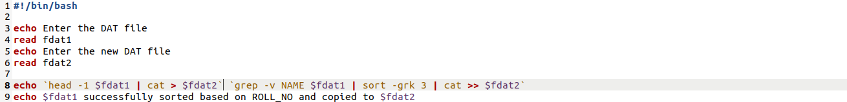
OUTPUT
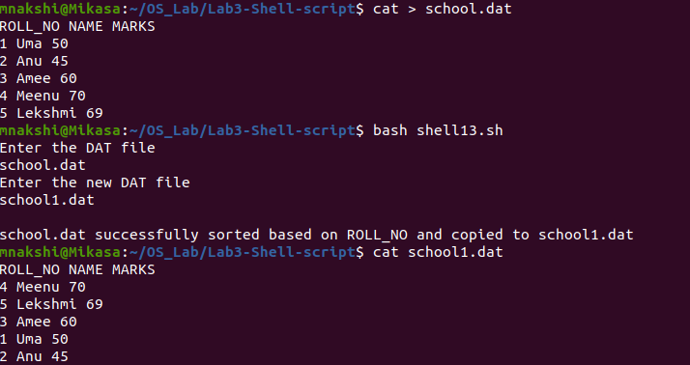

PROGRAM 14

SHELL SCRIPT
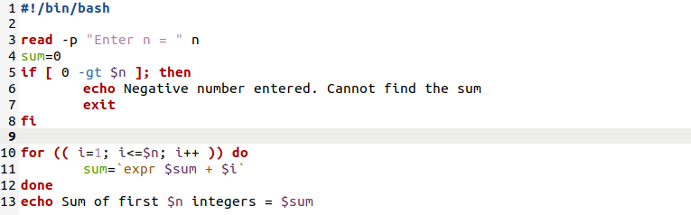
OUTPUT
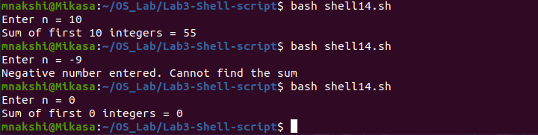
PROGRAM 15

SHELL SCRIPT
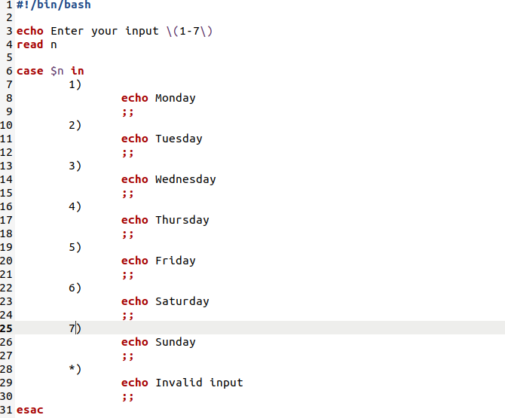

OUTPUT
