**Project Report**

## On

“Multi Vendor ecommerce website”

Submitted in the Partial fulfillment of the requirement for the Award of Degree of

# Bachelor of Technology

in

# COMPUTER SCIENCE & ENGINEERING

Batch (2018-2022)



## Submitted to Submitted by

HOD Sir

Sarika -1800307 Vishal kumar-1800335 Vishal Plathia-1800336 Subodh Yadav-1800323

## ACKNOWLEDGEMENT

This is a humble effort to express our sincere gratitude towards those who have guided and helped me to complete this project.

A project is major milestone during the study period of a student. As such this project was a challenge to us and was an opportunity to prove our caliber. We are highly grateful and obliged to each and every-one making me help out of problems being faced by us.

It would not have been possible to see through the undertaken project without the guidance of **Er. Sanjeev Kumar**. It was purely on the basis of their experience and knowledge that we able to clear all the theoretical and technical hurdles during the development phases of this project work.

Last but not the least we are very thankful to our Head of Department **Dr. Amarpreet Singh** and all Members of Computer Science Department. who gave us an opportunity to face real time problems while fulfilling need of an organization by making projects for them.

## DECLARATION

We all hereby declare that the project work entitled **“Multi vendor ecommerce website”** is an authentic record of our own work carried out as requirements of Institutional project for the award of degree of B.Tech(CSE), **Amritsar Group of Colleges, Amritsar,** under the guidance of **Er. Sanjeev Kumar** .

(Signature of student) Sarika 1800307

Vishal kumar 1800335

Vishal plathia 1800336

Subodh Yadav 1800323

**INDEX PAGE**

|  |  |  |
| --- | --- | --- |
| Sr.  No. | content | Page no. |
| 1. | Introduction | 5 |
| 2. | Objective of the project | 8 |
| 3. | DFD | 10 |
| 4. | code | 14 |
| 5. | description | 37 |

Introduction Of ONLINE GROCERY PROJECT

In Fast Pace Of Time Today Everyone Is Squeezed For Time People, People Want To Easily Shopping Without Going To Shop The Software Has Ability To Host Allow A User To Maintain The Online Shopping System In The Online Grocery Shop To Provide Many Facilities Like Home Delivery At The Time Debit-Card/Credit-Card /Cod/ In This Online Project Add To Cart Or Remove The Item From The Cart In This Project Different Shops Are Available In Each Shop Different Rates Of Their Products This Project Help To Purchase Online Grocery Item in this project we can also purchase item from diiferrent shops different price

### Objective Of Project On Online Grocery System

The main objective of the project on online grocery system to purchase the online products, and pay online system in this project admin can update the products admin can see the product and also available different shops local locaility

SYSTEM ANALYSIS

Exis2ng System

The online grocery system is provide the comfort for customer to purchase product through online mode not only for customer this also help shop owner to add their product through online mode In india there many websites of online grocery but this also help the customer to see the product from which shop when customer purchase product from different shop their order dilvered to owner of the shop

SoPware Development Cycle

It is a process used by the soPware industry to design, develop and test high quality soPware. The SDLC aims to produce a high-quality soPware that meets or exceeds customer expecta2ons, reaches comple2on within 2mes and cost

### Functionalities Provided By Online Grocery System Are As Follows

* There are several objective of this website are following given belows
* The site give all the information about the grocery shop provides better services for customer
* It provide the facility to the customer who wants to buy grocery products to lack of time
* It provide facility to the customer to payment by the cash or debit card
* It provides full detail about the grocery product and related information about the products like cost weight
* IN this online grocery system we can also buy product from different shops

# Scope Of The Project Online Grocery System

This System Will Reduce The Manual Operation Required To Take Care All The Records Of Booking Information And Also Generates The Various Reportsfor Analysis Main Concept Of The Project Is To Enter Transcation ReportsAnd To Take Care Of Customers Records Hence This Softwares Can Be Used In Any Mobile Or Device To Maintain The Record Easily The Data Is Directly Stored In The Database The System Alow Rto The Customer To Maintain Cart For Add Or Remove The Products THE Online Shopping System Well Design Database Can Help The Management Guide Customers In this system we can also buy product from different shops at different price

Hardware Requirements

* Keyboard
* Mouse
* Monitor
* CPU

SoPware Requirements

* + XAMPP SERVER
* Visual studio
* BROWSER Languages Use
  + PHP7
  + SQL
  + CSS
  + HTML
  + JAVASCRIP
* Feasibility
* The feasibility study is a management-oriented ac2vity. The objec2ve of a feasibility study is to find out if an informa2on system project can be done and to suggest possible alterna2ve solu2ons.
* A feasibility study should provide:
* Whether the project can be done
* Whether the ﬁnal product will beneﬁt its intended users and organiza2on
* What are the alterna2ves among which a solu2on will be chosen?
* Is there a preferred alterna2ve?

▪

## Technical Feasibility

* The ﬁrst thing to check that being, is the project feasible within the limits of current technology, and our project is feasible as website development technology is highly advanced.
* This technology doesn’t exist at all as there is no plajorm for student and alumni of an ins2tute to communicate.
* So, this system is totally new. This is a medium sized website which would require at least 2-4 people and 4000-10000 man-hours. The hardware requirements for developing this

system are an opera2ng system, storage

* devices, keyboard, mouse, and the soPware requirements
* Server, Sublime Text Editor, Browser and the languages
* used are HTML, CSS, JavaScript, SQL, PHP.
* These are all the technical resources which are sufficient for developing this system.

## OperaAonal Feasibility

* Opera2onal feasibility is a measure of how well a proposed system solves the problems,

and takes advantage of the opportuni2es iden2fied during scope defini2on and how it sa2sfies the requirements iden2fied in the requirements analysis phase of system development**.**

## This project help for customers to purchase product online and also purchase from different shops different price also help the shopkeeper to register their shops

**and also add their product in website and also purchase customer from different shops**

* So, our project provides a great plajorm for customers to

DFD ADD TO CART

Userclick

products

add tocart

And also sent to the shop

owner



Order_users Order_managers

Item added inyour cart

All data sent to the admin

panel

Order_users Order_mangers

Click on cart form displayed for

informa2on

When informa2on is

added then cllick on

Then order is purchased

Order_mangers

Order_user

Usernam e/passwo rd

Shop owner

shops

in correct rederect

Check detail of login

Login page

DFD shop login

14

Order

Shop panel

displayed

Shop owner add your

product

Also display their order

orders

Order_managers

Processed/ dilvered/no

t

Order_manger

Order_users

Product

APer login in shop owner

l

DFD of admin login and register page

admin

Usernam e/passwo

rd

Admin_user

Check detail of login

Login page

Also show their orders

Order_manages Order_users

Shop register

page and also

add their

products

products

Added your shop informa2o

shops

Then shop owner sucessf

INPUTS TO ALL PAGES

Before Login

*Home Bunon: The user clicks on HOME bunon in naviga2on bar.*

About Bunon: The user clicks on ABOUT bunon in naviga2on bar. Contact Bunon: The user clicks on CONTACT bunon in naviga2on bar.

Admin login Up Bunon: The user clicks on SIGN UP bunon in naviga2on bar. Sign In Bunon: The user clicks on Sign IN bunon in naviga2on bar.

Shop login Up Bunon: The shop owner login bunon on naviga2on bar Sign In Bunon: The shop owner clicks on Sign IN bunon in naviga2on bar.

Language List: The user changes the language on selec list.

Register: The user Inserts general details like shop name, shop phonenumber

, , email,2me,username, password, address which are stored in shop table Login: The user enters the email and password

Contact: The user enters his details like full name and email and the message he wants to send to us.

Add to cart:The user click on add item add in their cart

Viewdetail:The user also see the product from which shop from shop detail

AFTER ADD TO CART

Item_added:The user click on add to cart item increase in cart

Quan2ty:The user can increase the quan2ty when quan2ty increase price also

increase Item_price:The user see the item price

Remove: the user can also remove the item from the from the add to cart

FORM:The user can enter the detail and detail stored in user and order_mangers table

Purchase_bunon:when user click on purchase order detail record on the users and order_managers table

AFTER SHOP LOGIN

Shop_login :when shop owner ﬁll correct username and password then shop panel displayed in the screen

Add your product:The user also add their product name

,product image , product code

Orders:The shop keeper also see their order on click

orders

Order_panel :The shopkeepar see their product name product price,product date 2me ,name of the person

,address of the person whose order,phone number of the person

Status:The shopkeeper also set status of order processed,dilvered,not dilvered

User interface

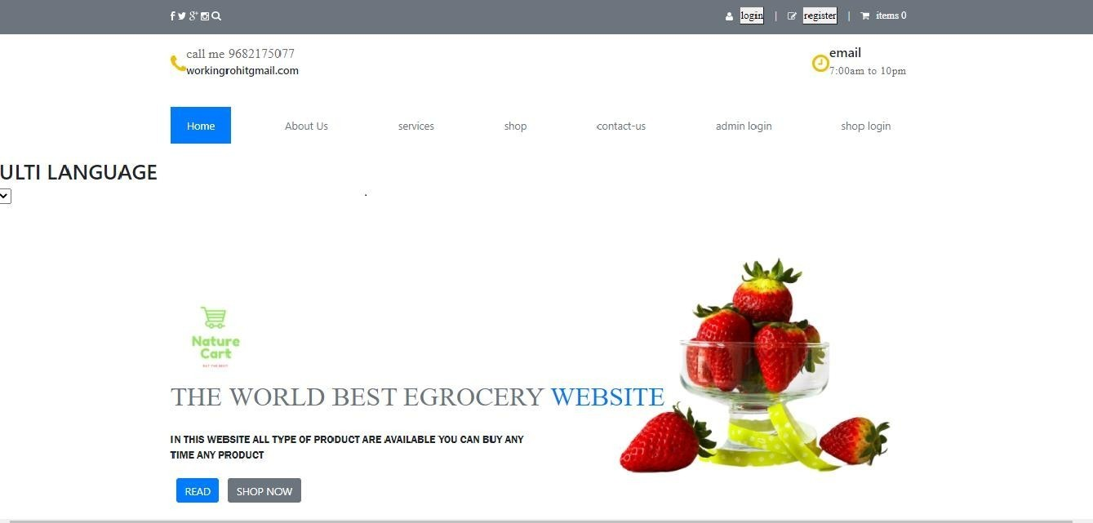

Code:

<?Php

Include('mult.php'); Include('language.php'); Session_start();

?>

<!Doctype html>

<html lang="en">

<head>

<meta charset="uj-8">

<meta hnp-equiv="x-ua-compa2ble" content="ie=edge">

<meta name="viewport" content="width=device-width, ini2al-scale=1.0">

<2tle>local groc store</2tle>

<link rel="stylesheet" href="stylcon.css">

<link rel="stylesheet" href="style.css">

<link rel="stylesheet"

href="hnps://maxcdn.bootstrapcdn.com/bootstrap/4.5.2/css/bootstrap.min.css"

>

<link rel="stylesheet" href="https://cdnjs.cloudflare.com/ajax/libs/font- awesome/4.7.0/css/font-awesome.min.css">

<link rel="stylesheet" href=" https://cdnjs.cloudflare.com/ajax/libs/slick- carousel/1.8.1/slick.css">

</head>

<body>

<header class="topbar">

<div class="container ﬂex jus2fy-between items-center">

<div>

<a href=""></a> <img src="./icons/facebook.svg" alt=""></a>

<a href="#"><img src="./icons/twiner.svg" alt=""></a>

<a href="#"><img src="./icons/google.svg" alt=""></a>

<a href="#"><img src="./icons/instagram.svg" alt=""></a>

<a href="#"><img src="./icons/search.svg" alt=""></a>

</div>

<div class="auth ﬂex items-center">

<div>

<img src="./icons/user-icon.svg" alt="">

<bunon type="bunon" onclick="popup('login-pop')"><?php echo

$top_nav[$language]['0'] ?></bunon>

</div>

<span class="divider">|</span>

<div>

<img src="./icons/edit.svg" alt="">

<bunon class="butn-deco" type="bunon" onclick="popup('register-pop')"><?php echo $top_nav[$language]['1'] ?> </bunon>

</div>

<span class="divider">|</span>

<div>

<!-- add to cart -->

<?Php

$count=0; If(isset($_session['cart']))

{

$count=count($_session['cart']);

}

?>

<img src="./icons/cart.svg" alt="">

<a href="mycart.php"><?php echo $top_nav[$language]['2'] ?> <?Php echo

$count ?></a>

</div>

</div>

</div>

</header>

<div class="popup-container" id="login-pop">

<div class="popup">

<form ac2on="" method="post">

<h2>

<span>userlogin</span>

<bunon type="reset"onclick="popup('login-pop')">x</bunon>

</h2>

<input type="text" name="username" placeholder="email or username">

<input type="passsword " name="password" placeholder="password">

<bunon type="submit" name="submit" class="login-btn">login</bunon>

</form>

<!-- <div class="ﬁeld_error">

</div> -->

</div>

</div>

<div class="popup-container" id="register-pop">

<div class=" register popup">

<form ac2on="">

<h2>

<span>user register</span>

<bunon type="reset"onclick="popup('register-pop')">x</bunon>

</h2>

<input type="text" placeholder="full name">

<input type="username " placeholder="username">

<input type="email " placeholder="email

{

get_popup =document.getelementbyid(popup_name); if(get_popup.style.display=="ﬂex")

{

get_popup.style.display="none";

}

else{ get_popup.style.display=" ﬂex";

}

}

</script>

<script src="hnps://code.jquery.com/jquery-3.5.0.min.js"></script> Code:top

<?Php Include('language.php');

$en_select='';

$hi_select='';

$language='';

If((isset($_get['language']) && $_get['language']=='en') ||

!isset($_get['language'])){

$en_select='selected';

$language='en';

}else{

$hi_select='selected';

$language='hi';

}

?>

</nav>

<div class="top " >

<div class="container ﬂex jus2fy-between">

<div class="contact ﬂex items-center">

<img src="./icons/phone.svg" alt="">

<div>

<h5><?php echo $top_nav[$language]['3'] ?> 9682175077</h5>

<h6><?php echo $top_nav[$language]['4'] ?>rohitgmail.com </h6>

</div>

</div>

<div class="branding">

<img src="." alt="">

</div>

<div class="2me ﬂex items-center">

<img src="./icons/clock.svg"alt="">

<div>

<h5><?php echo $top_nav[$language]['5'] ?></h5>

<h6>7:00am to 10pm </h6>

</div>

</div>

</div>

</div>

<div class="navbar magic-shadow">

<div class="container ﬂex jus2fy-center">

<a href="index.php" class="ac2ve"><?php echo $top_nav[$language]['6'] ?></a>

<a href="aboutus.php"><?php echo $top_nav[$language]['7'] ?></a>

<a href="newservices.php"><?php echo $top_nav[$language]['8'] ?></a>

<a href="regs.php"><?php echo $top_nav[$language]['9'] ?></a>

<a href="#"><?php echo $top_nav[$language]['11'] ?></a>

<a href="admlogin.php"><?php echo $top_nav[$language]['12'] ?></a>

<a href="admproduct.php"><?php echo $top_nav[$language]['13'] ?></a>

</div>

</div>

</div>

<div id="mul2">

<h2>mul2 language</h2>

<select onchange="set_language()" name="language" id="language">

<?Php

$en_select='';

$hi_select='';

If((isset($_get['language']) && $_get['language']=='en') ||

!isset($_get['language'])){

$en_select='selected';

}else{

$hi_select='selected';

}

?>

<op2on value="en"<?php echo $en_select?>>en</op2on>

<op2on value="hi"<?php echo$hi_select?>>hi</op2on>

<op2on></op2on>

<op2on></op2on>

</select>

</div>

</nav>

<script src="hnps://code.jquery.com/jquery-3.5.0.min.js"></script>

<script>

func2on set_language(){

var language=jquery('#language').val(); window.loca2on.href='hnp://127.0.0.1/ groccx/grocc/ grocc.php?language='+lang uage;

}

</script> code:slider

<?Php

Require_once 'class.user.php';

$reg_user = new user();

$mainqry ="select * from product";

$stmt = $reg_user->runquery($mainqry);

$stmt->execute();

$transac2on = $stmt->fetchall(pdo::fetch_assoc); If($transac2on>0)

{

?>

<sec2on class="top-products">

<div class="container">

<h1 class="sec2on-heading"> top products</h1>

<div class="slider">

<div class="food-slider">

<?Php

foreach($transac2on as $arrvalues)

{

?>

<link rel="stylesheet" href="hnps://maxcdn.bootstrapcdn.com/ bootstrap/4.5.2/ css/bootstra p.min.css">

<2tle>Admin Panel</2tle>

<style> body{ marg in: 0;

}

div.header{ col

or: #f0f0f0;

font-family: poppins; display: ﬂex;

ﬂex-direc2on: row; align-items: center;

jus2fy-content: space-between; padding: 0 60px;

background-color: #1c1c1e;

}

div.header

bunon{ background-color: #f0f0f0; font-size: 16px; font-weight: 550; padding: 8px 12px; border: 2px solid black; border-radius: 5px;

}

</style>

</head>

<body>

<div class="header">

<h1>Shop PANEL - <?php echo htmlspecialchars($_SESSION['shop_name']) ?></h1>

<form ac2on="<?php echo $_SERVER['PHP_SELF'] ?>" method="post">

<bunon type="submit" name="Logout">LOG OUT</bunon>

</form>

</div>

<div class="row">

<div class="col-lg-12">

<table class="table table-dark table-striped">

<thead>

<tr>

<th scope="col">Order_id</th>

<th scope="col">customer Name</th>

<th scope="col">phoneNO</th>

<th scope="col">Address</th>

<th scope="col">pay mode</th>

<th scope="col" width='12%'>Order status</th>

<th scope="col">Update</th>

<th scope="col">orders</th>

</tr>

</thead>

<tbody>

<form method="POST" ac2on='' id='frm' enctype='mul2part/form- data'>

<?php include"conec2on.php"

; #

$query="SELECT * FROM order_managers WHERE EXISTS (SELECT Order_Id FROM order_users WHERE order_managers.Order_Id = order_users.Order_Id and shop_id = '$shop_id')"; // Get User detail from order manager where Order ID is comman in both tables.

$user_result= mysqli_query($con,$query); while($user_fetch=mysqli_fetch_assoc($user_result))

{

$order_id = $user_fetch['Order_Id']; echo"

<tr>

<td>$user_fetch[Order_Id]</td>

<td>$user_fetch[Full_Name]</td>

<td>$user_fetch[Phone_No]</td>

<td>$user_fetch[Address]</td>

<td>$user_fetch[Pay_Mode]</td>

<td><select type='text' name='order_status' id='order_status' class='form-control'>";

$status = $user_fetch['order_status']; foreach($arrStatus as $arrItem){

if($arrItem == $status) { echo "<op2on value='$arrItem'

selected='selected'>$arrItem</op2on>";

}

else{

echo "<op2on value='$arrItem'>$arrItem</

op2on>";

}

}

echo" </select>

</td>

<td>

<bunon type = 'submit' name = 'btn-update' value

='$user_fetch[Order_Id]' class='btn btn-success'>Update</bunon>

</td>

<td>

<table class='table table-dark table-striped'>

<thead>

<tr>

<th scope='col'>Item Name</th>

<th scope='col'>Price </th>

<th scope='col'>Quan2ty</th>

<th scope='col'>Order Date</th>

</tr>

</thead>

<tbody>";

$order_query="SELECT * FROM order_managers as a inner join order_users as b on a.Order_Id=b.Order_Id WHERE b.Order_Id='$order_id' and b.shop_id = '$shop_id'"; // Get Orders details form the orderd user table where order id is selected and shop logined.

$order_result=mysqli_query($con, $order_query); while($order_fetch=mysqli_fetch_assoc($order_result))

{

echo"<tr>

<td>$order_fetch[Item_Name]</td>

<td>$order_fetch[Price]</td>

<td>$order_fetch[Quan2ty]</td>

<td>$order_fetch[Timedate]</td>

</tr>";

}

echo"</tbody>

</table>

</td>

</tr> ";

}

?>

</form>

</tbody>

</table>

</div>

</div>

<?php

#when click on logout if(isset($_POST['Logout']))

{

session_destroy(); header("loca2on: grocc.php");

}

?>

</body>

</html>

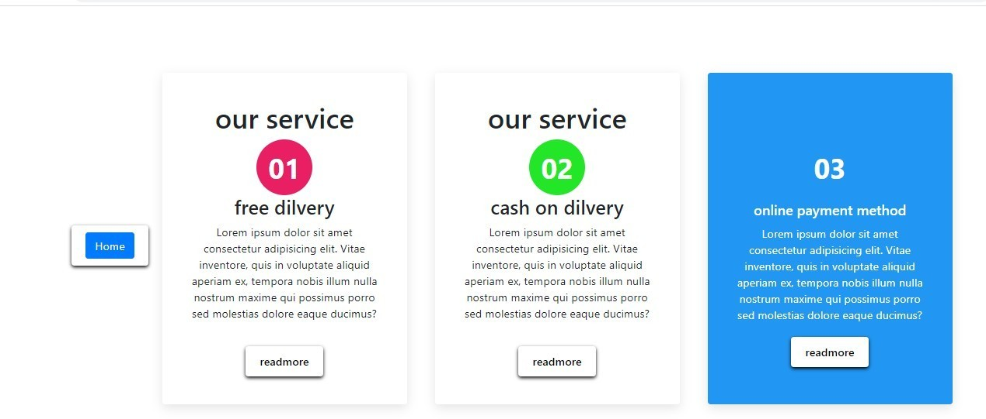

*CODE:our services*

<!DOCTYPE html>

<html lang="en">

<head>

<meta charset="UTF-8">

<meta hnp-equiv="X-UA-Compa2ble" content="IE=edge">

<meta name="viewport" content="width=device-width, ini2al- scale=1.0">

<2tle>Document</2tle>

<link rel="stylesheet" href="hnps://maxcdn.bootstrapcdn.com/ bootstrap/4.5.2/ css/bootstra p.min.css">

body{

margin: 0;

padding: 0; display: ﬂex;

jus2fy-content: center; align-items: center; min-height: 100vh;

}

.cona2ner{

display: ﬂex; ﬂex-wrap: wrap;

jus2fy-content: space-between;

}

.cona2ner .box{

posi2on: rela2ve; width: 350px; padding: 40px; background: #ﬀf;

box-shadow: 0 5px 15px rgba(0,0,0,.1); border-radius: 4px;

margin: 20px;

box-sizing: border-box;

overﬂow: hidden;

text-align: center;

}

.cona2ner .box .icon{

posi2on: rela2ve; color: #ﬀf; width: 80px; height: 80px;

background: #000; display: ﬂex;

jus2fy-content: center; align-items: center; margin: 0 auto;

border-radius: 50%; font-size: 40px;

font-weight: 700; transi2on: 1s;

}

.cona2ner .box:nth-child(1) .icon

{

box-shadow: 0 0 0 0 #e91e63; background:#e91e63 ;

}

.cona2ner .box:nth-child(1):hover .icon

{

box-shadow: 0 0 0 400px #e91e63;

}

.cona2ner .box:nth-child(2) .icon

{

box-shadow: 0 0 0 0 #23e629; background:#23e629 ;

}

.cona2ner .box:nth-child(2):hover .icon

{

box-shadow: 0 0 0 400px #23e629;

}

.cona2ner .box:nth-child(3) .icon

{

box-shadow: 0 0 0 0 #2196f3; background:#2196f3 ;

}

.cona2ner .box:nth-child(3):hover .icon

{

box-shadow: 0 0 0 400px #2196f3;

}

.cona2ner .box .content

{

posi2on: rela2ve; z-index: 1; transi2on: 0.5s;

}

.cona2ner .box:hover .content

{

color: #ﬀf;

}

.cona2ner .box:hover .content h3{

font-size: 20px; margin: 10px 0;

padding: 0;

}

.cona2ner .box:hover .content p{

margin: 0;

padding: 0;

}

a{

display: inline-block; padding: 10px 20px; background: #ﬀf; border-radius: 4px; text-decora2on: none; color: #000;

font-weight: 500; margin-top: 20px;

box-shadow: 0 2px 5px rgba(0,0,0,2);

}

</style>

</head>

<body>

<a href="grocc.php"> <bunon type="bunon" class="btn btn- primary">Home</ bunon></a>

<div class="cona2ner">

<div class="box">

<h1>our service</h1>

<div class="icon">01</div>

<div class="content">

<h3>free dilvery </h3>

<p>Lorem ipsum dolor sit amet consectetur adipisicing elit. Vitae inventore, quis in voluptate aliquid aperiam ex, tempora nobis illum nulla nostrum maxime qui possimus porro sed moles2as dolore eaque ducimus?</p>

<a href="#">readmore</a>

</div>

</div>

<div class="box">

<h1>our service</h1>

<div class="icon">02</div>

<div class="content">

<h3>cash on dilvery </h3>

<p>Lorem ipsum dolor sit amet consectetur adipisicing elit. Vitae inventore, quis in voluptate aliquid aperiam ex, tempora nobis illum nulla nostrum maxime qui possimus porro sed moles2as dolore eaque ducimus?</p>

<a href="#">readmore</a>

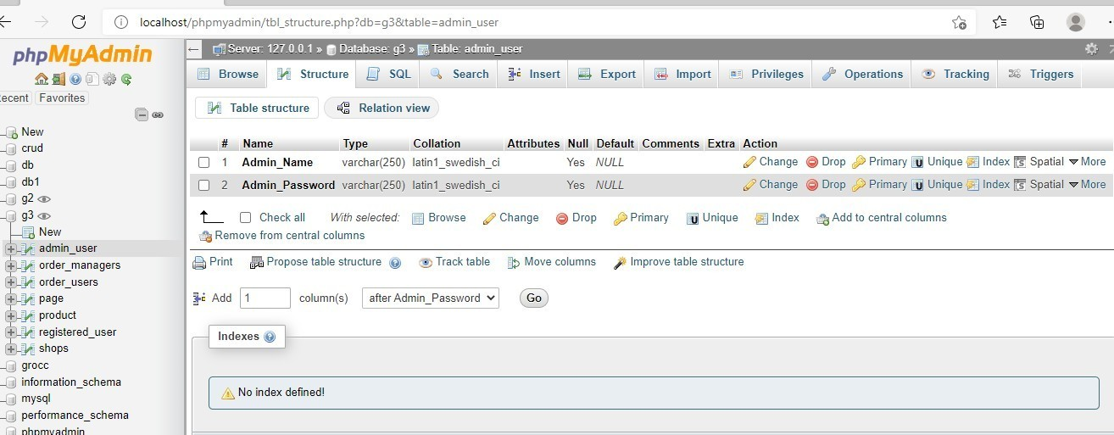

Order_users:

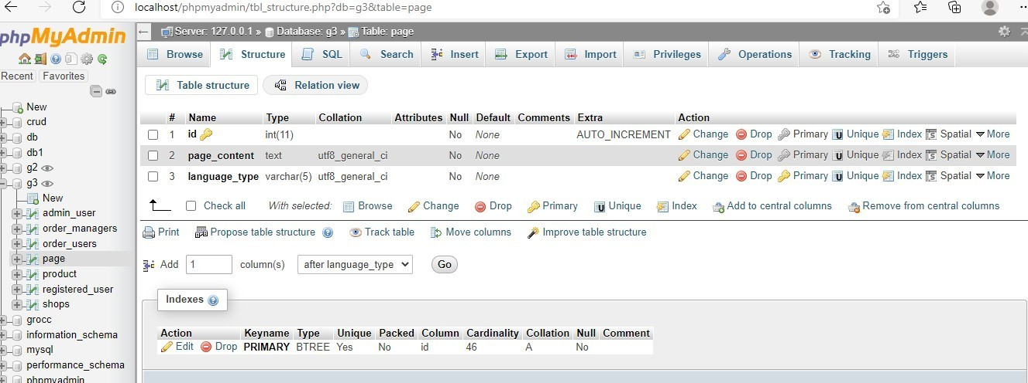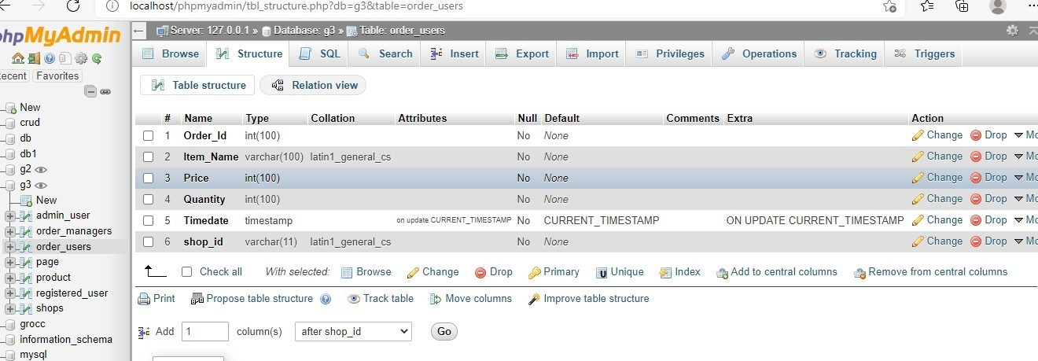

Order_managers:

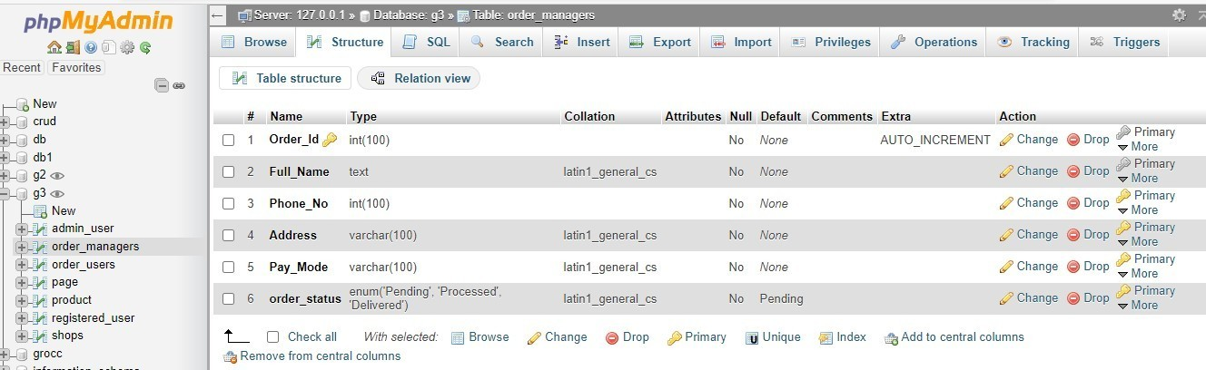

# DESCRIPTION

The aim of this project is to provide daily household needs to everyone.

We will build this system so that company can manage its customers and stocks .

It will also facilitate the customers so that in their busy life, they can easily buy their everyday staple foods i.e. Household needs using Internet Facility

This website will deal many brands of Grocery Items e.g Nestle, Cadbury, Tata, Nescafe

Customers can buy products from different shops at different price

IMPLEMENTATION ISSUES

There are some challenges faced during implemen2ng the project. Today, there are a lot of web hos2ng companies in the market which oﬀer seemingly great web hos2ng plans with over 99 percent up2me

and a number of addi2onal facili2es. But without enough informa2on about the web hos2ng field, it will always be difficult to decide the best hos2ng facility. The problems faced during the web hos2ng are:

1. Slow Website Loading and Naviga2on Speed: For a website to get more traffic, it is necessary that it is has fast naviga2on within the site. The web hos2ng service plays a big part with regard to the naviga2on speed of the website. If a site takes long 2me to load and too much 2me in internal naviga2on, it is bound to get less users. This will also result in lowering down the lis2ng of the site in the search results. Overall, this will greatly reduce the number of visitors coming to the site. According toa

study, 75% of people would not return to websites that took longer than 4 seconds to load. Moreover, it also revealed that 88% of online consumers are less likely to return to a site aPer a bad experience. 2. Excessive Cost of a Web Hos2ng Plan: There are some companies that offer free hos2ng services while there are others who are charging enormously for it

1. Too Much Time in Resolving Web Hos2ng Problems: There are some

companies which provide 24 x 7 x 365 days online support to resolve any of your queries at any 2me. While some just provide a contact form to register you complains and get it resolved at their convenience. There are other companies

which just help you with their FAQ’s and forums to resolve your issue. They aren’t quick enough to support you even when your website is facing a down2me and you are wai2ng for a solu2on.

1. Not Disclosing Limita2ons of a Web Hos2ng Plan: Many web hos2ng service

providers do not disclose the limita2ons of their web hos2ng services in advance. Due to this, customer fails to understand the scope of service offered by the web hos2ng

company. The next problem is of manpower. Due to less funding, the problem of manpower raised. We might have troubles ﬁnding skilled programmers for our web development project. The common reasons of such problems are the following: 1. We don’t know what type of specialists we need.

2. We don’t know where to search. 3. Services of tech experts cost too much. Web app development cannot be successful without skilled workforce. Thus, we compete for qualiﬁed employees, oﬀering them unique perks and high Page 90 of 91 salaries. And funds are arranged through Ads on our websites. We give a sec2on to user in website where they donate some money if they are happy with our work. We charge minimum fee to provide pooling facili2es. We u2lize that fund is making website more eﬀec2ve but it's not

MISCELLANEOUS

To complete this project many people helps us and also internet plays a vital role in comple2on of project. Our teacher Prof.

Parminder Kumar, friends and family help us. There sugges2ons and instruc2ons have served as a major contributor towards the comple2on of the project. With the help of Google and YouTube, problems are resolved that faced duringdevelopment of project. There are several

us and provide valuable content i.e., There are several YouTube channels through that we learn about how to developed

website, which soPware and languages are required to design

it. From YouTube, we learn about Bootstrap

https://youtube.com/playlist?list=PLW...

that help in designing faster. YouTube channels are: TJ WEBDEV: We

learn how to make connec2on with database, how

to retrieve and delete data from database, bootstrap classes, designing. TJ WEBDEV::They help us to understand the concept of hacking, SQl injec2ons, XSMM and how to protect website from such anacks

contribu2on to Project

The contribu2on in this project is to developing all pages of the project. All the pages displayed in the front pages like add to cart orderdetail and database part The languages are HTML, JavaScript, CSS, PHP and SQL for developing this project. PHP is used for backend processes because it is a fast and feature-rich open source and serverside scrip2ng language. Some of its features are: • It is very simple and easy to use, compared to another scrip2ng language. • It is an interpreted language,

i.e. there is no need for compila2on. • It is faster than other scrip2ng languages e.g., asp and jsp. • Open source means you no need to pay for using PHP, you can free download and use.

* PHP code will be run on every plajorm, Linux, UNIX, Mac OS X, and Windows. Bootstrap is also used in it for designing Home.