**Assignment 4,1**

1. Histogram for all variables in a dataset mtcars. Write a program to create histograms for all columns.

|  |  |
| --- | --- |
| |  | | --- | |  | |

> View(mtcars)

> library(purrr)

> library(tidyr)

> library(ggplot2)

> mtcars %>%

+ keep(is.numeric) %>%

+ gather() %>%

+ ggplot(aes(value)) +

+ facet_wrap(~ key,scales = "free") +

+ geom_histogram(col="blue")

`stat_bin()` using `bins = 30`. Pick better value with `binwidth`.

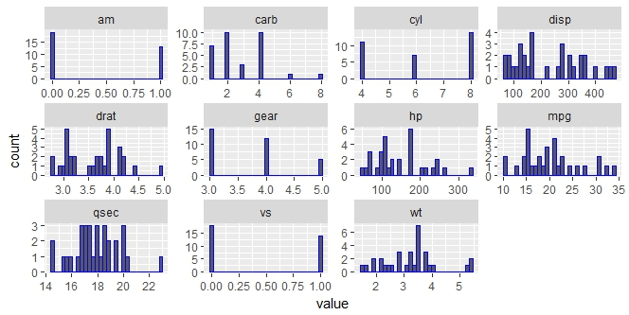

2.Check the probability distribution of all variables in mtcars

|  |
| --- |
| > library(ggplot2)  > mtcars %>%  + keep(is.numeric) %>%  + gather() %>%  + ggplot(aes(value)) +  + facet_wrap(~ key,scales = "free") +  + stat_density() |
|  |
| |  | | --- | |  | |

#stat_bin is suitable only for continuous x data.

#If our x data is discrete, we probably want to use stat_count.

#we can also use geom_density function

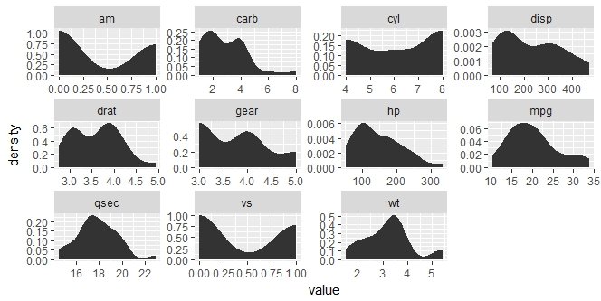

|  |
| --- |
|  |
|  |

1. Write a program to create boxplot for all variables.

|  |
| --- |
| > library(ggplot2)  > library(reshape)  Attaching package: ‘reshape’  The following objects are masked from ‘package:tidyr’:  expand, smiths  > m1 <- melt(mtcars)  Using as id variables  > ggplot(m1,aes(x = variable,y = value)) + facet_wrap(~variable) + geom_boxplot() |
|  |
|  |

