# CS4023D Artificial Intelligence

## Assignment 1

Meenakshi Madhu – B180390CS

Q1.

Outputs:

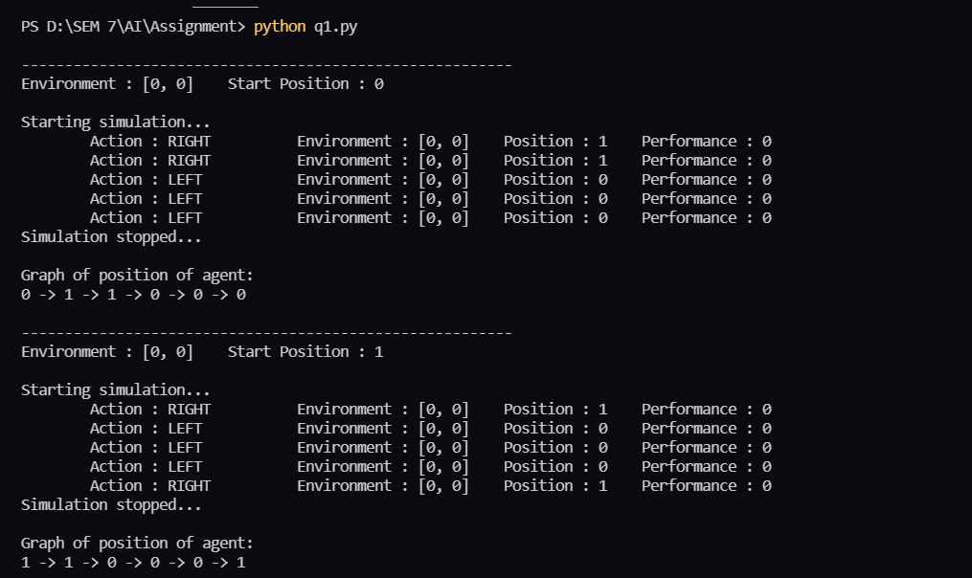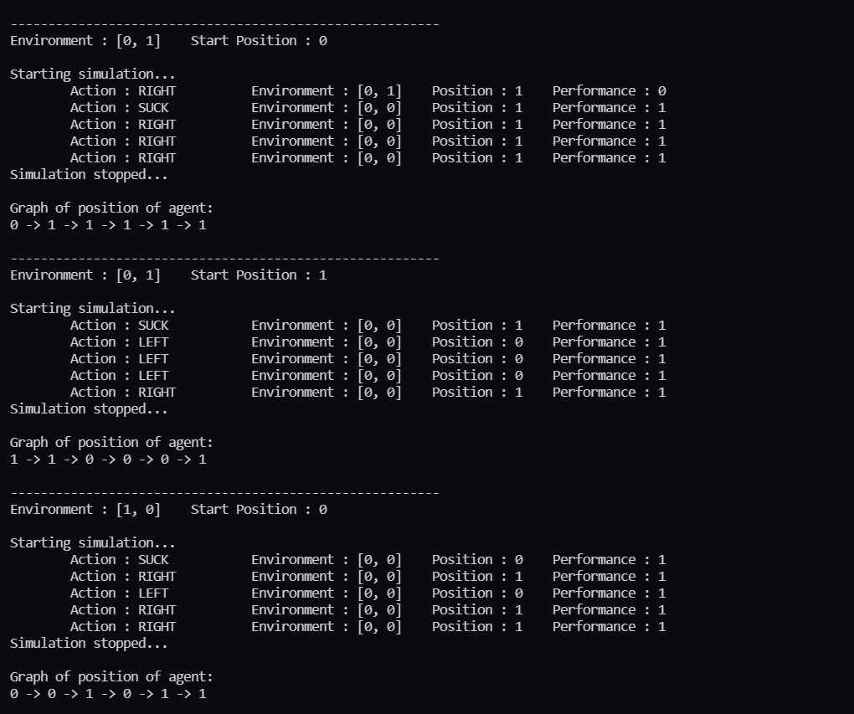

### 

The agent has been programmed to run 5 steps for the purpose of providing sample output images.