# CS4023D Artificial Intelligence

## Assignment 1

Meenakshi Madhu – B180390CS

Q2.

Outputs:

* An example where the computer (agent) will win the game.

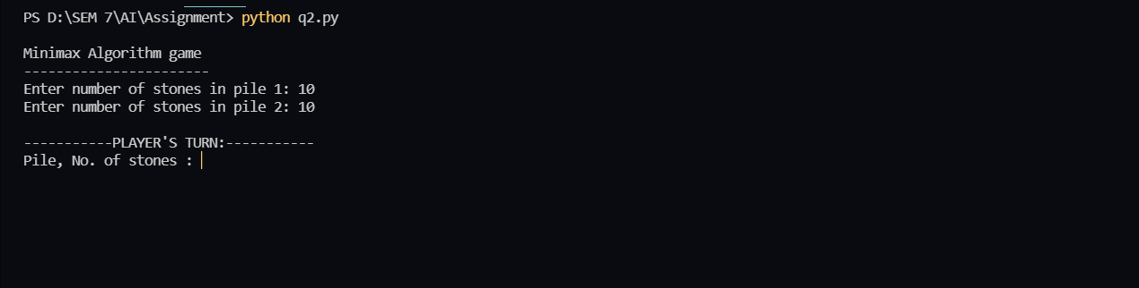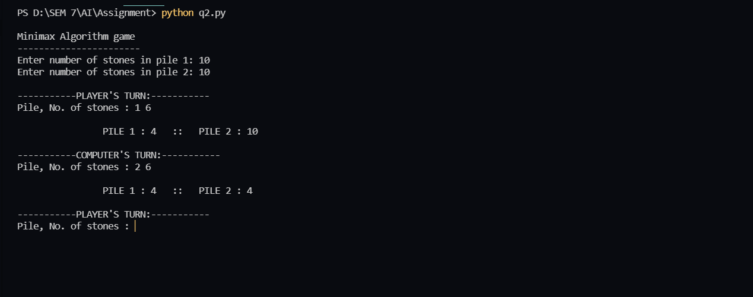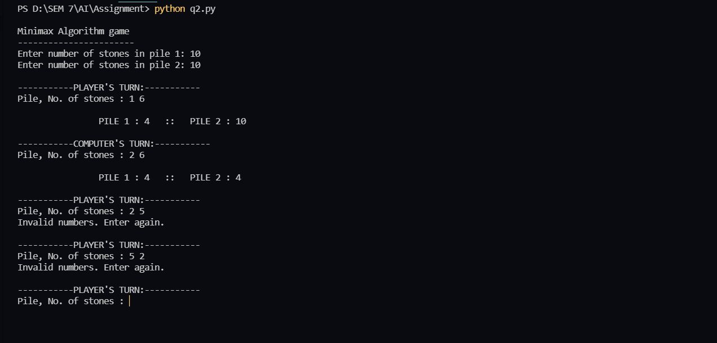

The image below shows the event where the human player enters invalid pile/stone numbers.

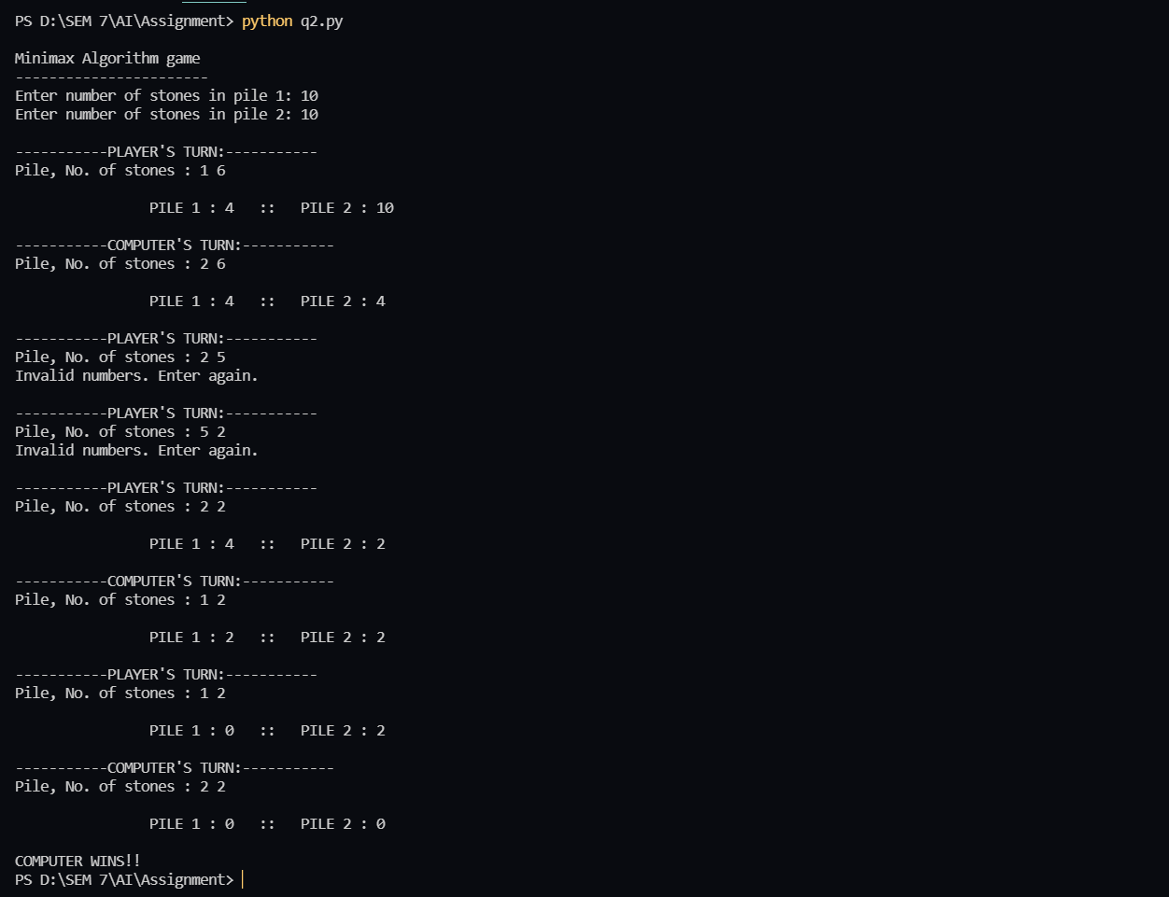

* An example where the computer (agent) will win the game.

