1. Pre-reqs: Create a Cassandra node cluster for Kong’s configuration

  - . Pre-reqs: Create VPC, subnets, ec2 instances and set up Java environment

1.1.1. Create a VPC with a public and private subnet(for you may want to isolate the cluster in future)
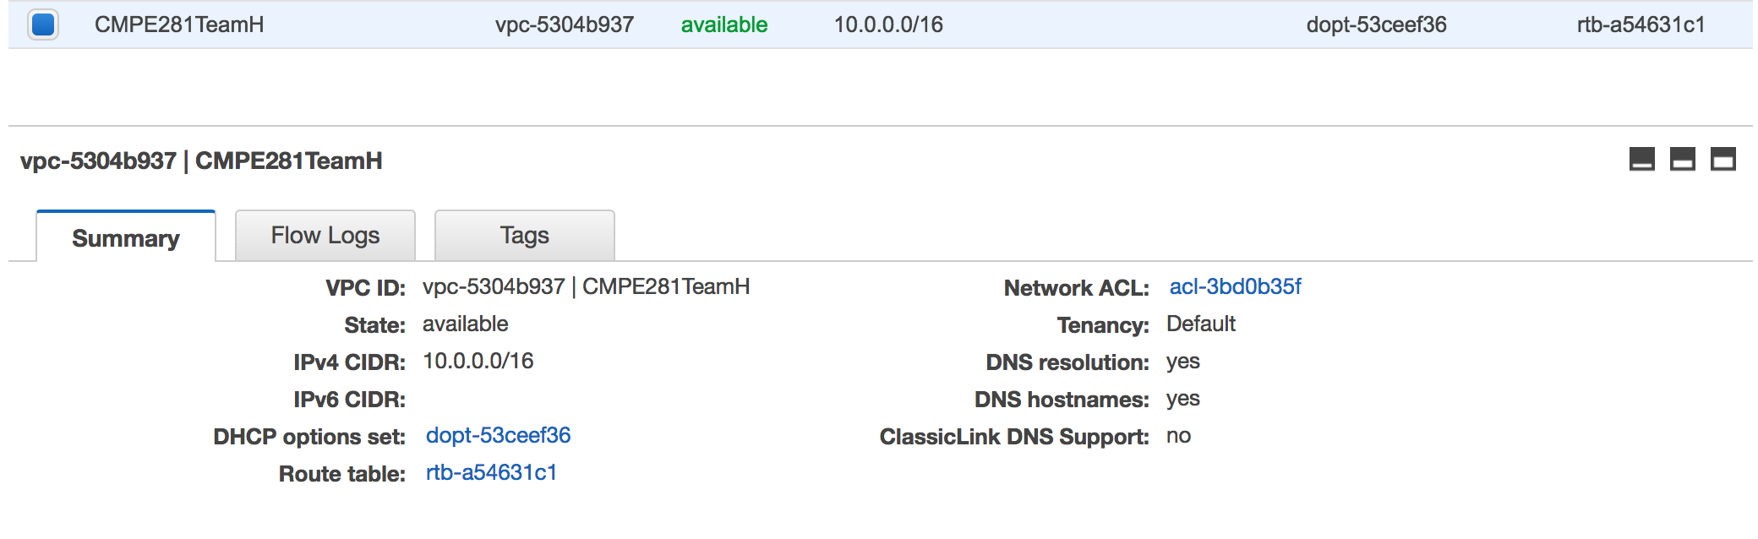

1.1.2. Create a Security Group marking inbound rules to instances.
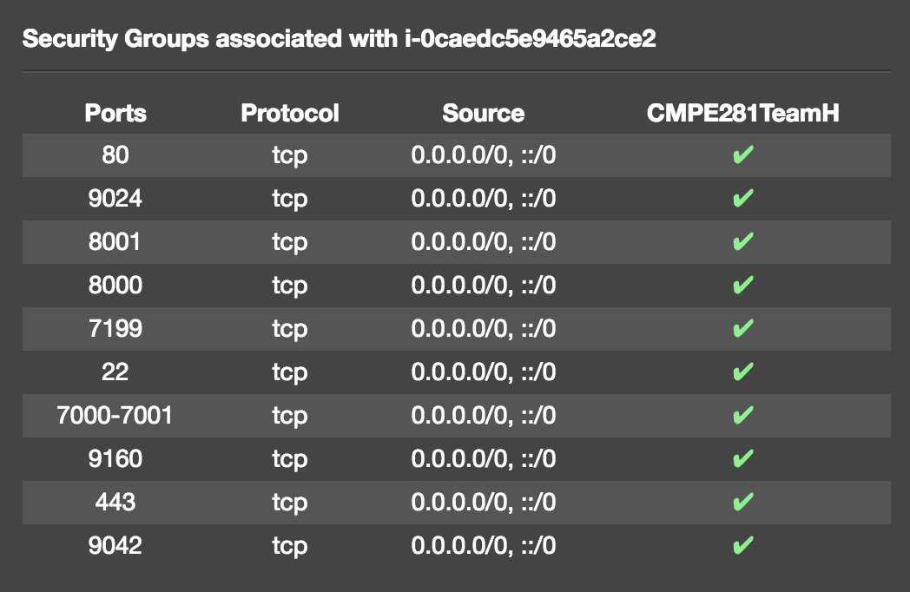

1.1.3. Spin up your ec2 instances (Ubuntu in our case)
Note: Consider allocating more memory to each instances.
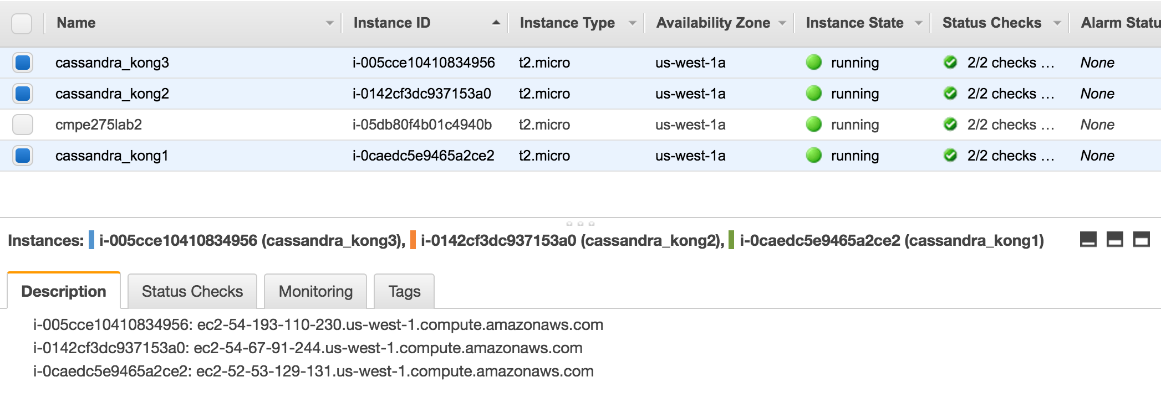

1.1.4. Setup Java environment in each node
sudo add-apt-repository ppa:webupd8team/java

sudo apt-get update

sudo apt-get install oracle-java8-installer

1.2. Install Cassandra on each node (aws ec2 instance in our case)
Follow the instructions from apache website,
http://cassandra.apache.org/download/

1.3. Configure cassandra.yaml on each node to set up the Cassandra node cluster. You can find this file in /etc/cassandra/ directory.
Change the fields below,

cluster_name: '<Your Cassandra Cluster Name>'
seed_provider:
# seeds is actually a comma-delimited list of addresses.
- seeds: "<ip1>,<ip2>,<ip3>"

listen_address: <ip1>
rpc_address: <ip1>

1.4. Start cassandra service on each node (as a background process),
sudo cassandra –R &

1.5. To check if you have a healthy cluster,
nodetool status

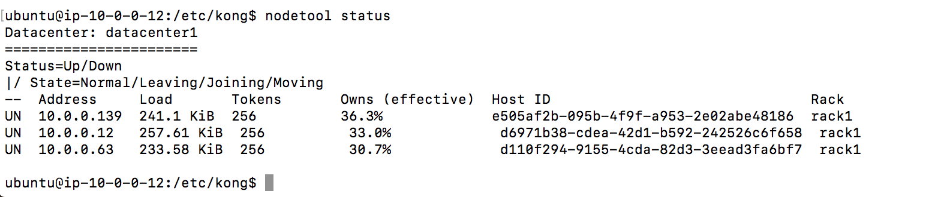

2. Setup Kong in the master node.

2.1. Select any instance as master node from the three.
Follow the instructions below to download it’s Debian package, for your Ubuntu instance,

wget https://github.com/Mashape/kong/releases/download/0.10.1/kong-0.10.1.xenial_all.deb

sudo dpkg -i kong-0.10.1.xenial_all.deb

2.2. Rename kong.conf.default file to kong.conf
You can find this file in /etc/kong/ directory
2.3. Modify kong.conf file to take Cassandra as it’s datastore.

database = cassandra

cassandra_contact_points = <ip1>,<ip2>,<ip3>

and uncomment all properties related to Cassandra

2.4. Start Kong with,

sudo kong start

You can check on Kong’s health with,

sudo kong health

You may also use cqlsh to use cassandra’s shell to look into cassandra datastore in any of the nodes and use DESCRIBE KEYSPACES; to see kong as one of the the keyspace.

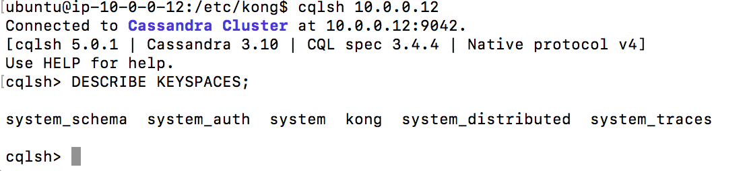

3. You’re almost set. Now add your API routes to Kong.

Kong Admin API is exposed on port 8001 and to configure the API routes, we need to make a HTTP-POST request to /apis.
Example:
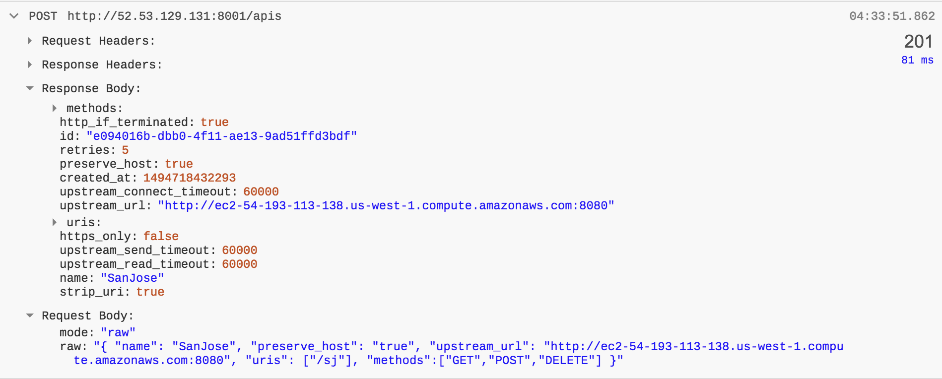

4. Once everything’s set up, Kong listens to all it’s API requests on port 8000.
Congratulations! You have set up Kong API Gateway.

Known issues:

- If Kong won’t start on your t2.micro instance due to low memory, you may try to increase the process limit
Another option is to modify mem_cache_size = 32m which is the size of the in-memory cache for database entities in kong.conf file.

https://github.com/Mashape/kong/issues/208

- Cassandra might cause your t2.micro instance to go out of memory and crash out. In that case before restarting Cassandra, remove all it’s generated log files

sudo rm –rf /var/lib/cassandra/*

- Replace a deadnode in Cassandra

http://blog.alteroot.org/articles/2014-03-12/replace-a-dead-node-in-cassandra.html

