Question 1.

Query:

SELECT orders.orderNumber,products.productName, customers.customerName ,payments.amount,payments.checkNumber

FROM orders

INNER JOIN orderdetails

ON orders.orderNumber=orderdetails.orderNumber

INNER JOIN products

ON orderdetails.productCode=products.productCode

INNER JOIN customers

ON orders.customerNumber=customers.customerNumber

INNER JOIN payments

ON payments.customerNumber=customers.customerNumber

WHERE orders.orderNumber=10100;

Output:

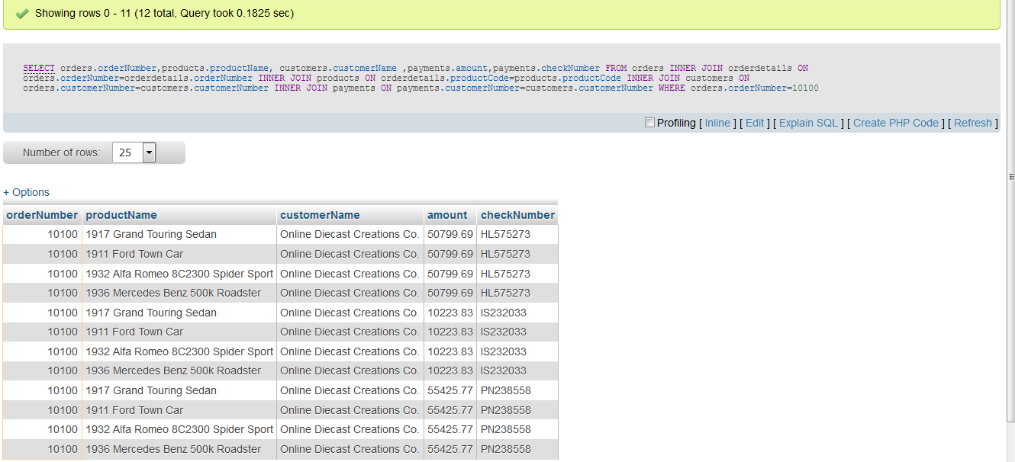

2.Question

Query:

SELECT orders.orderNumber,SUM(payments.amount)AS total_paid_amount_for_the_order_10100

FROM orders

INNER JOIN orderdetails

ON orders.orderNumber=orderdetails.orderNumber

INNER JOIN products

ON orderdetails.productCode=products.productCode

INNER JOIN customers

ON orders.customerNumber=customers.customerNumber

INNER JOIN payments

ON payments.customerNumber=customers.customerNumber

WHERE orders.orderNumber=10100;

Output:

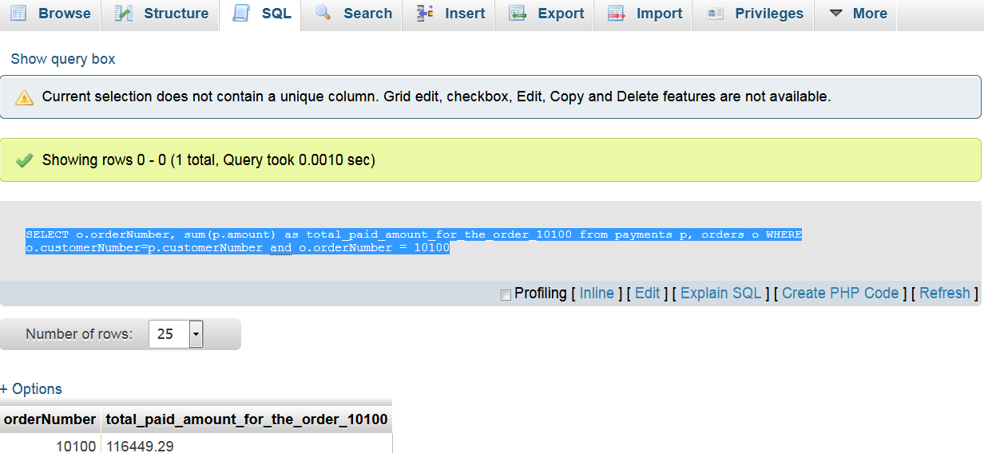

3.Question

Query:

SELECT DISTINCT orders.orderNumber,payments.checkNumber

FROM orders

INNER JOIN orderdetails

ON orders.orderNumber=orderdetails.orderNumber

INNER JOIN products

ON orderdetails.productCode=products.productCode

INNER JOIN customers

ON orders.customerNumber=customers.customerNumber

INNER JOIN payments

ON payments.customerNumber=customers.customerNumber

WHERE orders.orderNumber=10100;

Output:

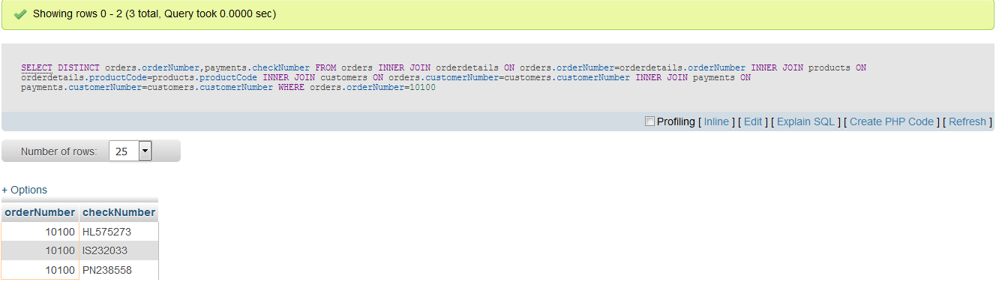

4.Question.

Query:

SELECT MIN(quantityInStock)AS least_value_in_quantityInStock,MAX(quantityInStock)AS max_value_in_quantityInStock

FROM products;

Output:

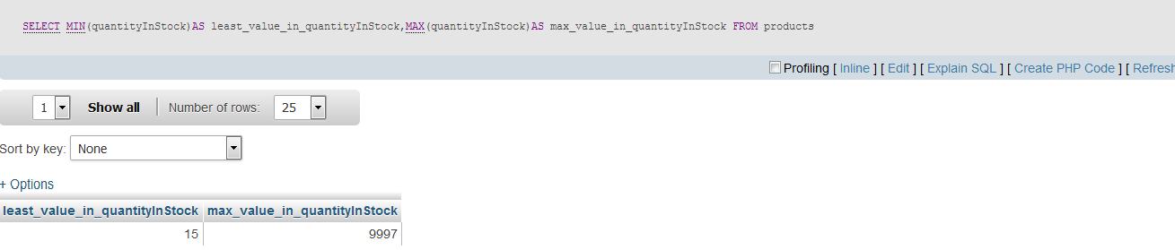

5.Question.

Query:

SELECT products.productCode,products.productLine,productLines.htmlDescription

FROM `products`

INNER JOIN productlines

ON products.productLine=productlines.productLine WHERE products.productLine=(SELECT productLine FROM productlines WHERE productLine='Classic Cars')

AND(productCode='S12_3380'OR productCode='S12_3891'OR productCode='S12_3990');

Output:

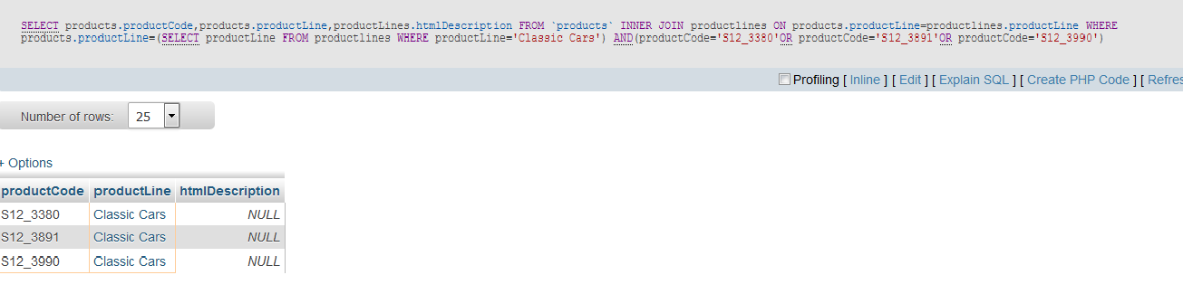

6.Question.

Query:

SELECT COUNT(*)FROM productLines WHERE htmlDescription=NULL;

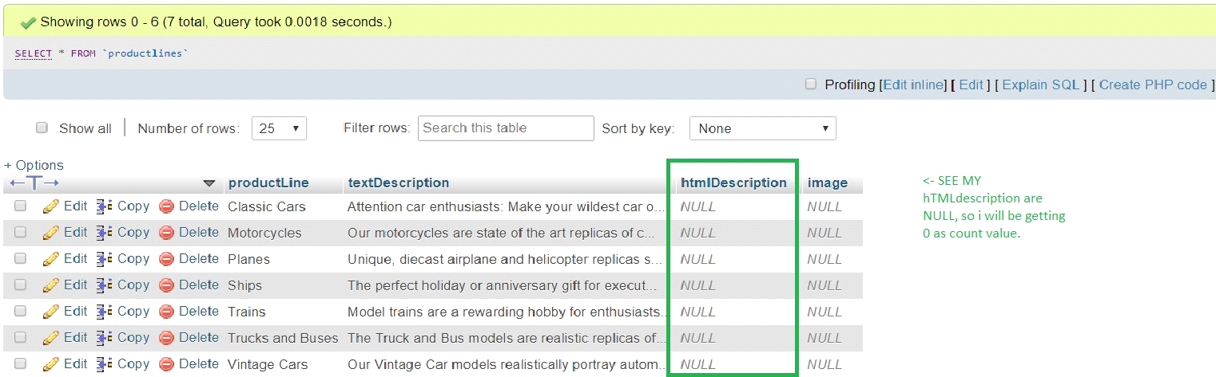

Output:

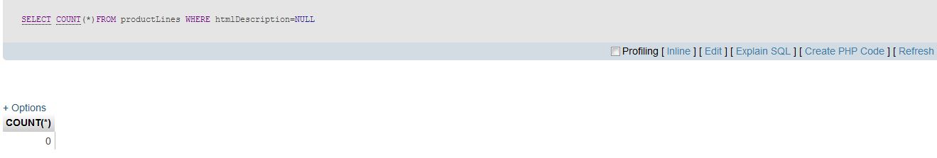

7.Question.

Query:

SELECT DATE_FORMAT(STR_TO_DATE('2019-08-18 12:49:24','%Y-%m-%d %H:%i:%S'), '%d-%b-%a') output

Output:

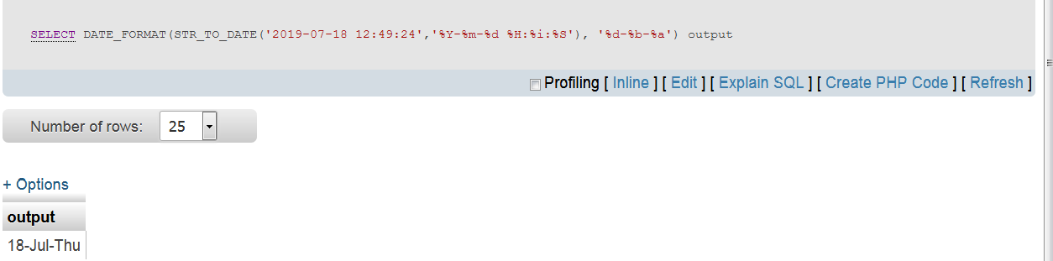

8.Question.

Query:

SELECT amount FROM payments ORDER BY amount DESC LIMIT 2,1

Output:

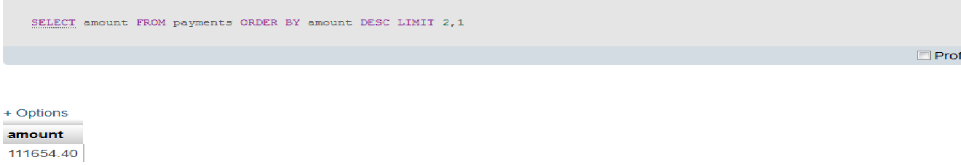

9.Question.

Query:

SELECT contactFirstName FROM customers WHERE contactFirstName LIKE 'C%a '

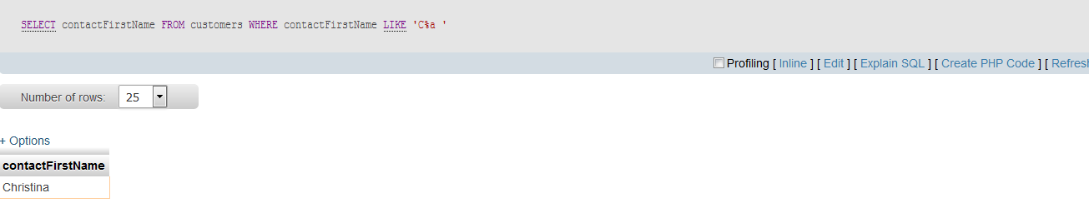

10.Question.

Query:

SELECT productLines.productLine,productLines.textDescription,productLines.htmlDescription,productLines.image

FROM `productlines`

INNER JOIN products

ON products.productLine=productlines.productLine

WHERE productLines.productLine <> products.productLine;

Output:

