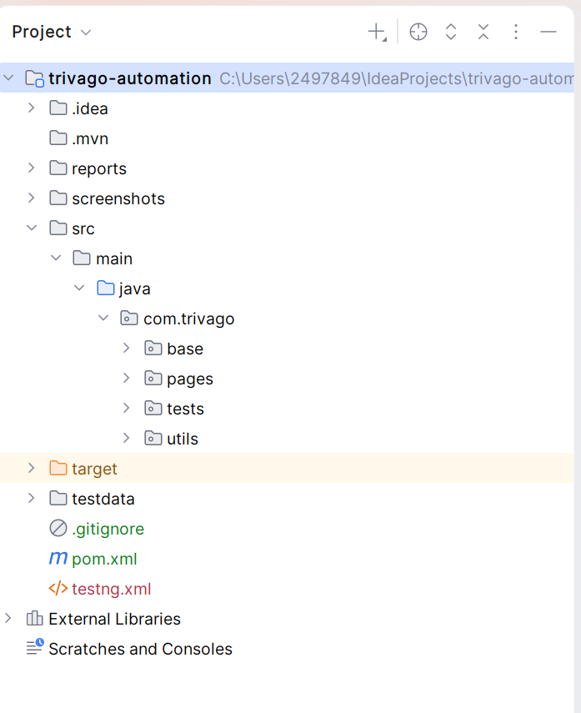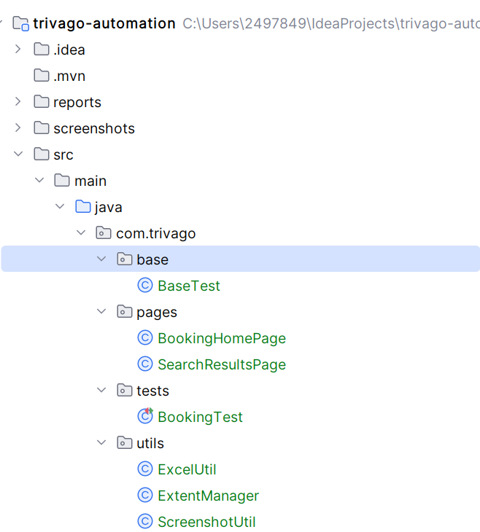

package com.trivago.base;
import com.aventstack.extentreports.ExtentReports;
import com.aventstack.extentreports.ExtentTest;
import com.trivago.utils.ExtentManager;
import org.openqa.selenium.WebDriver;
import org.openqa.selenium.chrome.ChromeDriver;
import org.openqa.selenium.firefox.FirefoxDriver;
import org.openqa.selenium.support.ui.WebDriverWait;
import org.testng.annotations.*;
import java.time.Duration;
public class BaseTest {
protected WebDriver driver;
protected WebDriverWait wait;
protected ExtentReports extent;
protected ExtentTest test;
@BeforeSuite
public void setupReport() {
extent = ExtentManager.getReport();
}
@AfterSuite
public void endReport() {
extent.flush();
}
@Parameters("browser")
@BeforeMethod
public void setUp(@Optional("chrome") String browser) {
if (browser.equalsIgnoreCase("chrome")) {
driver = new ChromeDriver(); // Selenium Manager
} else {
driver = new FirefoxDriver();
}
driver.manage().window().maximize();
wait = new WebDriverWait(driver, Duration.ofSeconds(10));
driver.get("https://www.booking.com");
System.out.println("✅ Browser Launched");
}
@AfterMethod
public void tearDown() {
if (driver != null) {
driver.quit();
System.out.println("✅ Browser Closed");
}
}
}

package com.trivago.pages;
import org.openqa.selenium.*;
import org.openqa.selenium.support.FindBy;
import org.openqa.selenium.support.PageFactory;
import org.openqa.selenium.support.ui.*;
import java.time.Duration;
import java.util.List;
public class BookingHomePage {
WebDriver driver;
WebDriverWait wait;
// =============================
// Constructor
// =============================
public BookingHomePage(WebDriver driver) {
this.driver = driver;
this.wait = new WebDriverWait(driver, Duration.ofSeconds(10));
// ✅ PageFactory Initialization
PageFactory.initElements(driver, this);
}
// =============================
// Locators (converted to PageFactory)
// =============================
@FindBy(name = "ss")
WebElement destination;
@FindBy(css = "[data-testid='searchbox-dates-container']")
WebElement dateBox;
@FindBy(css = "[data-testid='searchbox-datepicker']")
WebElement calendarContainer;
@FindBy(css = "button[type='submit']")
WebElement searchButton;
@FindBy(css = "[aria-label='Dismiss sign-in info.']")
WebElement popupClose;
// =============================
// Methods (UNCHANGED LOGIC)
// =============================
// Enter City
public void enterCity(String city) {
handlePopup();
WebElement searchBox = wait.until(
ExpectedConditions.visibilityOf(destination)
);
searchBox.click();
((JavascriptExecutor) driver)
.executeScript("arguments[0].value='';", searchBox);
searchBox.sendKeys(city);
wait.until(ExpectedConditions.visibilityOfElementLocated(
By.cssSelector("[data-testid='autocomplete-results']")
));
WebElement firstOption = wait.until(ExpectedConditions.elementToBeClickable(
By.cssSelector("[data-testid='autocomplete-result']")
));
firstOption.click();
System.out.println("✅ City Entered: " + city);
}
// Handle Popup
public void handlePopup() {
try {
WebElement closeBtn = wait.until(
ExpectedConditions.elementToBeClickable(popupClose)
);
closeBtn.click();
System.out.println("✅ Popup closed");
} catch (Exception e) {
System.out.println("✅ No popup found");
}
}
// Select Dates
public void selectDates(String checkInDay, String checkOutDay) {
try {
List<WebElement> calendar = driver.findElements(
By.cssSelector("[data-testid='searchbox-datepicker']")
);
if (calendar.size() == 0) {
WebElement dateBoxElement = wait.until(
ExpectedConditions.elementToBeClickable(dateBox)
);
((JavascriptExecutor) driver)
.executeScript("arguments[0].click();", dateBoxElement);
}
wait.until(ExpectedConditions.visibilityOf(calendarContainer));
selectDate(checkInDay);
selectDate(checkOutDay);
System.out.println(" Dates Selected");
} catch (Exception e) {
throw new RuntimeException("Date selection failed: " + e.getMessage());
}
}
// Select Individual Date
private void selectDate(String day) {
List<WebElement> dates = wait.until(
ExpectedConditions.presenceOfAllElementsLocatedBy(
By.xpath("//span[text()='" + day + "']")
)
);
for (WebElement d : dates) {
if (d.isDisplayed() && d.isEnabled()) {
((JavascriptExecutor) driver)
.executeScript("arguments[0].click();", d);
return;
}
}
throw new RuntimeException("❌ Date not clickable: " + day);
}
// Click Done
public void clickDone() {
try {
WebElement doneBtn = wait.until(
ExpectedConditions.elementToBeClickable(
By.xpath("//button//span[text()='Done']")
)
);
doneBtn.click();
System.out.println("✅ Done clicked");
} catch (Exception e) {
System.out.println("✅ Done not required");
}
}
// Click Search
public void clickSearch() {
driver.findElement(By.tagName("body")).click();
WebElement searchBtn = wait.until(
ExpectedConditions.visibilityOf(searchButton)
);
((JavascriptExecutor) driver).executeScript(
"arguments[0].scrollIntoView({block: 'center'});", searchBtn);
try { Thread.sleep(1000); } catch (Exception e) {}
wait.until(ExpectedConditions.elementToBeClickable(searchBtn));
try {
searchBtn.click();
} catch (Exception e) {
((JavascriptExecutor) driver)
.executeScript("arguments[0].click();", searchBtn);
}
System.out.println(" Search Clicked");
}
}
package com.trivago.pages;
import com.trivago.utils.ExcelUtil;
import org.openqa.selenium.*;
import org.openqa.selenium.support.FindBy;
import org.openqa.selenium.support.PageFactory;
import org.openqa.selenium.support.ui.*;
import java.time.Duration;
import java.util.*;
public class SearchResultsPage {
WebDriver driver;
WebDriverWait wait;
// Constructor
public SearchResultsPage(WebDriver driver) {
this.driver = driver;
this.wait = new WebDriverWait(driver, Duration.ofSeconds(10));
// ✅ Initialize PageFactory
PageFactory.initElements(driver, this);
}
// =============================
// Locators (PageFactory)
// =============================
@FindBy(css = "[data-testid='title']")
List<WebElement> hotelTitles;
@FindBy(css = "[data-testid='price-and-discounted-price']")
List<WebElement> prices;
@FindBy(css = "[data-testid='review-score']")
List<WebElement> ratings;
// =============================
// Methods (UNCHANGED LOGIC)
// =============================
public void waitForResults() {
wait.until(ExpectedConditions.presenceOfElementLocated(
By.cssSelector("[data-testid='title']")
));
System.out.println("Search Results Loaded");
}
// Print Hotel Names + Prices
public void printHotelNamesWithPrices() {
List<WebElement> hotelList = driver.findElements(
By.cssSelector("[data-testid='property-card']")
);
System.out.println("\nHOTEL NAME + PRICE:\n");
for (WebElement hotel : hotelList) {
try {
String name = hotel.findElement(
By.cssSelector("[data-testid='title']")
).getText();
String price = hotel.findElement(
By.cssSelector("[data-testid='price-and-discounted-price']")
).getText();
System.out.println(name + " -> " + price);
} catch (Exception e) {
// skip
}
}
}
// Validate Ratings Descending
public void validateRatingsDescending() {
List<Double> ratingValues = new ArrayList<>();
for (WebElement r : ratings) {
try {
ratingValues.add(Double.parseDouble(r.getText()));
} catch (Exception ignored) {}
}
boolean sorted = true;
for (int i = 0; i < ratingValues.size() - 1; i++) {
if (ratingValues.get(i) < ratingValues.get(i + 1)) {
sorted = false;
break;
}
}
if (sorted) {
System.out.println(" Ratings are in descending order");
} else {
System.out.println(" Ratings NOT sorted correctly");
}
}
// Scroll to load all hotels
public void scrollToLoadHotels() {
JavascriptExecutor js = (JavascriptExecutor) driver;
int previousCount = 0;
while (true) {
List<WebElement> hotels = driver.findElements(
By.cssSelector("[data-testid='property-card']")
);
int currentCount = hotels.size();
System.out.println("Hotels loaded: " + currentCount);
js.executeScript("window.scrollBy(0, 1500);");
try {
wait.until(driver -> {
int newCount = driver.findElements(
By.cssSelector("[data-testid='property-card']")
).size();
return newCount > currentCount;
});
} catch (TimeoutException e) {
System.out.println(" Reached end of results");
break;
}
previousCount = currentCount;
}
}
// Validate first 5 hotels belong to city
public void validateFirstFiveHotels(String city) {
System.out.println("\n HOTEL CITY VALIDATION:");
for (int i = 0; i < 5 && i < hotelTitles.size(); i++) {
String text = hotelTitles.get(i).getText();
if (text.toLowerCase().contains(city.toLowerCase())) {
System.out.println(" " + text);
} else {
System.out.println(" Not " + city + ": " + text);
}
}
}
// Export to Excel
public void exportHotelDataToExcel() {
List<WebElement> hotelList = driver.findElements(
By.cssSelector("[data-testid='property-card']")
);
List<String> names = new ArrayList<>();
List<String> pricesList = new ArrayList<>();
for (WebElement hotel : hotelList) {
try {
String name = hotel.findElement(
By.cssSelector("[data-testid='title']")
).getText();
String price = hotel.findElement(
By.cssSelector("[data-testid='price-and-discounted-price']")
).getText();
names.add(name);
pricesList.add(price);
} catch (Exception e) {
// skip
}
}
ExcelUtil.writeHotelData(names, pricesList);
}
}
package com.trivago.tests;
import com.aventstack.extentreports.ExtentTest;
import com.trivago.base.BaseTest;
import com.trivago.pages.BookingHomePage;
import com.trivago.pages.SearchResultsPage;
import com.trivago.utils.ScreenshotUtil;
import org.testng.annotations.Test;
public class BookingTest extends BaseTest {
@Test
public void testHotelAvailability() {
ExtentTest test = extent.createTest("Booking Hotel Test");
try {
test.info("Test Started");
// Page Objects
BookingHomePage homePage = new BookingHomePage(driver);
SearchResultsPage resultsPage = new SearchResultsPage(driver);
// Step 1: Enter City
homePage.enterCity("Mumbai");
test.pass("City Entered: Mumbai");
// Step 2: Handle Popup
homePage.handlePopup();
test.pass("Popup handled");
// Step 3: Select Dates
homePage.selectDates("20", "22");
test.pass("Dates Selected");
// Step 4: Click Done
homePage.clickDone();
test.pass("Done Clicked");
// Step 5: Click Search
homePage.clickSearch();
test.pass("Search Clicked");
// Step 6: Wait for Results Page
resultsPage.waitForResults();
test.pass("Search Results Loaded");
// Step 7: SCROLL TO LOAD ALL HOTELS (IMPORTANT FIX)
resultsPage.scrollToLoadHotels();
test.pass("All hotels loaded using smart scrolling");
// Step 8: Print Hotel Name + Price
resultsPage.printHotelNamesWithPrices();
test.pass("Hotel Names & Prices Extracted");
// Screenshot once
String screenshotPath = ScreenshotUtil.captureScreenshot(driver, "HotelResults");
test.addScreenCaptureFromPath(screenshotPath);
test.pass("Screenshot captured and attached");
// Step 9: Export Data to Excel
resultsPage.exportHotelDataToExcel();
test.pass("Excel File Generated");
// Step 10: Validate Ratings
resultsPage.validateRatingsDescending();
test.pass("Ratings Verified");
// Step 11: Validate City
resultsPage.validateFirstFiveHotels("Mumbai");
test.pass("City Validation Completed");
System.out.println(" TEST COMPLETED SUCCESSFULLY");
test.pass("Test Completed Successfully");
} catch (Exception e) {
System.out.println(" TEST FAILED: " + e.getMessage());
// Screenshot on failure
ScreenshotUtil.captureScreenshot(driver, "BookingTest");
// Report failure
test.fail("Test Failed: " + e.getMessage());
throw e;
}
}
}
package com.trivago.utils;
import org.apache.poi.ss.usermodel.*;
import org.apache.poi.xssf.usermodel.XSSFWorkbook;
import java.io.FileOutputStream;
import java.util.List;
public class ExcelUtil {
public static void writeHotelData(List<String> names, List<String> prices) {
try {
Workbook workbook = new XSSFWorkbook();
Sheet sheet = workbook.createSheet("Hotel Data");
// Header
Row header = sheet.createRow(0);
header.createCell(0).setCellValue("Hotel Name");
header.createCell(1).setCellValue("Price");
// Data rows
for (int i = 0; i < names.size(); i++) {
Row row = sheet.createRow(i + 1);
row.createCell(0).setCellValue(names.get(i));
row.createCell(1).setCellValue(prices.get(i));
}
// Write to file
FileOutputStream fos = new FileOutputStream("./testdata/HotelData.xlsx");
workbook.write(fos);
fos.close();
workbook.close();
System.out.println("✅ Excel file created: ./testdata/HotelData.xlsx");
} catch (Exception e) {
System.out.println("❌ Excel write failed: " + e.getMessage());
}
}
}
package com.trivago.utils;
import com.aventstack.extentreports.ExtentReports;
import com.aventstack.extentreports.reporter.ExtentSparkReporter;
public class ExtentManager {
private static ExtentReports extent;
public static ExtentReports getReport() {
if (extent == null) {
// Create HTML report file
ExtentSparkReporter reporter =
new ExtentSparkReporter("./reports/ExtentReport.html");
reporter.config().setReportName("Booking Automation Report");
reporter.config().setDocumentTitle("Test Execution Report");
extent = new ExtentReports();
extent.attachReporter(reporter);
}
return extent;
}
}
package com.trivago.utils;
import org.openqa.selenium.*;
import java.io.File;
import java.text.SimpleDateFormat;
import java.util.Date;
public class ScreenshotUtil {
public static String captureScreenshot(WebDriver driver, String testName) {
try {
TakesScreenshot ts = (TakesScreenshot) driver;
File src = ts.getScreenshotAs(OutputType.FILE);
String timestamp = new SimpleDateFormat("yyyyMMdd_HHmmss").format(new Date());
String path = "./screenshots/" + testName + "_" + timestamp + ".png";
File dest = new File(path);
dest.getParentFile().mkdirs();
src.renameTo(dest);
System.out.println("📸 Screenshot saved: " + path);
return path;
} catch (Exception e) {
System.out.println("❌ Screenshot failed: " + e.getMessage());
return null;
}
}
}

<?xml version="1.0" encoding="UTF-8"?>
<project xmlns="http://maven.apache.org/POM/4.0.0"
xmlns:xsi="http://www.w3.org/2001/XMLSchema-instance"
xsi:schemaLocation="http://maven.apache.org/POM/4.0.0 http://maven.apache.org/xsd/maven-4.0.0.xsd">
<modelVersion>4.0.0</modelVersion>
<groupId>org.trivago</groupId>
<artifactId>trivago-automation</artifactId>
<version>1.0-SNAPSHOT</version>
<properties>
<maven.compiler.source>21</maven.compiler.source>
<maven.compiler.target>21</maven.compiler.target>
<project.build.sourceEncoding>UTF-8</project.build.sourceEncoding>
</properties>
<dependencies>
<!-- Apache POI for Excel -->
<dependency>
<groupId>org.apache.poi</groupId>
<artifactId>poi-ooxml</artifactId>
<version>5.2.5</version>
</dependency>
<!-- Selenium -->
<dependency>
<groupId>org.seleniumhq.selenium</groupId>
<artifactId>selenium-java</artifactId>
<version>4.20.0</version>
</dependency>
<dependency>
<groupId>io.github.bonigarcia</groupId>
<artifactId>webdrivermanager</artifactId>
<version>5.8.0</version>
</dependency>
<dependency>
<groupId>org.testng</groupId>
<artifactId>testng</artifactId>
<version>7.12.0</version>
<scope>compile</scope>
</dependency>
<dependency>
<groupId>org.apache.logging.log4j</groupId>
<artifactId>log4j-core</artifactId>
<version>2.23.1</version>
</dependency>
<!-- Bridge SLF4J to Log4j -->
<dependency>
<groupId>org.apache.logging.log4j</groupId>
<artifactId>log4j-slf4j2-impl</artifactId>
<version>2.23.1</version>
</dependency>
<dependency>
<groupId>org.slf4j</groupId>
<artifactId>slf4j-nop</artifactId>
<version>2.0.12</version>
</dependency>
<dependency>
<groupId>org.apache.logging.log4j</groupId>
<artifactId>log4j-api</artifactId>
<version>2.23.1</version>
</dependency>
<dependency>
<groupId>com.aventstack</groupId>
<artifactId>extentreports</artifactId>
<version>5.1.1</version>
</dependency>
</dependencies>
</project>
<!DOCTYPE suite SYSTEM "https://testng.org/testng-1.0.dtd">
<suite name="Booking Test Suite" parallel="false">
<test name="Booking Test - Chrome">
<!-- Browser parameter -->
<parameter name="browser" value="chrome"/>
<classes>
<class name="com.trivago.tests.BookingTest"/>
</classes>
</test>
</suite>

