Object Oriented Programming

LAB- II

Note : Include / Exclude Data fields, parameters and Methods as per requirements.
1. Find the Area and perimeter of the circle.
Class Name : Circle
Data Fields
: radius
Constructors : Circle( radius)
Methods
: getArea()
getPerimeter()
Circle object-1 Circle Object-2 Circle Object-3
Data Fields : radius :5 Data Fields : radius :10 Data Fields : radius :15

EXECUTABLE PROGRAMME
____________________________

import java.util.*;
public class area
{
public static void main(String args[])
{
Scanner sc=new Scanner(System.in);
int r;
System.out.println("enter radius :");
r=sc.nextInt();
double area=3.14*r*r;
double perimeter=2*Math.PI*r;

System.out.println("area of circle is:"+area);
System.out.println("perimeter of circle is:"+perimeter);

}
}
OUTPUT
_________
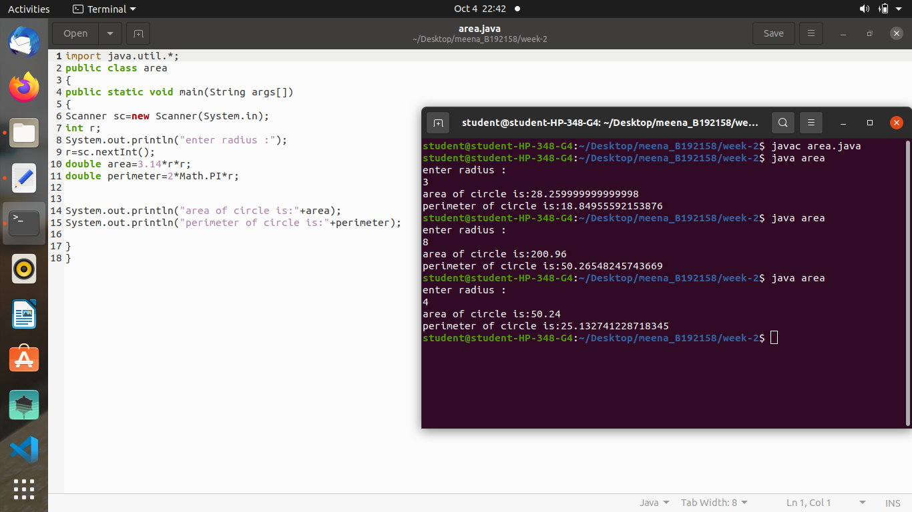

2. Switch on/off the led light and switch on/off the halogen light.
Note : turnOn()/turnOff() will print the state of light as On/Off.
Class Name : Lamp
Data Fields
: isOn
:boolean
lampType : String
Constructors : Lamp( isOn)
Methods
: turnOn()
turnOff()
Lamp object-1 : led Lamp Object-2 : halogen
Data Fields : isOn : true Data Fields : isOff : false

EXECUTABLE PROGRAMME
____________________________

import java.util.*;
class Lamp
{
private boolean isOn;
String lampType;
public Lamp(boolean isOn)
{
this.isOn=isOn;
}
void turnon()
{
if(isOn)
System.out.println("light is already on");
else{
isOn=true;
System.out.println("lamp is on");
}
}
void turnoff()
{ if(!isOn)
System.out.println("light is already off");
else{
isOn=false;
System.out.println("lamp is off");
}
}
}
public class lamp
{public static void main(String args[])
{
Lamp led=new Lamp(false);
Lamp halogen=new Lamp(true);
System.out.println("turn on led lamp");
led.turnon();
System.out.println();
System.out.println("turn off halogen lamp");
halogen.turnoff();
}
}
OUTPUT
_________
s
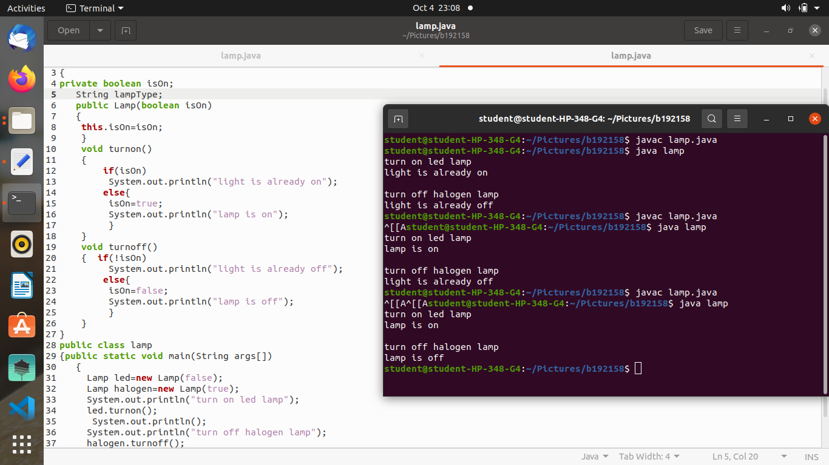

3. Television simulation
Class Name : TV Details of data members / Methods
Channel : int
volume level : int
on: boolean Channels ( 1 to 40)
volume level ( 1 to 7)
indicates TV on/off
TV()
turnOn() : void
turnOff():void
setChannel(newChannel:int) : void
setVolume(newVolumeLevel : int) : void
channelUp() :void
channelDown():void
volumeUp():void
volumeDown():void Constructs default TV object
Turns on the TV
Turns off the TV
sets a new channel for this TV
sets a new colume level for this TV
increases the channel number by 1
decreases the channel number by 1
increases the volume by 1
decreases the volume level by 1

EXECUTABLE PROGRAMME
____________________________

import java.util.*;

public class TV{

int channel;
int volume;
boolean on;

void TV()
{
channel;
volue;
on;

}
void turnon()
{
on=true;
System.out.println("TV is ON");
System.out.println(on);
}
void turnoff()
{
on=false;
System.out.println("TV is OFF");
System.out.println(on);
}

void setchannel(int newchannel)
{
channel=newchannel;
System.out.println("new channel is "+channel);
}
void setvolume(int volumelevel)
{
volume=volumelevel;
System.out.println("volume is "+volume);
}
void channelup()
{
channel++;
System.out.println("channel is "+channel);
}
void channeldown()
{
channel--;
System.out.println("channel is" +channel);
}
void volumeup()
{
volume++;
System.out.println("volume is "+volume);
}
void volumedown()
{
volume--;
System.out.println("volume is "+volume);
}
public static void main(String a[])
{
TV obj=new TV();
obj.turnon();
//obj.turnoff();
obj.setchannel(6);
obj.setvolume(7);
obj.channelup();
obj.channeldown();
obj.volumeup();
obj.volumedown();
obj.turnoff();

}
}

OUTPUT
_________
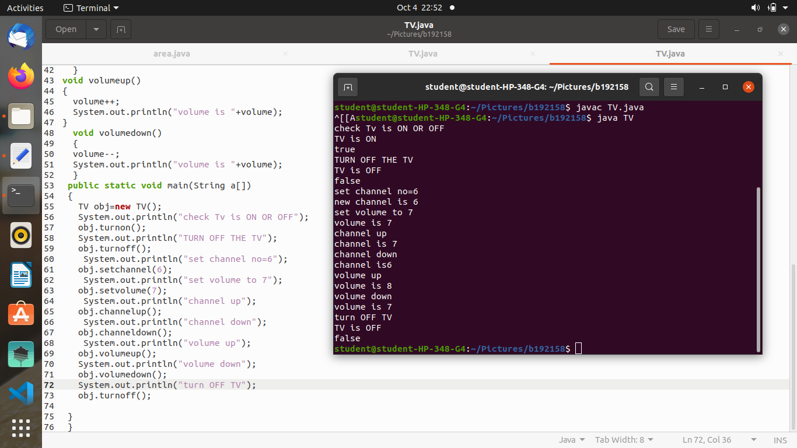

4. Suggest the car for the journey.Journey details : Travel to warangal with minimum possible fuel consumption & leat possible
Time.
Class Name : Car
Data Fields
: company : String
mileage : double
Speed
: double
color
: String
Constructors : Car ()
Methods
: getMileage()
getSpeed()
:::::::::::::
Car object-1 : Ford Car Object-2 : Toyota Car Object-3:volkswagon
Data Fields : -------- Data Fields : ----------- Data Fields : ----------

EXECUTABLE PROGRAMME
____________________________

import java.util.*;
class Cars
{
String name;
double mielege;
double speed;
String color;
public Cars()
{

}
public double getmielege()
{
return mielege;
}
public double getspeed()
{
return speed;
}
}
public class car
{
public static void main(String args[])
{
Scanner sc=new Scanner(System.in);
Cars c1=new Cars();
c1.name="ford";
//c1.mielege=10.00;
System.out.println("enter car1 mileage:");
c1.mielege=sc.nextDouble();
System.out.println("enter car1 speed:");
c1.speed=sc.nextDouble();
//c1.speed=120.54;
c1.color="red";
double a=c1.getmielege();
double b=c1.getspeed();
Cars c2=new Cars();
c2.name="toyoto";
//c2.mielege=9.00;
System.out.println("enter car2 mileage:");
c2.mielege=sc.nextDouble();
//c2.speed=121.54;
System.out.println("enter car2 speed:");
c2.speed=sc.nextDouble();
c2.color="black";
double c=c2.getmielege();
double d=c2.getspeed();
Cars c3=new Cars();
c3.name="volkswagan";
//c3.mielege=11.00;
System.out.println("enter car3 mileage:");
c3.mielege=sc.nextDouble();
System.out.println("enter car3 speed:");
c3.speed=sc.nextDouble();
//c3.speed=123.54;
c3.color="white";
double e=c3.getmielege();
double f=c3.getspeed();
if(a>c && a>e && b>d && b>f)
{
System.out.println(c1.name);
}
else if(c>e && d>f)
{
System.out.println(c2.name);
}
else
System.out.println(c3.name);
}
}

OUTPUT
__________

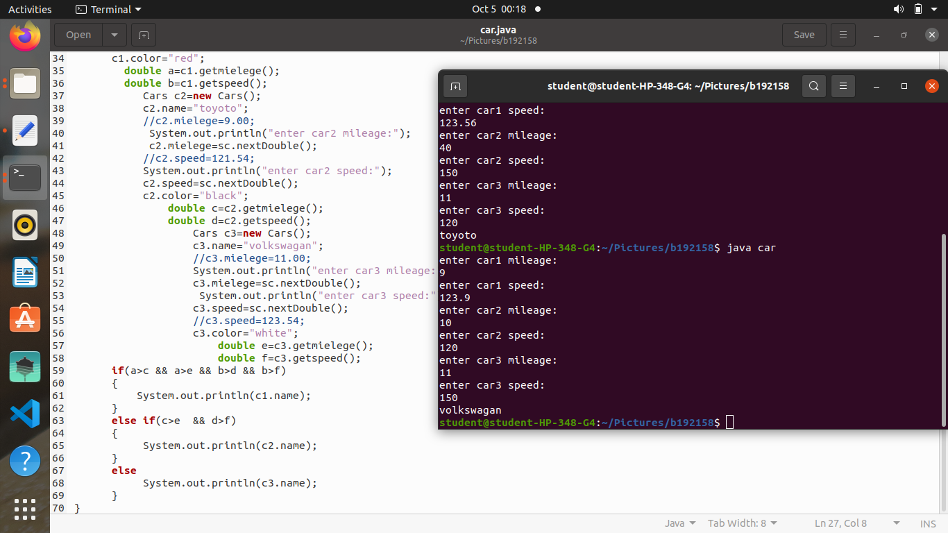

output3;

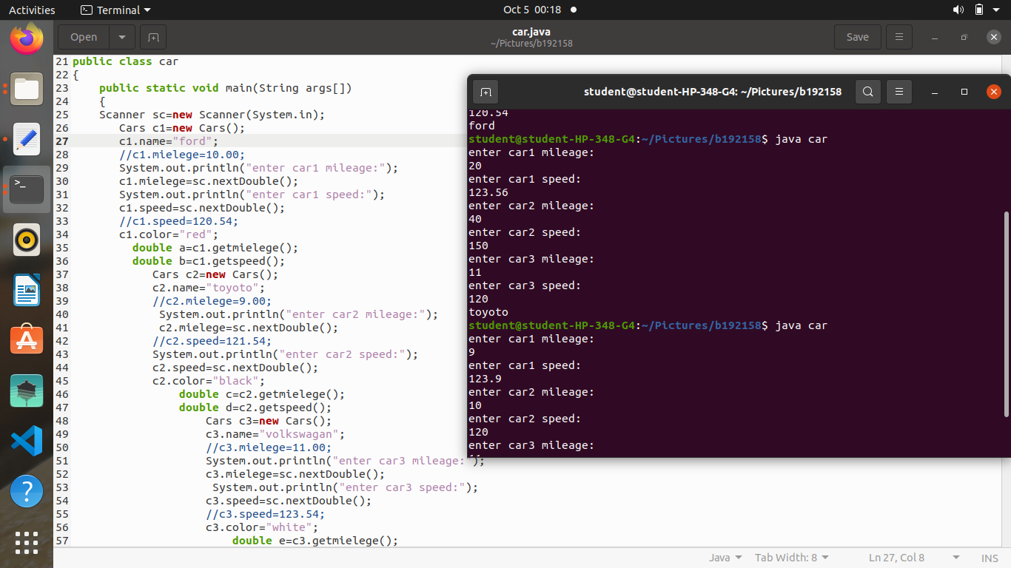
mnjsh

5. Suggest the Dog to the buyer in a Kennel.
Get input from the user and suggest the Dog. Inputs may include : breed, type, height etc.,,
output is dogs name.
Class Name : Dog
Data Fields
: name : String
breed : String
color: String
height : double
type: String
Constructors : Dog( )
Methods
: getBreed()
getName()
:::::::::::::
Dog object-1 : snoopy
Dog Object-2 : rocky
Data Fields :
Data Fields :
name : snoopy
name : rocky
breed : pomerian
breed : lab
color: white
color: brown
height : 1 ft
height : 3 ft
type: gaurd
type: sniffer
Dog Object-3 : snowy
Data Fields :
name : snowy
breed : g.sheperd
color: black
height : 4 ft
type: sheperd

EXECUTABLE PROGRAMME
____________________________

import java.util.*;
class Dog
{
String name,breed,colour,type;
double height;

public Dog(String name,String breed,String colour,double height,String type)
{
this.name=name;
this.breed=breed;
this.colour=colour;
this.type=type;
this.height=height;
}
public String getBreed()
{
return breed;
}
public String getType()
{
return type;
}
public double getHeight()
{
return height;
}
public String getName()
{
return name;
}
}

public class dog
{
public static void main(String args[])
{
Dog snoopy=new Dog("snoopy","pomerian","white",1.00,"guard");
Dog rocky=new Dog("rocky","lab","brown",3.00,"sniffer");
Dog snowy=new Dog("snowy","sheperd","black",4.00,"sheperd");
Scanner sc=new Scanner(System.in);
System.out.println("enter desired breed");
String breed=sc.nextLine();
System.out.println("enter desired type");
String type=sc.nextLine();
System.out.println("enter desired height");
double height=sc.nextDouble();

Dog suggestedDog=null;

if(breed.equals(snoopy.getBreed()) && type.equals(snoopy.getType()) && height==snoopy.getHeight())
suggestedDog=snoopy;
else if(breed.equals(rocky.getBreed()) && type.equals(rocky.getType()) && height==rocky.getHeight())
suggestedDog=rocky;
else if ( breed.equals(snowy.getBreed()) && type.equals(snowy.getType() )&& height==snowy.getHeight())
suggestedDog=snowy;

if(suggestedDog!=null)
{
System.out.println("Dog I suuggest is "+ suggestedDog.getName());
}
else
{
System.out.println("sorry,I wouldn't find a dog to your criteria");
}
}
}

OUTPUT
________
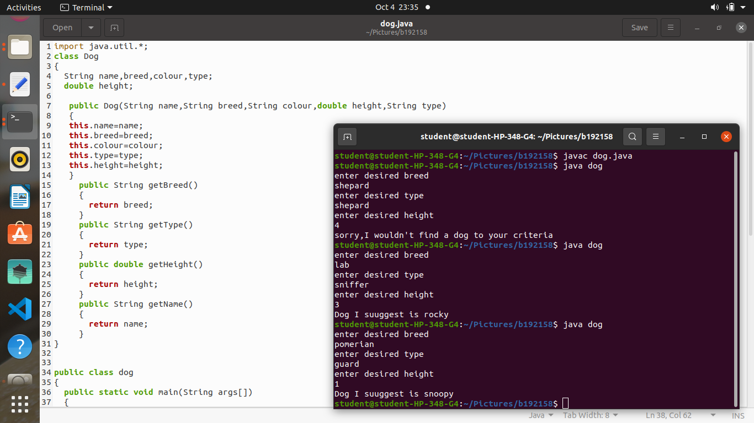

n

WEEK-1 PROGRAMMES

1)CALCULATORS OPERATION

EXECUTABLE PROGRAMME
___________________________

import java.util.*;
public class Calculator {

public static void main(String[] args){
double num1, num2;
Scanner sc = new Scanner(System.in);

System.out.println("Enter the numbers:");
num1 = sc.nextDouble();
num2 = sc.nextDouble();
System.out.println("Enter the operator (+,-,*,/):");
char op = sc.next().charAt(0);
double c = 0;

switch (op) {
case '+':
c = num1 + num2;
break;
case '-':
c = num1 - num2;
break;

case '*':
c = num1 * num2;
break;
case '/':
c = num1 / num2;
break;

default:
System.out.println(" entered ivalid input");
}

System.out.println("The final result:");
System.out.println();
System.out.println(num1 + " " + op + " " + num2 + " = " + c);
}
}

OUTPUT
_________

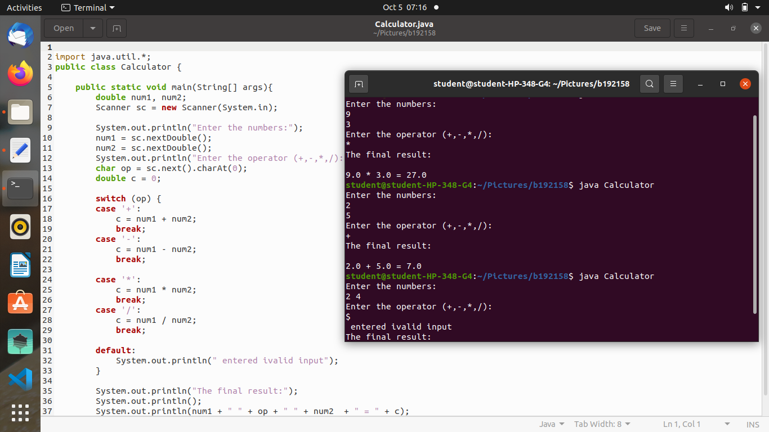
4
2)quadratic quation roots

EXECUTABLE PROGRAMME
___________________________

import java.util.*;
/*real and imaginary roots of quadratic equation*/
public class quad{
public static void main(String [] args){

System.out.println("enter a b c values :");
Scanner sc=new Scanner(System.in);
int a=sc.nextInt();
int b=sc.nextInt();
int c=sc.nextInt();
double r1,r2;
int d=(b*b)-(4*a*c);
if(d==0){
r1=-b/(2*a);
System.out.println("euqal roots: " +r1);
}
else if(d>0){
r1=(-b+Math.sqrt(d))/2*a;
r2=(-b-Math.sqrt(d))/2*a;
System.out.println("r1 = " +r1 +" r2= " +r2);
}

}
}

OUTPUT
_________
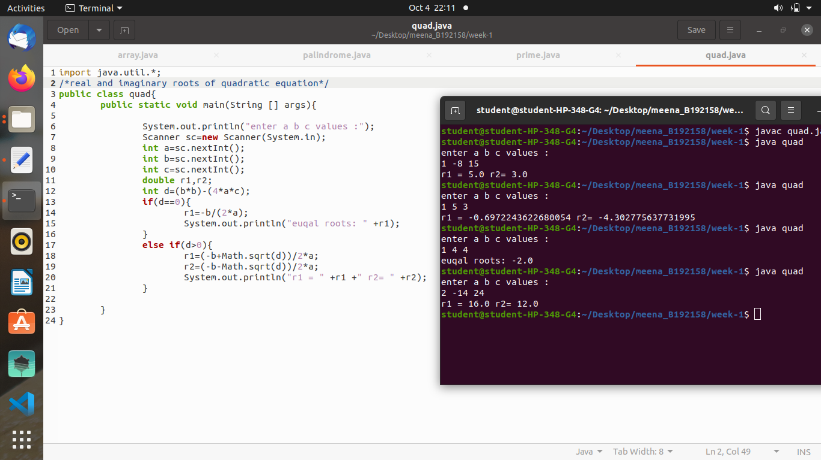

3)prime factors of a number

EXECUTABLE PROGRAMME
___________________________

import java.util.*;
/*4)prime factors of a number*/
public class prime{
public static void main(String args[])
{
Scanner sc=new Scanner(System.in);
int a=sc.nextInt();
int i,j,c=0;
for(i=2;i<=a;i++)
{
if(a%i==0)
{
for(j=2;j<i;j++)
{
if(i%j==0)
c++;
}
if(c==0)
System.out.println("prime factor is:"+i);
}}
}
}

OUTPUT
_________

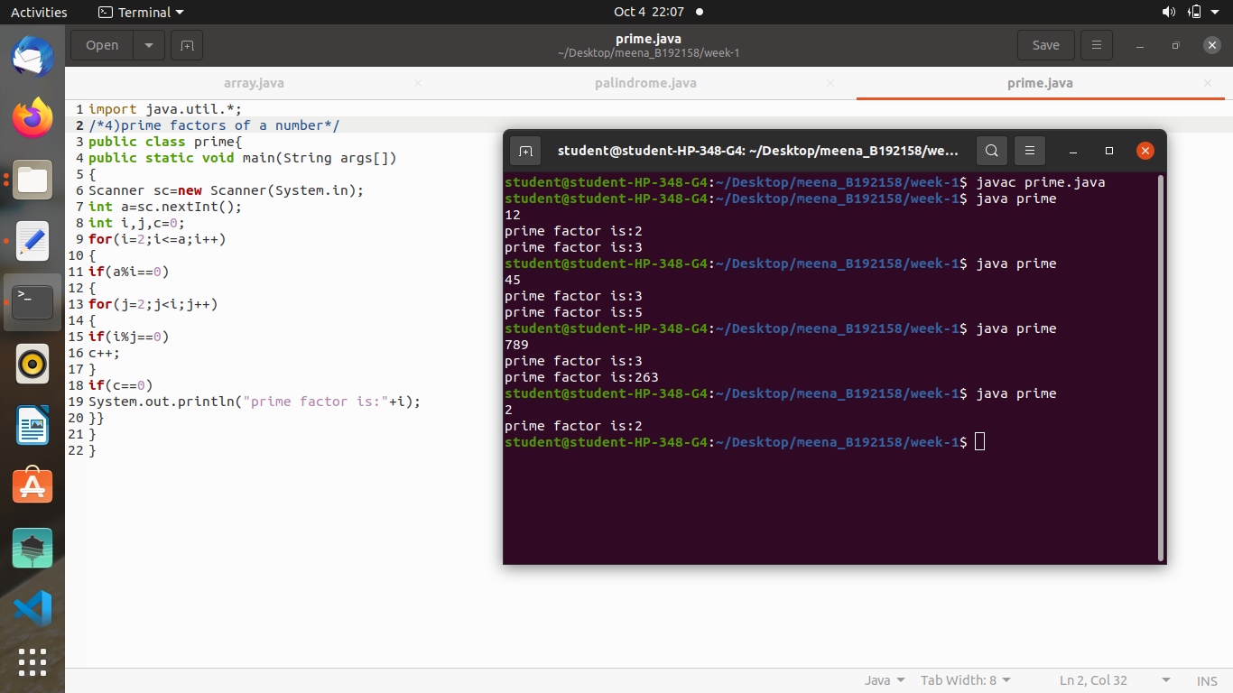
nn
4)palindrome or not

EXECUTABLE PROGRAMME
___________________________

import java.util.*;
public class palindrome
{
public static void main(String args[])
{
System.out.println("enter no:");
Scanner sc=new Scanner(System.in);
int n=sc.nextInt();
int t=n;
int sum=0;
while(n>0)
{
sum=(sum*10)+(n%10);
n=n/10;
}
if(t==sum)
{
System.out.println("it is palindrome");
}
else
{
System.out.println("not palindrome");
}
}}

OUTPUT:
_________

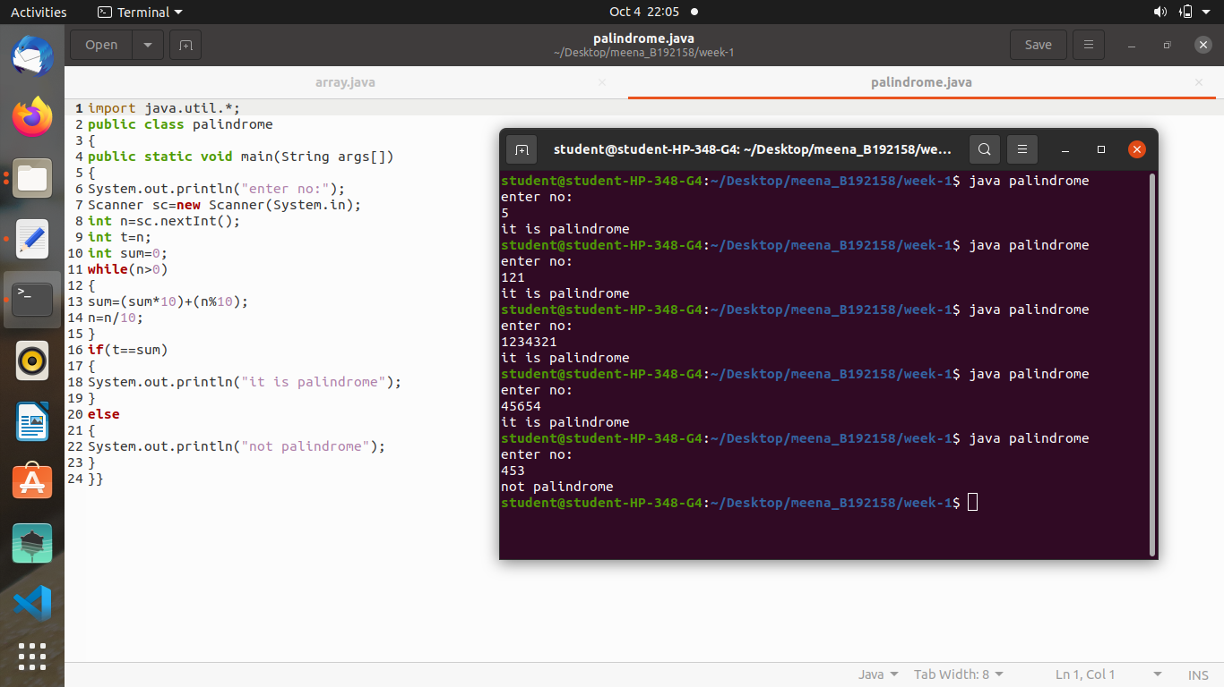

5)min max
import java.util.*;
/*declare 5 integers and print largest and smallest in the group*/
public class array{
public static void main(String args[])
{
Scanner sc=new Scanner(System.in);
System.out.println("n:");
int n=sc.nextInt();
int a[]=new int[n];
for(int i=0;i<n;i++)
a[i]=sc.nextInt();
int max=a[0];
int min=a[0];
for(int i=0;i<n;i++)
{
if(a[i]>max)
max=a[i];
if(a[i]<min)
min=a[i];
}
System.out.println("max is:"+max);
System.out.println("min is:"+min);
}}

OUTPUT:
_________

