**Rank Table**

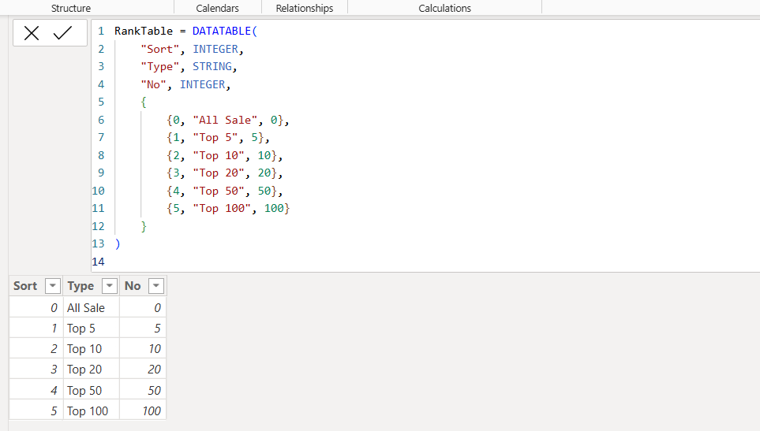

**DAX Measures**

1. Active User



2.Curent Year Sale



3.Dynamic subheading

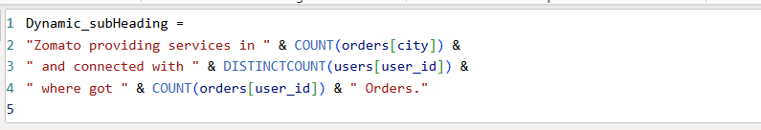

4.Dynamic TopN_Title

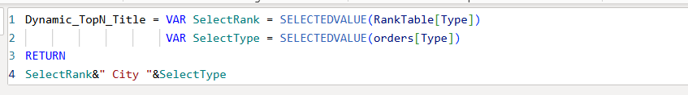

5.Gain customers



6**.**Lostcustomers



7.Previous Year



8. Previous year sale

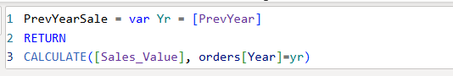

9.Sales Value



10.TopN_Sale

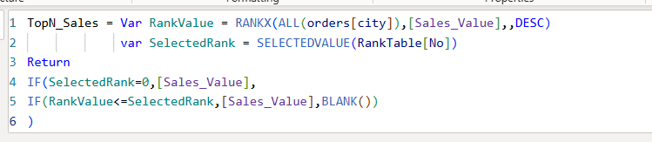

11.User count

