PARKISTEP TWIN
Phase 0: Requirements, Research & MVP Definition
A personalized digital twin for forecasting freezing-of-gait onset in Parkinson’s disease
Happiest Health • Digital Twin Challenge 2026
Version 0.1 | Prepared 19 October 2026

Decision summary: Use FoG-STAR as the primary dataset because it provides linked anonymized clinical data and wearable IMU time series. Test a 3-second forecast first; 1- and 5-second horizons remain sensitivity analyses. The project only claims forecasting if held-out-subject results show genuine pre-onset warning.

1. Executive decision
ParkiStep Twin will test whether recent wearable movement signals, interpreted with a participant’s available clinical profile, can predict a forthcoming freezing-of-gait (FoG) episode in Parkinson’s disease. The prototype will replay open sensor data as an incoming stream, update a patient-state object, produce an early-warning estimate, and display the forecast beside expert-annotated event times.
Safety boundary: This is a research proof of concept, not a diagnosis, treatment recommendation, or clinically validated alert. We will not claim that it prevents falls or is ready for real-world clinical use.

Phase 0 decisions
Decision | Phase 0 choice | Status
Target population | People with Parkinson’s disease represented in FoG-STAR | Locked for MVP
Target event | New annotated FoG episode onset | Locked
Primary forecast horizon | 3 seconds ahead | Provisional; check label timing and feasibility
Secondary horizons | 1 second and 5 seconds | Sensitivity analyses only
Input context | Trailing 2-second IMU window, about 120 samples at 60 Hz | Provisional
Prediction cadence | Every 0.5 seconds, about 30 samples at 60 Hz | Provisional
Primary dataset | FoG-STAR | Selected
Secondary dataset | Daphnet | Optional sensor-only benchmark
Fusion | Static clinical features + rolling sensor-window features | Selected
Models | Trivial baseline, sensor-only logistic regression, fused logistic regression; optional tree challenger | Selected
Evaluation | Participant-wise outer split; threshold/preprocessing selection inside training subjects | Selected
UI | Streamlit replay dashboard | Selected
Code license | MIT for original code; keep dataset CC BY 4.0 attribution/terms | Proposed

2. Prediction problem

2.1 Problem statement
Freezing of gait is a brief failure to initiate or maintain effective stepping. ParkiStep will test whether movement in the recent past, interpreted alongside available clinical context, contains information about a future FoG onset.

2.2 Exact target definition
Primary model output: At timestamp t, estimate P(at least one annotated FoG onset in (t, t + H] | information available at or before t). The primary candidate is H = 3 seconds. H = 1 second and H = 5 seconds are sensitivity analyses.

Each input uses a trailing, nominally 2-second sensor window ending at t. A positive window has an annotated onset in the next H seconds; a negative window has no onset in that horizon. Windows whose input already contains active FoG are excluded from the early-warning training task. They may be used separately for a detection benchmark, which must be labelled as detection rather than forecasting.
A 0.5-second prediction stride is a starting setting only. Confirm actual timestamps, gaps, sampling regularity, label alignment, event durations, and class balance in Phase 1 before freezing it. Report warning lead time in light of the finite temporal resolution of the event annotations.

2.3 Research question
Does clinical + IMU fusion forecast onset in held-out participants better than a trivial baseline, and what is the trade-off between event sensitivity and false alerts? A second question is whether adding the clinical profile improves on a sensor-only model. That benefit must be measured, not assumed.

3. The two input streams

3.1 Static / historical clinical stream
Use the actual anonymized participant-level variables supplied by FoG-STAR: demographic data and clinical assessments documented by the dataset, including age, gender, disease duration, Hoehn and Yahr stage, MDS-UPDRS Part III, FoG-Q, MoCA, FES-I and PDQ-8. `subjectID` links the clinical file to the sensor file.
Important: This is an EHR-like clinical profile, not a complete EHR. FoG-STAR does not supply a full clinical record with routine laboratory results, genetic markers or full medication history. Do not fabricate these fields or imply they are real. Any extra synthetic UI-only fields must be labeled synthetic and excluded from model training.

3.2 Dynamic / wearable stream
FoG-STAR provides 24 IMU channels at 60 Hz: tri-axial acceleration and gyroscope data from the left ankle, right ankle, back/lower back and wrist. The sensor table also includes timestamp, participant/session/task IDs, activity labels, FoG labels and severity annotations.
Replay observations in timestamp order to simulate streaming. At inference time, use only observations at or before the prediction timestamp. FoG labels are ground truth for training and post-hoc evaluation only; they must never be passed to the model as predictor features.

3.3 Fusion method
- Validate and link static clinical features to each participant by subjectID.
- For each prediction time, construct a causal trailing sensor window and derive signal features.
- Join that current sensor feature vector with the participant’s clinical feature vector.
- Compare a sensor-only model against the clinical + sensor model with identical participant-wise splits.
- Track missingness and show unavailable fields transparently; fit scaling/imputation on training participants only.

4. Dataset and licensing strategy

4.1 Primary dataset: FoG-STAR
- Public record: https://zenodo.org/records/17838806
- Paper: Borzì et al. (2026), Scientific Data 13, 305, https://doi.org/10.1038/s41597-026-06645-1.
- Reported scope: 22 participants; four IMUs; 60 Hz; 329,027 sensor rows; 101 expert-annotated FoG episodes; one 22-row clinical table with 10 variables.
- License: CC BY 4.0. Attribute the dataset authors, link the license and identify modifications.
- The protocol used standardized motor tasks and a 12-hour levodopa washout, limiting claims about free-living or medicated performance.
- Do not commit the full raw CSVs by default. Document how to obtain them; keep raw data out of Git unless redistribution is confirmed appropriate.

4.2 Secondary dataset: Daphnet (stretch only)
Public record: https://archive.ics.uci.edu/dataset/245/daphnet%2Bfreezing%2Bof%2Bgait; citation DOI https://doi.org/10.24432/C56K78. Daphnet is CC BY 4.0 and provides three acceleration sensors and FoG annotations, but no linked participant-level clinical table or gyroscope signals. It can support an optional sensor-only replication, not the clinical + sensor fusion claim.

4.3 Data governance
- Use open/anonymized data and clearly labeled synthetic demo data only; do not attempt re-identification.
- Track provenance, citation, license and preprocessing.
- The proposed MIT license covers original project code only; it does not replace third-party dataset terms.
- If redistribution rights are uncertain, provide download instructions instead of redistributing raw data.

5. Model and digital-twin plan

5.1 Models
- Reference baseline: trivial/prevalence baseline for comparison.
- Sensor-only baseline: rolling IMU features plus regularized logistic regression.
- Fused model: the same IMU features plus available clinical variables; start with regularized logistic regression.
- Optional challenger: random forest or gradient-boosted trees only if time and grouped validation permit.
- Consider an ablation with and without FoG-Q because it is a historical questionnaire closely related to freezing burden.
- Avoid deep sequence models until a simple baseline is reproducible and the dataset size justifies complexity.

5.2 Twin state
Maintain an updatable state object containing participant profile, current timestamp, latest sensor window/features, data-quality status, latest predicted risk, recent alert history, and (evaluation mode only) annotated ground-truth events. The UI must distinguish evaluation labels from actual model inputs.

5.3 Interpretation
For the baseline, show measured signal features and model-derived contributions/coefficients. Avoid causal claims that are not supported by the data. If the model does not learn a reliable predictive relationship, report it and narrow the claim.

6. Evaluation protocol

6.1 Participant-wise validation
Use participant-grouped outer evaluation, preferably leave-one-subject-out (LOSO) if feasible. Threshold selection, feature selection, scaling, imputation, calibration and any hyperparameter tuning must happen using training participants only. No windows from the held-out participant may influence the model or fitted preprocessing. Report fold/participant-level results and the number of events contributing to each metric.

6.2 Metrics
Metric | Definition | Role
Event sensitivity | Share of annotated FoG episodes with at least one valid pre-onset alert in the allowed horizon | Primary
False alerts/hour | False alert episodes per hour of eligible non-FoG monitoring time | Primary
Warning lead time | Time from first valid pre-onset alert to annotated onset; report distribution | Primary
PR-AUC / precision / recall | Window-level measures for the imbalanced forecast labels | Secondary
Calibration / Brier score | Probability quality, where sample size supports interpretation | Exploratory
Accuracy or ROC-AUC alone is not sufficient for the imbalanced event-forecasting task.

6.3 Alert accounting
Choose alert threshold and any alert-merge/cooldown rule using training data only. Merge consecutive high-score windows into one alert episode under a documented, pre-declared rule. A hit must occur before onset and within H seconds of that onset. An alert not followed by onset in its declared horizon counts as false under the same rule. Do not tune these rules against the final test participant.

6.4 Scientific success gate
No arbitrary accuracy target: The model must provide reproducible, non-trivial improvement over a trivial baseline on held-out participants and show the sensitivity/false-alert trade-off. If evidence only supports detection during FoG, revise the project claim to detection; do not call it forecasting.

7. Initial architecture
The architecture separates predictor inputs from event annotations used for evaluation. The annotation stream is intentionally excluded from the live prediction path to prevent leakage.
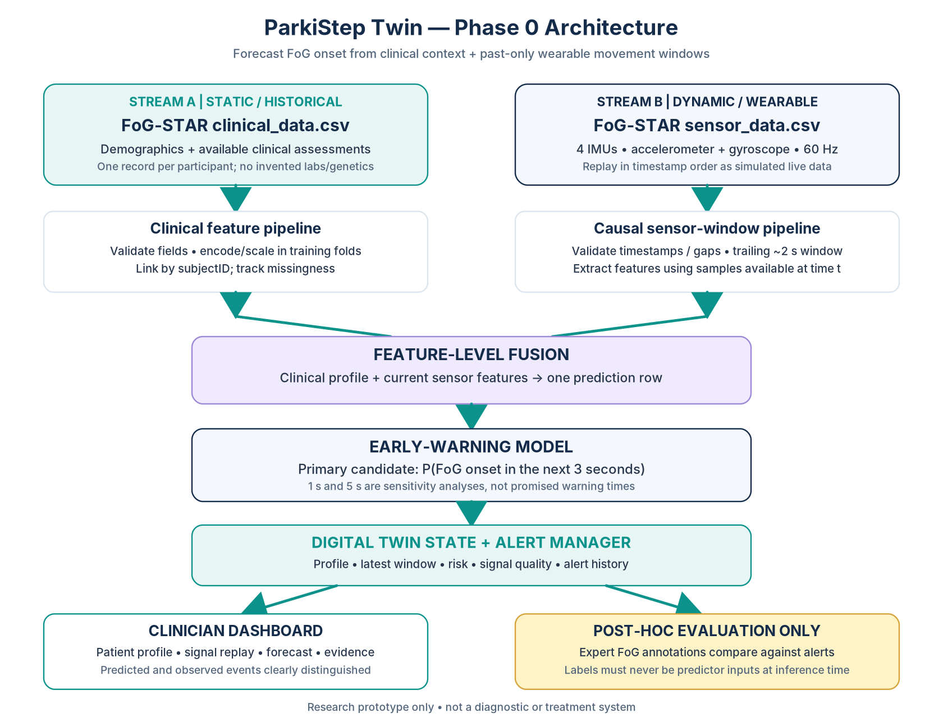
Figure 1. Proposed Phase 0 architecture. FoG labels are training targets and post-hoc evaluation labels only, never live inference inputs.

8. MVP boundaries

Must have
- Reproducible data acquisition instructions and schema validation.
- Actual linked clinical + wearable streams from FoG-STAR.
- Causal pre-onset labels for the primary 3-second horizon, with 1- and 5-second sensitivity analyses if feasible.
- Sensor-only and fused baseline models.
- Participant-wise evaluation with event sensitivity, false alerts/hour, lead-time distribution and PR-AUC.
- Replay-updated patient state and working Streamlit dashboard.
- README, attribution, architecture, presentation, and minimum 20-minute demo video.

Out of scope for this submission
- Certified medical device or clinical decision making.
- Treatment/medication recommendations or claims of fall prevention.
- Physical wearable integration or a production mobile app.
- Mandatory Daphnet transfer learning; this is a stretch goal.
- Claims of individualized online learning unless implemented and evaluated.

9. Risks and mitigations
Risk | Why it matters | Mitigation
Small cohort: 22 participants | High variance and overfitting | Simple models; grouped validation; report participant-level uncertainty
Only 101 annotated episodes | Limited positive events | Inspect event distribution; avoid excessive tuning; report counts
Detection may masquerade as forecasting | Ongoing FoG signals can inflate performance | Use only pre-onset windows; measure lead time and event-level hits
FoG-Q is related to target | May dominate fused result | Compare sensor-only, fused, and no-FoG-Q ablation
Controlled/off-medication study | May not generalize to daily life | Disclose setting and avoid deployment claims
No full EHR, labs or genetics | Historical record is partial | Use only provided fields; mark all other fields unavailable
Daphnet modality mismatch | Accelerometers only, no clinical join | Keep optional and report separately
Submission deadline | Prototype submission currently listed to end 20 Oct 2026, 7 PM IST | Verify the current official Unstop page; prioritize credible end-to-end MVP

10. Phase 0 completion checklist

Data and requirements
☐ Prediction target, primary horizon and sensitivity horizons are documented.
☐ FoG-STAR version, citations, license and acquisition steps are documented.
☐ Clinical/sensor schemas and participant join have been specified.
☐ Event labels, timestamp alignment, sampling rate and missingness will be audited before training.
☐ No synthetic field will be represented as real clinical data.

Model and evaluation
☐ Only past/current samples will be used for a prediction.
☐ Active-FoG input windows are excluded from the forecast task.
☐ Participant-wise split is specified.
☐ Fitted preprocessing and thresholds stay inside training folds.
☐ Trivial, sensor-only and fused models will be compared.
☐ Event sensitivity, false alerts/hour and lead time will be reported.
☐ Project claims will be revised if advance forecasting is unsupported.

Digital twin and submission
☐ Twin state changes as replay advances.
☐ Dashboard distinguishes prediction from ground-truth evaluation labels.
☐ Public repository, README, license and data attribution are planned.
☐ Architecture PDF/PPT, presentation PDF/PPT, and 20-minute demo video are included.

11. References
1. Borzì, L. et al. (2026). A multi-level annotated sensor dataset of gait freezing manifestations and severity in Parkinson’s disease. Scientific Data, 13, 305. https://doi.org/10.1038/s41597-026-06645-1
2. FoG-STAR dataset deposit, Zenodo record 17838806. https://zenodo.org/records/17838806 (CC BY 4.0).
3. Roggen, D., Plotnik, M. & Hausdorff, J. (2010). Daphnet Freezing of Gait. UCI Machine Learning Repository. https://doi.org/10.24432/C56K78 (CC BY 4.0).
4. Happiest Health, Digital Twin Challenge 2026, Unstop. https://unstop.com/hackathons/crp-digital-twin-challenge-2026-happiest-health-1757873

