Creating Repository in GitHub

Step 1 Click new nearby repository

Step 2 Give the repository name

Step 3 select the "Add README"

Step 4 Click Create Repository

Adding Content to README file

Step 1 Open the repository create

Step 2 Open README.md in edit mode and add the content

Step 3 Click commit changes

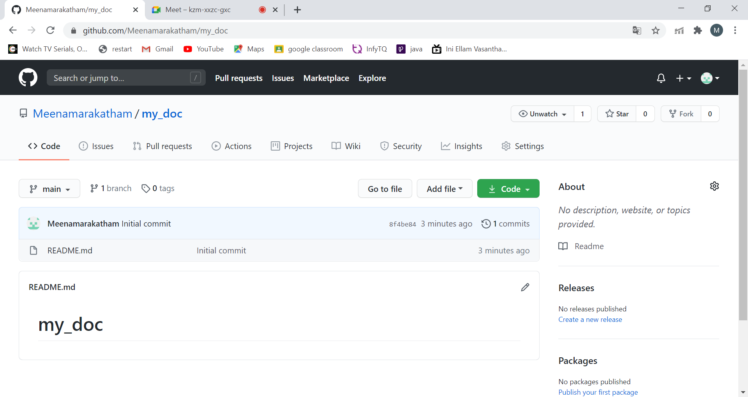

Cloning Repository:

MeenaPavi@DESKTOP-SJD0F20 MINGW64 ~

$ ls

'3D Objects'/

AppData/

'Application Data'@

Contacts/

Cookies@

Desktop/

Documents/

Downloads/

Favorites/

IBA_IOAPDATA/

Intel/

IntelGraphicsProfiles/

Links/

'Local Settings'@

MicrosoftEdgeBackups/

Music/

'My Documents'@

NetHood@

NTUSER.DAT

ntuser.dat.LOG1

ntuser.dat.LOG2

NTUSER.DAT{894b088e-dc88-11ea-8901-9c3e9e124e00}.TxR.blf

NTUSER.DAT{894b088f-dc88-11ea-8901-9c3e9e124e00}.TM.blf

NTUSER.DAT{894b088f-dc88-11ea-8901-9c3e9e124e00}.TMContainer00000000000000000001.regtrans-ms

NTUSER.DAT{894b088f-dc88-11ea-8901-9c3e9e124e00}.TMContainer00000000000000000002.regtrans-ms

ntuser.ini

OneDrive/

Pictures/

PrintHood@

Recent@

Roaming/

'Saved Games'/

Searches/

SendTo@

'Start Menu'@

Templates@

Videos/

MeenaPavi@DESKTOP-SJD0F20 MINGW64 ~

$ git clone https://github.com/Meenamarakatham/my_doc.git

Cloning into 'my_doc'...

fatal: unable to access 'https://github.com/Meenamarakatham/my_doc.git/': Could not resolve host: github.com

MeenaPavi@DESKTOP-SJD0F20 MINGW64 ~

$ git clone https://github.com/Meenamarakatham/my_doc.git

Cloning into 'my_doc'...

remote: Enumerating objects: 3, done.

remote: Counting objects: 100% (3/3), done.

remote: Total 3 (delta 0), reused 0 (delta 0), pack-reused 0

Unpacking objects: 100% (3/3), 594 bytes | 34.00 KiB/s, done.

MeenaPavi@DESKTOP-SJD0F20 MINGW64 ~

$ ls

'3D Objects'/ Intel/ ntuser.dat.LOG1 Recent@

AppData/ IntelGraphicsProfiles/ ntuser.dat.LOG2 Roaming/

'Application Data'@ Links/ NTUSER.DAT{894b088e-dc88-11ea-8901-9c3e9e124e00}.TxR.blf 'Saved Games'/

Contacts/ 'Local Settings'@ NTUSER.DAT{894b088f-dc88-11ea-8901-9c3e9e124e00}.TM.blf Searches/

Cookies@ MicrosoftEdgeBackups/ NTUSER.DAT{894b088f-dc88-11ea-8901-9c3e9e124e00}.TMContainer00000000000000000001.regtrans-ms SendTo@

Desktop/ Music/ NTUSER.DAT{894b088f-dc88-11ea-8901-9c3e9e124e00}.TMContainer00000000000000000002.regtrans-ms 'Start Menu'@

Documents/ 'My Documents'@ ntuser.ini Templates@

Downloads/ my_doc/ OneDrive/ Videos/

Favorites/ NetHood@ Pictures/

IBA_IOAPDATA/ NTUSER.DAT PrintHood@

Moving to the repository:

MeenaPavi@DESKTOP-SJD0F20 MINGW64 ~

$ pwd

/c/Users/MeenaPavi

MeenaPavi@DESKTOP-SJD0F20 MINGW64 ~

$ cd my_doc

Adding files to repository - add command: