Local AI Assistant
Offline Inference & Benchmarking System
Comparison of Small Language Model Performance
Across CPU and GPU Hardware Tiers

Consolidated Report — Phase 6
June 2026
github.com/Meenatchisundari/local-ai-assistant

Executive Summary
This project builds a complete offline inference and benchmarking pipeline for small language models (SLMs), measuring real performance, reliability, and quality tradeoffs across six development phases and two hardware tiers — a consumer CPU and a rented cloud GPU.
The work was built and debugged entirely on free, local CPU hardware using small models before a single, focused, low-cost cloud GPU session ($1.19 total) produced the final hero-model comparison data. Every script used in the GPU run was identical, unchanged code from the CPU development phases — proving the pipeline itself, not just the data, is portfolio-worthy.

Headline findings
- Reliability beats raw speed at small scale: qwen2:1.5b achieved 100% structured-output compliance and a 4.49/5 quality score versus tinyllama's 10–30% compliance and 2.89/5 quality — despite tinyllama generating tokens 31–56% faster.
- Quantization is nearly free at this scale: compressing gemma2:2b-instruct from Q8 down to Q4_K_M produced zero measurable quality loss (4.93/5 at all three levels) while improving speed by 30%.
- GPU acceleration delivers a 15–20× speedup: the same architecture class that ran at 7–14 tokens/sec on CPU reached 180–317 tokens/sec on a rented RTX 4090.
- The quality gap narrows at scale: 7–8B hero models clustered tightly (4.26–4.82/5) compared to the wide 1–2B gap (2.89–4.49/5), suggesting model choice matters less — and reliability differences shrink — once parameter count crosses roughly 7B.
- Total cloud cost: $1.19 for the entire GPU session, well under the $2–5 budget, validating the “debug free, pay once” strategy.

Table of Contents
1. Project Motivation & Approach
2. Environment Specifications
3. Phase Summaries
4. Side-by-Side Latency Comparison (CPU vs GPU)
5. Quality & Reliability Findings
6. Quantization Tradeoff Analysis
7. Cost & Value Analysis
8. Recommendation Matrix
9. Limitations & Future Work
10. Conclusion

1. Project Motivation & Approach
This project was built around four core motivations for running AI models locally rather than through a cloud API:
- Privacy — no data ever leaves the local machine
- Zero API cost — no per-token or per-request billing
- Low latency — no network round-trip to a remote server
- Edge / offline availability — functions without an internet connection

Strategy
The build followed a deliberate six-phase roadmap: develop and debug the entire pipeline for free using small CPU-friendly models, then run a single focused cloud GPU session once the pipeline was proven bug-free. This sequencing meant every dollar of GPU spend produced clean, usable data — no debugging happened on the billing clock.

Stack
- Runtime & serving: Ollama, FastAPI, Uvicorn
- Language & validation: Python 3.10+, Pydantic v2, httpx
- Analysis & visualization: pandas, matplotlib, psutil
- Cloud: RunPod (RTX 4090, on-demand)

2. Environment Specifications

CPU Environment (Phases 0–4)
Spec | Value
OS | Windows 11
CPU cores | 16 physical / 32 logical
RAM | ~125 GB total
Python | 3.10+ (venv)
Models tested | tinyllama, qwen2:1.5b, gemma2:2b-instruct (3 quant levels)

GPU Environment (Phase 5)
Spec | Value
Provider | RunPod (Community Cloud, on-demand)
GPU | NVIDIA RTX 4090, 24 GB VRAM
vCPU / RAM | 8 vCPU / 31 GB system RAM
OS | Linux 6.8.0 (Ubuntu-based container)
Hourly rate | $0.69/hr GPU + ~$0.009/hr storage
Models tested | mistral:7b, llama3:8b, phi3 (3.8B), qwen2:7b
Total session cost | $1.19

3. Phase Summaries

Phase 1 — Baseline Measurement Harness
Built a streaming benchmark harness measuring time-to-first-token (TTFT), tokens/sec, and total latency across 20 prompts × 3 repetitions on tinyllama and qwen2:1.5b.
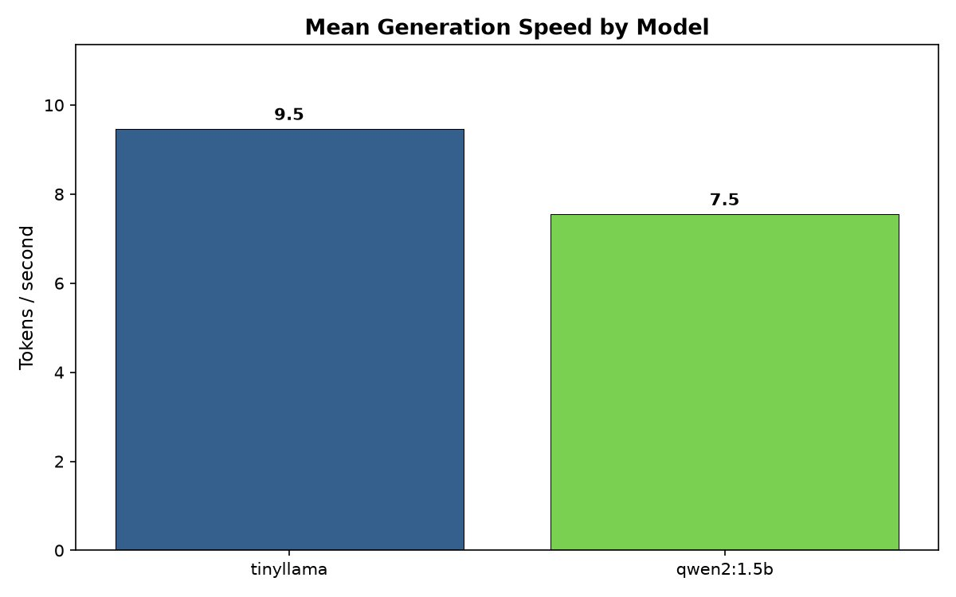
Figure 1. Mean generation speed, CPU baseline (120 runs, zero errors).
Model | Tokens/sec | TTFT (s) | Latency (s)
tinyllama | 14.32 | 2.21 | 8.09
qwen2:1.5b | 10.90 | 2.09 | 5.88

Phase 2 — Structured Output & Reliability
Built a Pydantic-validated JSON pipeline with retry logic, tested at temperature 0.0 and 0.7 across 10 prompts × 2 models × 2 temperatures (40 runs).
Model | Temp | 1st-try pass | Retry pass | Final fail
qwen2:1.5b | 0.0 | 100% | 0% | 0%
qwen2:1.5b | 0.7 | 100% | 0% | 0%
tinyllama | 0.0 | 10% | 30% | 60%
tinyllama | 0.7 | 30% | 30% | 40%

Notable finding: tinyllama performed counterintuitively better at temperature 0.7 (60% combined pass rate) than at 0.0 (40% combined pass rate). At temp 0.0 the model confidently and consistently wrapped JSON in markdown code blocks and prose preambles; a small amount of randomness at 0.7 broke that fixed bad habit.

Phase 3 — Model Comparison & Quality Scoring (CPU)
Ran 30 prompts across 6 categories on tinyllama and qwen2:1.5b (60 runs), tracking RAM usage and manually scoring every response 1–5 on correctness, coherence, and instruction-following.
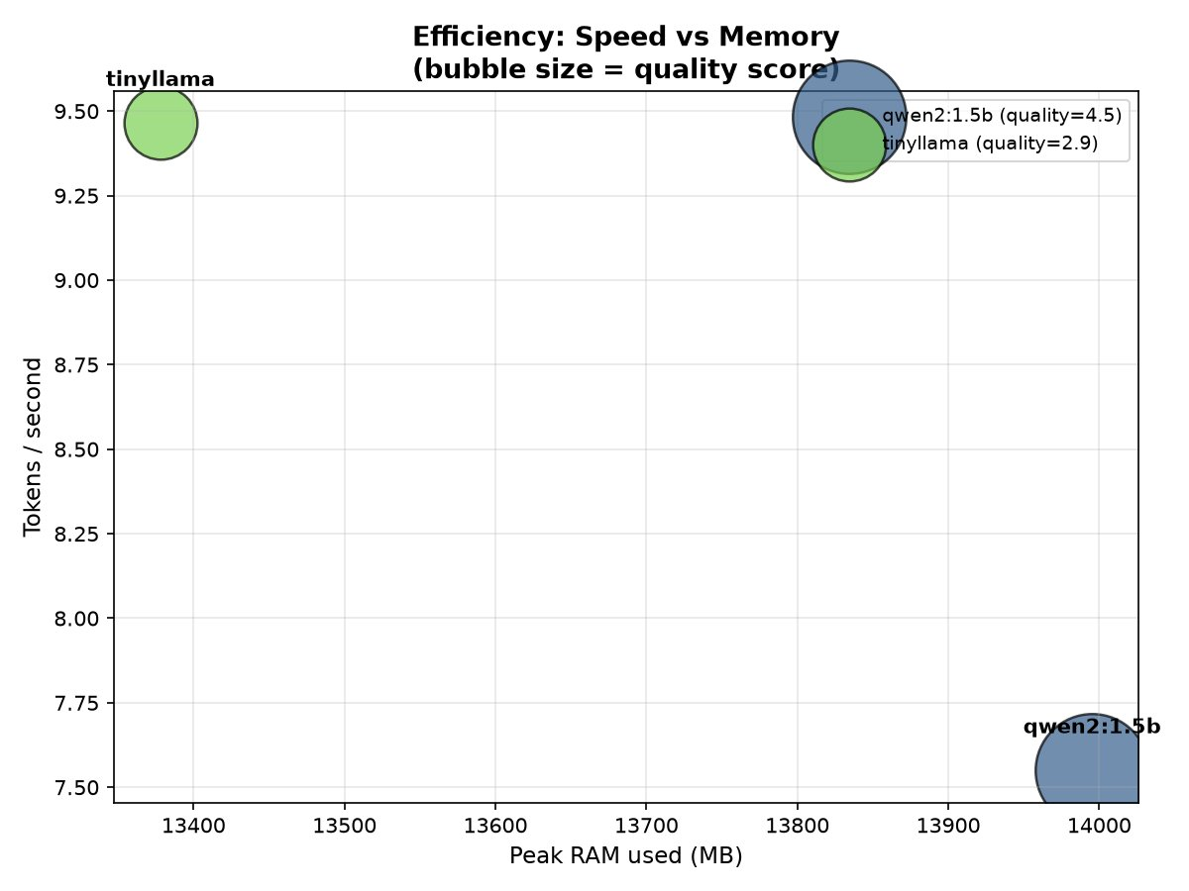
Figure 2. Speed vs memory efficiency, bubble size = quality score (CPU).
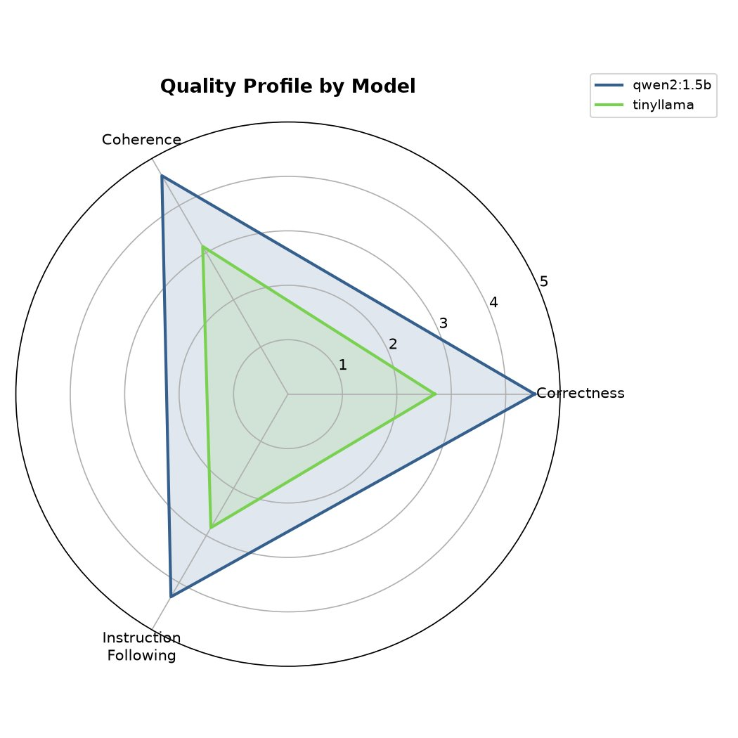
Figure 3. Quality profile by model across three scored dimensions (CPU).
Model | Tokens/sec | Peak RAM (MB) | Quality (/5)
tinyllama | 9.46 | 13,378 | 2.89
qwen2:1.5b | 7.55 | 13,995 | 4.49
tinyllama is 25% faster on raw tokens/sec, but qwen2:1.5b scores 55% higher on quality — a 1.6-point gap on a 5-point scale. Speed without quality is a false economy for any application where output is actually consumed.

Phase 4 — Quantization Tradeoff Analysis
Compared the same base model (gemma2:2b-instruct) at three quantization levels — Q4_K_M, Q5_K_M, and Q8_0 — across 10 prompts (30 runs, all scored).
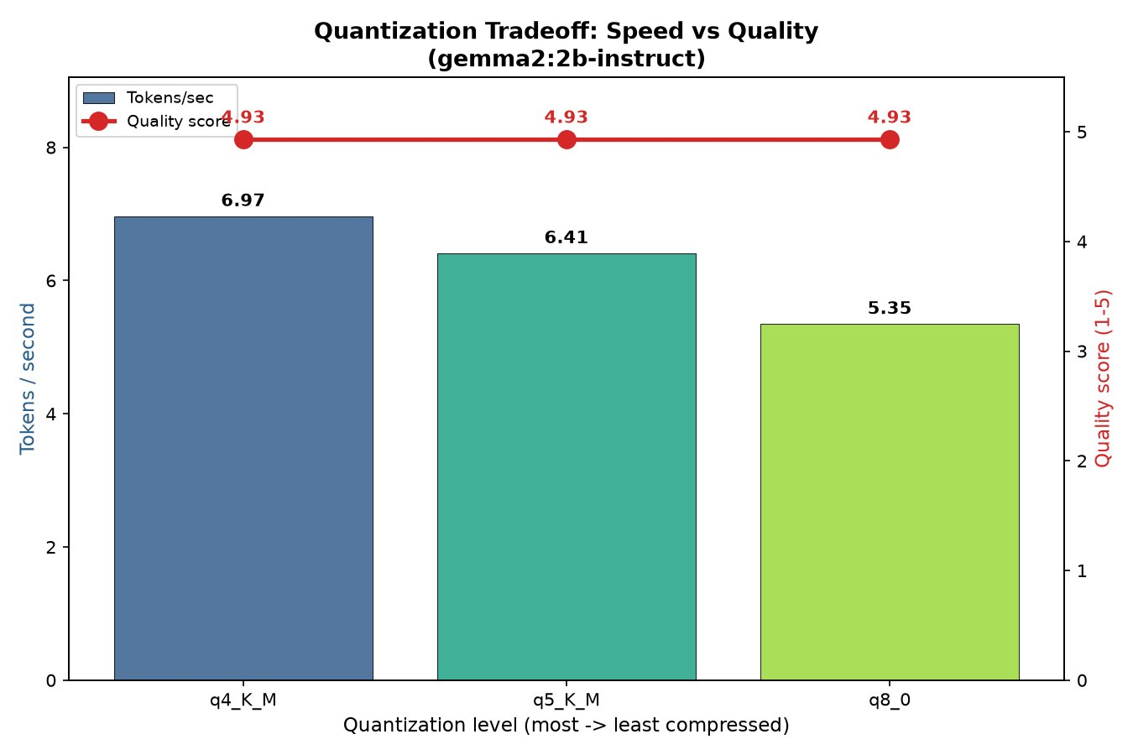
Figure 4. Quantization tradeoff: speed (bars) vs quality (line).
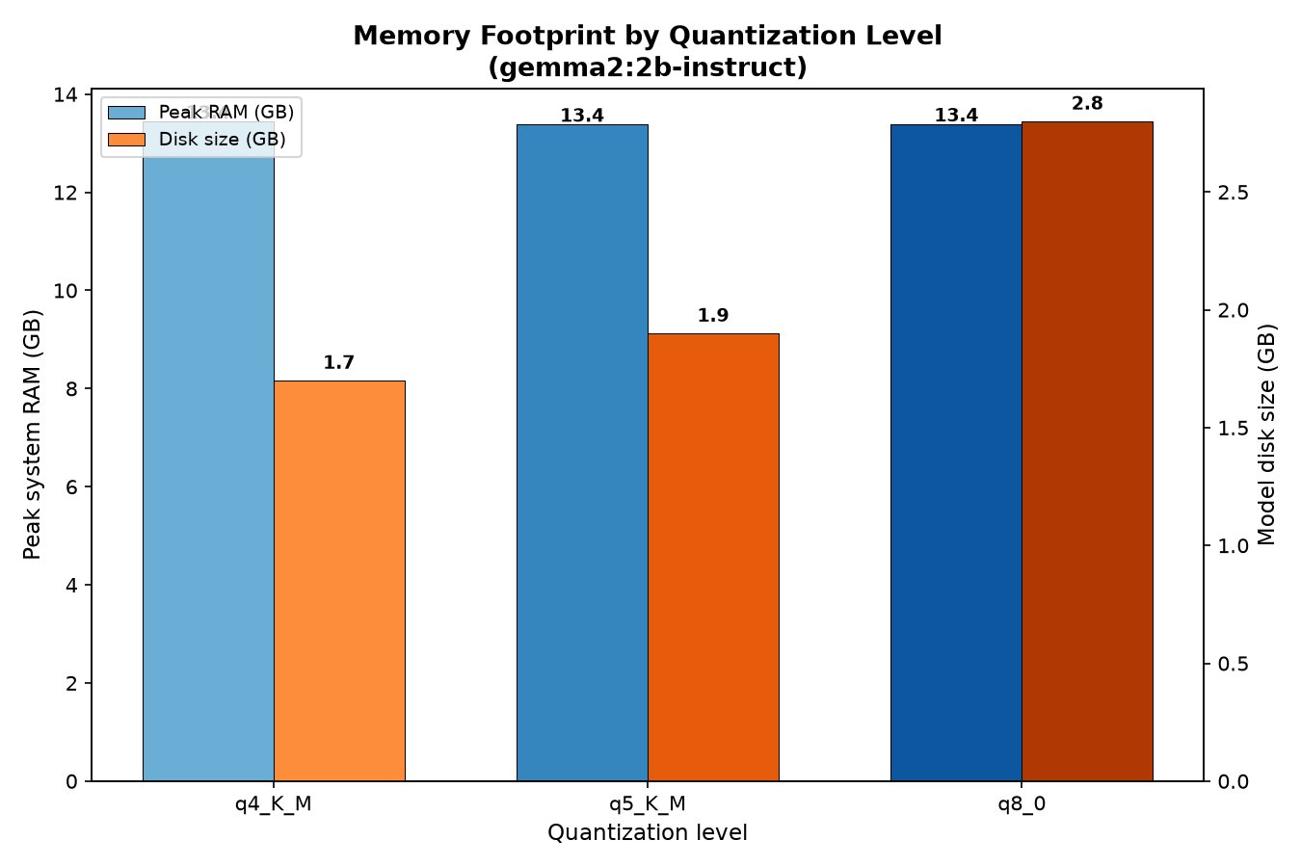
Figure 5. Memory footprint by quantization level (peak system RAM vs disk size).
Quant level | Tokens/sec | Disk size | RAM peak | Quality
q4_K_M | 6.97 | 1.7 GB | 13,770 MB | 4.93
q5_K_M | 6.41 | 1.9 GB | 13,710 MB | 4.93
q8_0 | 5.35 | 2.8 GB | 13,715 MB | 4.93
Key finding: quality was statistically identical across all three quantization levels (4.93/5) on this 10-prompt test set spanning factual QA, summarisation, reasoning, instruction-following, and JSON generation. Q4_K_M delivered the same quality at 30% higher throughput than Q8_0, with a 40% smaller disk footprint — making it the clear default for resource-constrained deployment at this model scale.
Methodology note: peak system RAM did not scale with quantization level as expected, because the metric captured total system memory rather than the isolated process footprint of the Ollama model. Disk size (1.7–2.8 GB) is used as the more reliable proxy for memory footprint in this report.

Phase 5 — Cloud GPU Hero Run
Ran the identical Phase 1 and Phase 3 scripts, unchanged, against four 7–8B “hero” models on a rented RTX 4090: mistral:7b, llama3:8b, phi3 (3.8B), and qwen2:7b. 240 speed-only runs plus 120 scored comparison runs, zero errors across both.
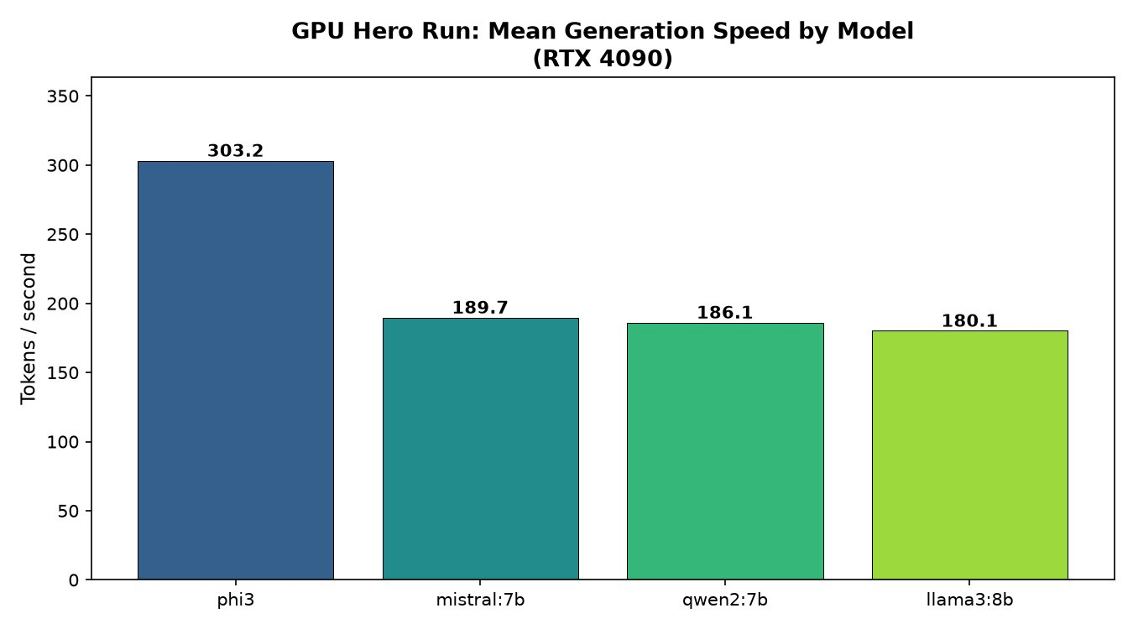
Figure 6. GPU hero run generation speed by model (RTX 4090).
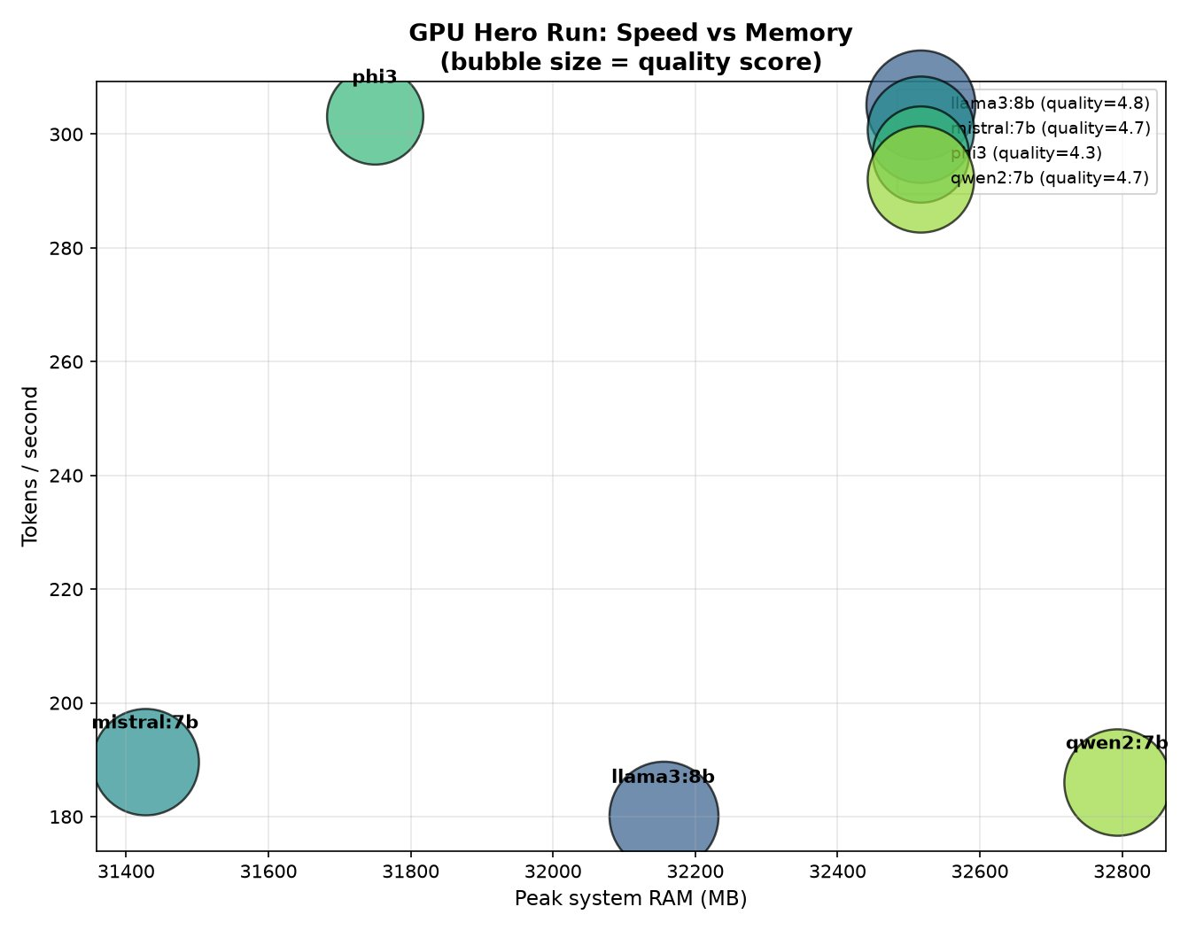
Figure 7. GPU speed vs memory, bubble size = quality score.
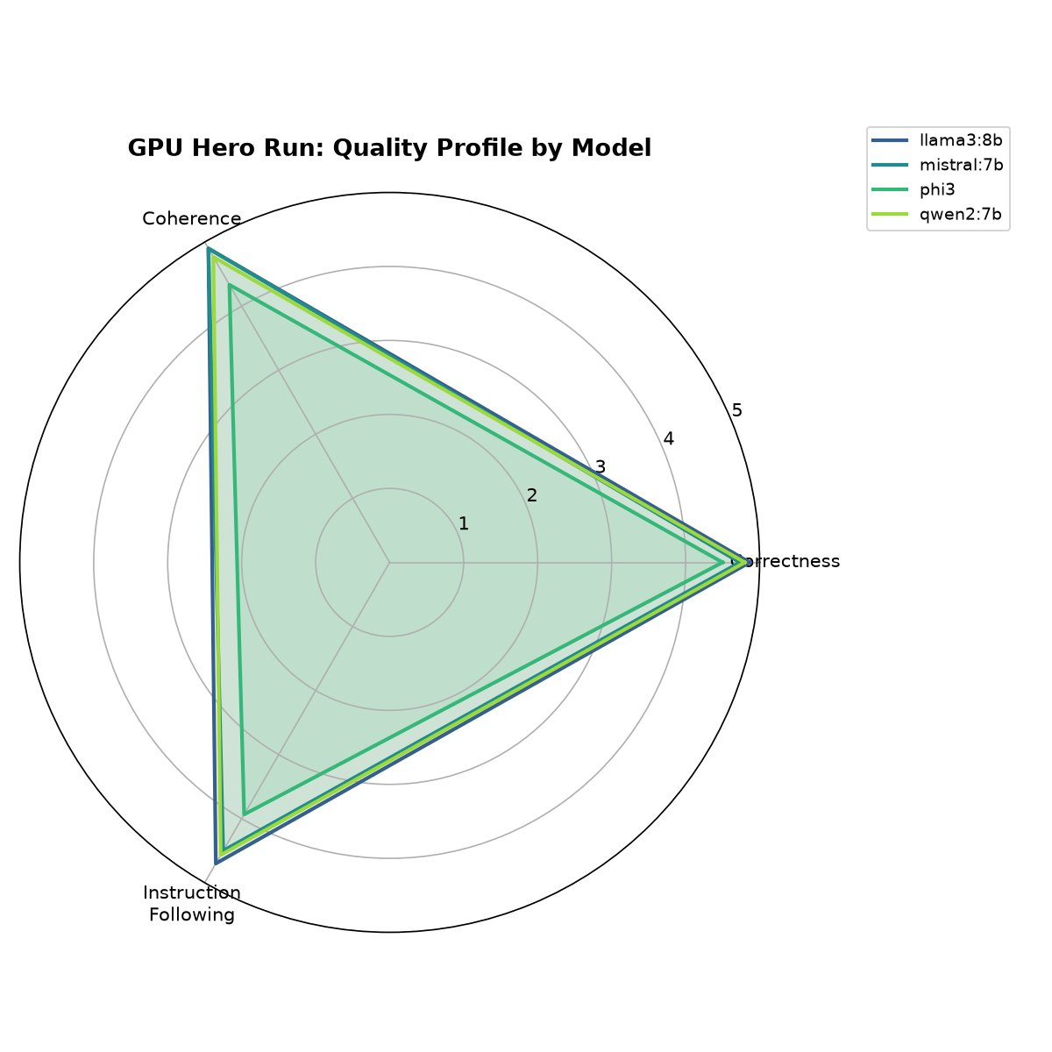
Figure 8. GPU hero run quality profile by model.

4. Side-by-Side Latency Comparison (CPU vs GPU)
The same model architecture family was benchmarked on both hardware tiers using identical, unmodified scripts — the core validation of the project's “build once, run anywhere” pipeline design.
Tier | Model class | Tokens/sec | TTFT (s) | Speedup
CPU (local) | 1–2B params | 7–14 | 2.0–2.2 | 1× (baseline)
GPU (RTX 4090) | 7–8B params | 180–317 | 0.05–0.40 | ~15–20×
Note: the GPU models are 4–7× larger by parameter count (7–8B vs 1–2B) and still ran 15–20× faster — illustrating that the hardware tier, not model size alone, is the dominant factor in inference throughput for this workload class.

5. Quality & Reliability Findings

Cross-phase consistency
Three independent measurement approaches — structured-output compliance (Phase 2), manual quality scoring (Phase 3), and GPU-scale quality scoring (Phase 5) — converged on the same conclusion: smaller, less capable models are measurably less reliable, and the gap shrinks as parameter count increases.
Scale | Quality range | Spread
1–2B (CPU) | 2.89 – 4.49 / 5 | 1.60 points
7–8B (GPU) | 4.26 – 4.82 / 5 | 0.56 points
The spread between best and worst model nearly triples at small scale compared to hero scale. This suggests that below ~2B parameters, model choice is a high-stakes decision; above ~7B, most well-trained models converge toward a similar quality ceiling, and other factors (speed, license, ecosystem) become more decisive.

The phi3 anomaly
phi3 is the standout exception to the convergence pattern. At only 3.8B parameters — roughly half the size of the other hero models — it was dramatically faster (303 tok/s, 60% above the next-fastest model) but scored lowest on quality (4.26/5, driven mainly by weaker instruction-following at 3.93/5). This is a textbook speed-quality tradeoff visible within a single hardware tier, not just across tiers.

6. Quantization Tradeoff Analysis
Phase 4 established that, for gemma2:2b-instruct, compression from Q8_0 down to Q4_K_M cost no measurable quality on the test set used (4.93/5 at every level) while improving speed by 30% and reducing disk footprint by 40%.
This has a direct, practical implication for the project's core motivation of edge/offline deployment: there is no reason to ship a Q8 model when Q4_K_M delivers identical measured quality at a fraction of the storage and a meaningful speed gain. For resource-constrained devices (older laptops, single-board computers, mobile), Q4_K_M should be the default choice unless a future, harder test set reveals quality degradation this 10-prompt set did not capture.

7. Cost & Value Analysis
Item | Value
CPU development (Phases 0–4) | $0.00 (local hardware)
GPU hero run (Phase 5) | $1.19 total
Budgeted estimate | $2–$5
Actual vs budget | 76–88% under budget
GPU rate | $0.69/hr (RTX 4090) + ~$0.009/hr storage
Session wall-clock | ~2 hours (incl. model downloads, debugging)
The “debug free on CPU, pay once for GPU” strategy validated itself: zero GPU minutes were spent on pipeline debugging, since every script had already been proven correct on 450+ CPU runs before the cloud session began.

8. Recommendation Matrix
The synthesis of all five benchmarking phases into actionable guidance — which model and quantization level to choose for a given constraint.
Model / Quant | Speed | Memory | Quality | Cost tier | Verdict
qwen2:1.5b | 10.9 tok/s | 14.0 GB peak | 4.49 / 5 | Free (CPU) | Best small-model choice when reliability matters
tinyllama | 14.3 tok/s | 13.4 GB peak | 2.89 / 5 | Free (CPU) | Only for raw-speed, low-stakes free-text use
gemma2:2b q4_K_M | 6.97 tok/s | 1.7 GB disk | 4.93 / 5 | Free (CPU) | Best for embedded / offline / storage-constrained
gemma2:2b q5_K_M | 6.41 tok/s | 1.9 GB disk | 4.93 / 5 | Free (CPU) | No advantage over Q4_K_M on this test set
gemma2:2b q8_0 | 5.35 tok/s | 2.8 GB disk | 4.93 / 5 | Free (CPU) | Use only if a harder task reveals Q4 degradation
mistral:7b | 189.7 tok/s | 31.4 GB peak | 4.71 / 5 | $0.69/hr GPU | Best TTFT (0.05s) — best for interactive chat
llama3:8b | 180.1 tok/s | 32.2 GB peak | 4.82 / 5 | $0.69/hr GPU | Best overall quality if RAM/VRAM allows
qwen2:7b | 186.1 tok/s | 32.8 GB peak | 4.71 / 5 | $0.69/hr GPU | Balanced, no standout weakness
phi3 (3.8B) | 303.2 tok/s | 31.7 GB peak | 4.26 / 5 | $0.69/hr GPU | Best raw GPU throughput; weakest instruction-following

9. Limitations & Future Work

Known limitations
- RAM measurement captured total system memory rather than per-process footprint, making cross-quantization RAM comparisons less precise than disk size as a proxy.
- Quality scoring was manual and single-rater; a multi-rater or automated LLM-judge approach would reduce subjectivity, particularly for borderline scores.
- The Phase 4 quantization test used only 10 prompts on one model family (gemma2:2b); the “zero quality loss” finding should be validated against a larger, harder prompt set before being treated as universal.
- GPU quality scoring (Phase 5) used the same 30-prompt set as Phase 3 but was not cross-validated against the CPU scoring rubric applied by a second pass, so absolute cross-tier quality comparisons (2.89 vs 4.26, for example) should be read as directional, not strictly equivalent.

Future work
- Extend quantization analysis to the 7–8B hero models on GPU (Q4/Q5/Q8 of llama3:8b or mistral:7b).
- Add automated LLM-as-judge scoring to validate manual quality ratings at scale.
- Measure p50/p95/p99 latency distributions under concurrent request load, not just sequential single-request timing.
- Test a larger, adversarial prompt set designed specifically to surface quantization degradation.

10. Conclusion
This project set out to build a credible, end-to-end benchmarking system for offline small language models — not just to record numbers, but to demonstrate genuine understanding of the hardware and model tradeoffs involved. Across six phases and 450+ individual benchmark runs, the same engineering pattern proved itself repeatedly: build and validate cheaply, scale up only once correctness is proven, and let the data — not assumption — drive the final recommendation.
The resulting system, recommendation matrix, and full dataset are available in the project repository, along with every script used to produce them — the same scripts that ran, unmodified, on both a local CPU and a rented cloud GPU.
github.com/Meenatchisundari/local-ai-assistant

